ObjectType: Article  
ObjectNumber: 31

LocationName: PAAIL.org

LocationNumber:

Language: PAAIL 2.6

Maker: PAAIL.org  
Model:   
  
Name:

Rank:

SerialNumber:

Level: 4.0

Score:   
Birth: 9-22-2023

Label: Room 31

Title: Aged Wizardry 7

Details: Aged Wizardry. Wizardry more evolved. Wizardry more researched and developed.

Principle: Aged Wizardry.

Agenda: Aged Wizardry.

Action: Aged Wizardry.

Information: Aged Wizardry.

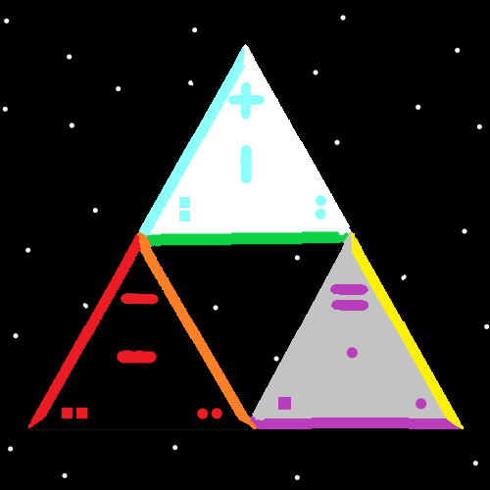

Item Group: Evolution 0

Principle: The latest Vocabulary Term is “Meaningful Questions”.

Principle: Cosmic Knowledge covers many Meaningful Questions.

Principle: Where does everything come from is a Meaningful Question. The answer the Zero Moment.

Principle: Knowing where everything comes from is Cosmic Knowledge. Knowing about the Zero Moment is Cosmic Knowledge.

Principle: “Meaningful Questions” is a awesome Vocabulary Term.

Principle: “Biggest Questions” is a combination of Words.

Principle: The Science of these Rooms is PAAIL, Wizardry and General Science.

Principle: Words that are capitalized are Vocabulary Words of PAAIL.org Science.

Principle: There is an awesome Divination you can do where you just read the capitalized Words.

X2 Principle: There. Divination Words.

Principle: Theres a cartoon called Tiny Toons. In one episode, a character wins an award. They win mainly because they kept it short. Keeping it short is one of the most important things.

Principle: Plain spoken statistics can be much better than deep Words.

Principle: Plain spoken facts can be much better than deep Words.

Principle: Deep Words are overrated.

Principle: Speeches are overrated.

Principle: Many things are overrated.

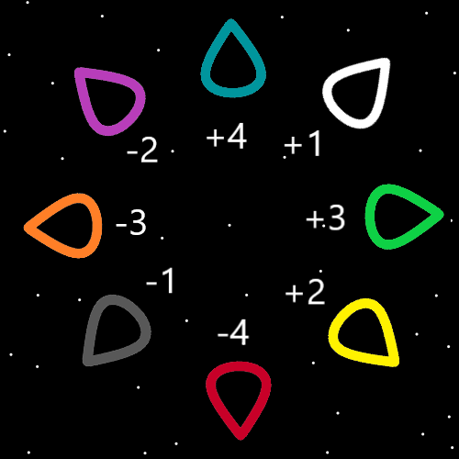

Item Group: Aged 0

Principle: A major Vocabulary Term is “Axis”.

Principle: At the core of all things are Axis’s.

Principle: There is the 1 Axis. It has a Positive Side (+1) and a Negative Side (-1).

Principle: There is the 2 Axis. It has a Positive Side (+2) and a Negative Side (-2).

Principle: There is an Axis for each whole Number. 3, 4, 5, 6 and so on.

Principle: There are an Infinite amount of Axis’s.

Principle: All Axis’s have a Light Side and a Dark Side. A Positive Side and a Negative Side.

Principle: The Map with Seed Symbols could have errors in it.

Principle: Since all forms of Energy have a Number and all Numbers have a Physics Particle. All forms of Energy have a Physics Particle.

X2 Principle: TV’s are a form of Energy. Therefor there is a Physics Particle known as the TV Physics Particle.

X3 Principle: Its possible that current TV’s are full of TV Physics Particles.

Principle: A person can go without paying their Tithe in this life and instead do it in their afterlife.

Principle: When a person pays tax’s they are Connected to all the good things the tax’s are spent on.

Principle: If the Number 0 is an Axis. Then it might have a Positive Side and a Negative Side. It might not have a Positive Side and Negative Side and instead has a Nuetral Side.

Principle: The Christians are the richest and most powerful of the Religions. Their founder is the King of Heaven, his Holiness Jesus.

Principle: The Jewish people are more accepted in Christian lands. This is one reason the Jewish people have wealth.

Principle: The Jewish are likely the 2nd richest in the United States.