
ObjectType: Article
ObjectNumber: 32
LocationName: PAAIL.org
LocationNumber:
Language: PAAIL 2.6
Maker: PAAIL.org
Model:
Name: Smith Spells 2
Rank:
SerialNumber:
Level: 4.0
Score:
Birth: 10-03-2023
Label: Room 32
Title: Smith Spells 2
Details: The latest in PAAIL.org Spells.
Principle: Sorcery.
Agenda: Sorcery.
Action: Sorcery.
Information: Sorcery.
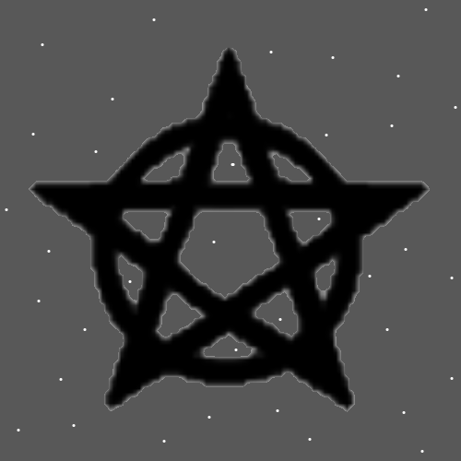
New Spells
Spell 11: Symbol Write 1x
Details: With a writing utensil. On paper or something similar. Write a Symbol.
Spell 12: Hand Symbol Sorcery 1x
Details: With the palm of your hand. In the air. Draw a Symbol.
Spell 6: Symbol Write 50x
Details: With a writing utensil. On paper or something similar. Write a Symbol 50 times.
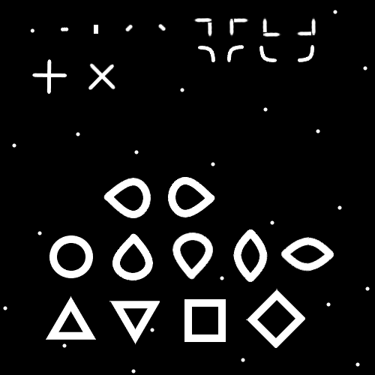
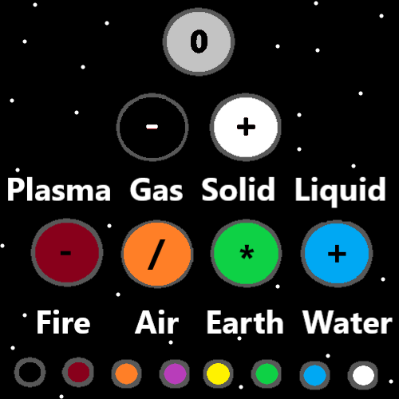
Basic Spells
Spell 0: Think Keywords 1x
Details: Think a Keyword or Keywords in your mind.
Spell 1: Repeat 1x
Details: Repeat a Spell or Spell Part over and over.
Spell 2: Breathe 1x
Details: Control your breathing and do a breathing exercise.
Spell 3: Pause 1x
Details: Pause for a moment.
Spell 4: Bow 1x
Details: Bow 1 time.
Spell 5: Fists 1x
Details: Make one fist or two fists.
Spell 6: Palms 1x
Details: Place the palms of your hands together.
Spell 7: Palm Fist 1x
Details: Make a fist and put it into the palm of your other hand.

Spell 8: Keywords Write 1x
Details: Write a Keyword or keywords.
Spell 9: Keywords Speak 1x
Details: Speak keywords or a keyword.
Spell 10: Vision 1x
Details: Envision something in your mind. Force a vision of something.
Spell 11: Symbol Write 1x
Details: With a writing utensil. On paper or something similar. Write a Symbol.
Spell 12: Hand Symbol Sorcery 1x
Details: With the palm of your hand. In the air. Draw a Symbol.
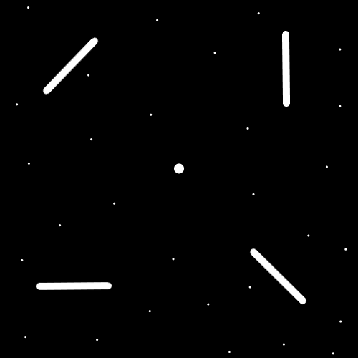
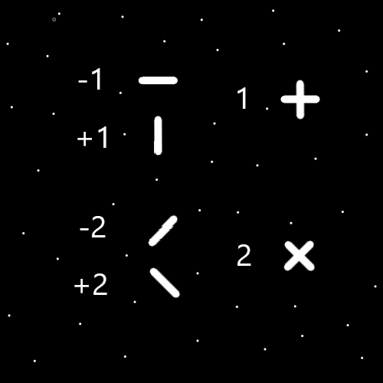
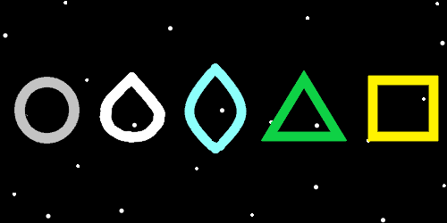
Standard Spells
Spell 0: Write Keywords 10x
Details: Write a Keyword or Keywords 10 times.
Spell 1: Smith Summons 1
Details: In your mind think a Keyword or Keywords 3 times. Pause for a moment, then repeat.
Spell 2: Smith Summons 2
Details: In your mind think a Keyword or Keywords 3 times. Then pause for a moment. During the pause do a breathing exercise. Then repeat.
Spell 3: Smith Summons 3
Details: Bow 3 times. Each time you bow think a Keyword or Keywords. Then Pause for a moment. During the pause do a breathing exercise. Then repeat.
Spell 4: Smith Summons 4
Details: Make a Fist or Fists. Then Bow 3 times. Each time you bow think a Keyword or Keywords. Then Pause for a moment. During the pause do a breathing exercise. Then repeat.
Spell 5: Smith Summons 5
Details: Make a Fist around an Energy Scroll. Then Bow 3 times. Each time you bow think a Keyword or Keywords. Then Pause for a moment. During the pause do a breathing exercise. Then repeat.
Spell 6: Symbol Write 50x
Details: With a writing utensil. On paper or something similar. Write a Symbol 50 times.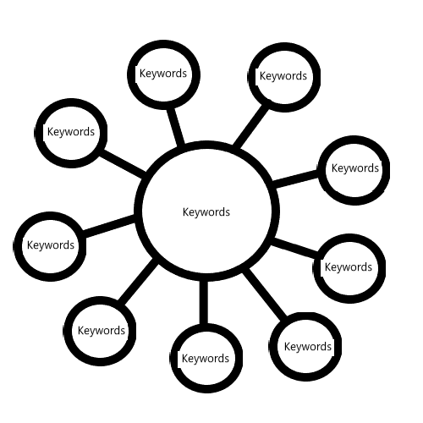
Alchemy Spells
Spell 0: Simple Energy Scroll
Details: Use the map above to make a scroll. Replace Keywords with the right Keyword or Keywords. Roll up the paper so it is a scroll. Fold it so it stays rolled up or tie it with string or ribbon or rope.
Spell 1: Shrine Charm 0
Details: Make a Shrine.
Spell 2: Enchant Shrine 0
Details: Use the right Charm and leave it with a Shrine to Enchant the Shrine. The Charms Enchantments rub off on the Shrine.
Spell 3: Personal Charm 0
Details: Place a Personal Charm at a Shrine. The Shrines Enchantments will rub off on the Personal Charm. This is one path for making a Personal Charm.
Spell 4: Collectable Owner 0
Details: For major things you are least Level 4 on…..own at least 1 Collectable Charm of the subject.

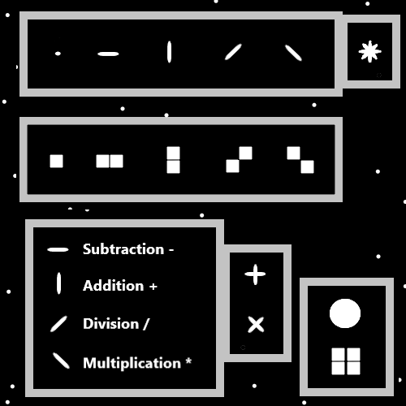
Advanced Spells
Spell 0: Smith Body Exercise 0
Details: Do a session of Body Exercises.
Spell 1: Smith Breathing Session 0
Details: Do a session of Breathing Exercises.
Spell 2: Smith Meditation 0
Details: Do a session of Meditation. The common type. Where you sit on the ground and whatnot.
Spell 3: Smith Group Meditation 0
Details: Join a Meditation Group and do group Meditation.
Spell 4: Smith Expert Blessing 0
Details: Bless a Charm with an Expert Blessing. Enchant a Charm with an Expert Blessing. If you’re a chess Expert you can Enchant things with a Chess Expert Blessing Enchantment.
Spell 5: Smith Custom Spell 0
Details: Make your own custom Spell.
Spell 6: Smith Add Part 0
Details: Add a Spell Part to a Spell.
