
ObjectType: Article
ObjectNumber: 33
LocationName: PAAIL.org
LocationNumber:
Language: PAAIL 2.6

Maker: PAAIL.org
Model:
Name:
Rank:
SerialNumber:

Level: 4.0
Score:
Birth: 9-30-2023

Label: Room 33
Title: Aged Wizardry 8
Details: Aged Wizardry. Wizardry more evolved. Wizardry more researched and developed.
Principle: Aged Wizardry.
Agenda: Aged Wizardry.
Action: Aged Wizardry.
Information: Aged Wizardry.
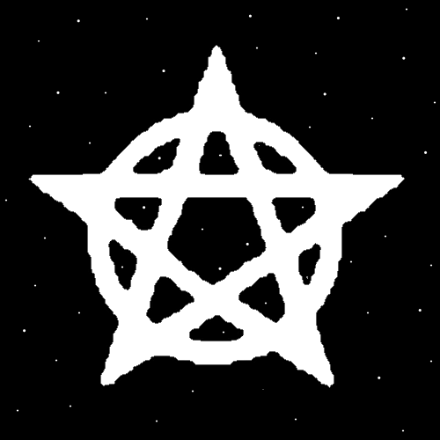
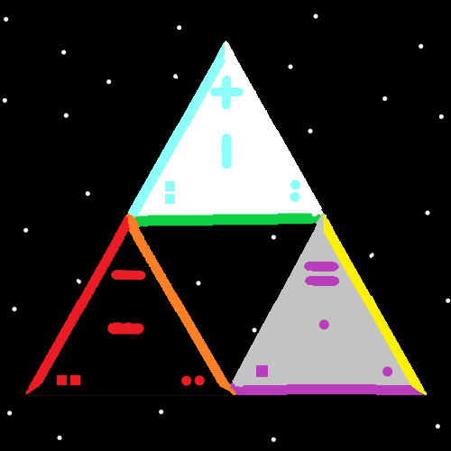
Item Group: Symbol Write 1x
Principle: The last Room was Room 32, Smith Spells 2. Three Spells were added to the Smith Spells collection. The first 3 Item Groups are about those 3 Spells.
Principle: The Spell “Symbol Write 1x”. You must actually ink paper or use a pencil on this Spell. A brush with paint works as well.
Principle: The Spell “Symbol Write 1x”. Part of this Spell is Wielding a Pen/Pencil/Brush or something similar. Part is using beginning of time paper. Since all paper is beginning of time paper. A person can use other things that are like paper. It’s a Spell that uses a beginning of time pen and beginning of time paper.
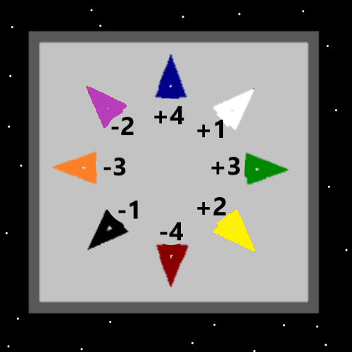
Item Group: Hand Symbol Sorcery 1x
Principle: The Spell “Hand Symbol Sorcery 1x”….doing the training surrounding this Spell is worth Wizard Levels. Maybe 0.2 to 0.3 Wizard Levels.
Principle: Doing the training surrounding this Spell Enchants a person.
Principle: The training surrounding this Spell has not yet been developed. The short Story is you do many hours of the main Symbols. Say the first 20 Symbols. First the Dot. Then the Minus Symbol. Then the “ | “ Symbol…..eventually the Triangle should be in your list. The Square should be in the 20 Symbols.
Principle: This Spell is rather new.
Principle: You are supposed to make big Symbols. 1.5 ft by 1.5 ft. At least.
Principle: Fluid Body movement is a priceless Spell Part during this Spell. You want Fluid movement.
Principle: My favorite Symbol for this Spell is the Triangle. 1 line for each of the 3 Energies. The Positive, the Negative, and the Neutral.
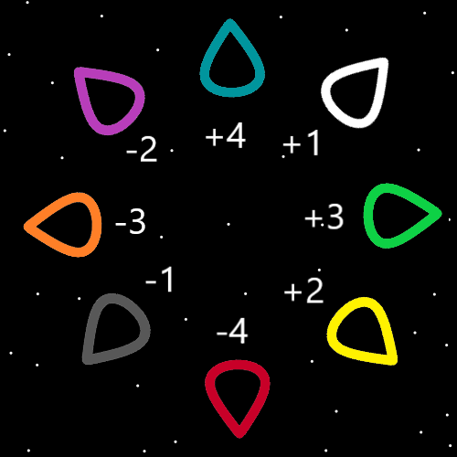
Item Group: Symbol Write 50x
Principle: The Spell “Symbol Write 50x”…this Spell is just like the Spell “Write Keywords 10x”. You do it to Enchant yourself.
Principle: Doing the training surrounding this Spell is worth Wizard Levels. Maybe 0.2 to 0.3 Wizard Levels.
Principle: The first Symbol you write 50 times is the Dot Symbol.
Principle: The training surrounding this Spell has not yet been developed. The short Story is you do many hours of the main Symbols. Say the first 20 Symbols. First the Dot. Then the Minus Symbol. Then the “ | “ Symbol…..eventually the Triangle should be in your list. The Square should be in the 20 Symbols.
Principle: The training is many hours. It may take a lot more than 20 Symbols to do that.
Principle: This Spell is rather new.
Principle: Fluid Body movement is a priceless Spell Part during this Spell. You want Fluid movement.
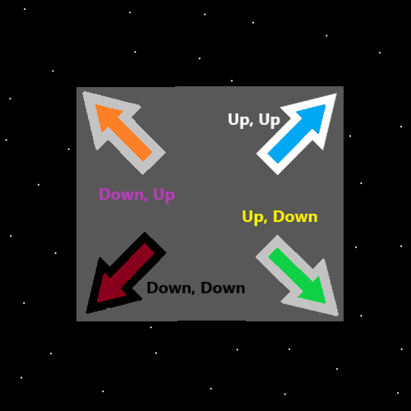
Item Group: Fluid. Movement.
Principle: Fluid Body movement is something that can be trained. It can be used all through out life.
Principle: Spells that specifically train Fluid Body movement are very powerful Spells.
Principle: “Trying” to have Fluid movement is the core of training Fluid movement.
Principle: A person can do a Exercise for Fluid movement…. where they Speak the Words, “Fluid. Move. Ment.”. Another example… “Light. Bright. Height.”. Say it…or think it in a Fluid way.
Principle: There are many Fluid movement training Spells that exist.
Principle: Fluid Movement has been gone over before. Its worth going over again.
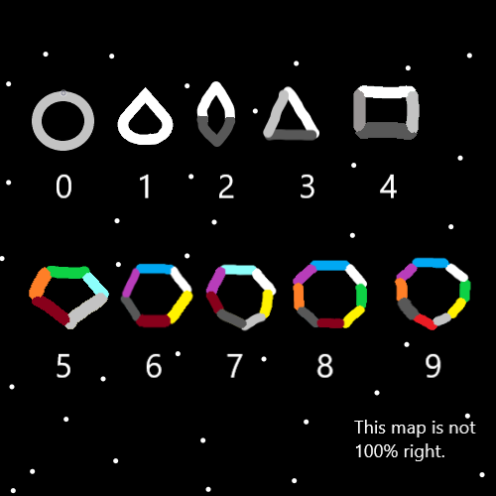

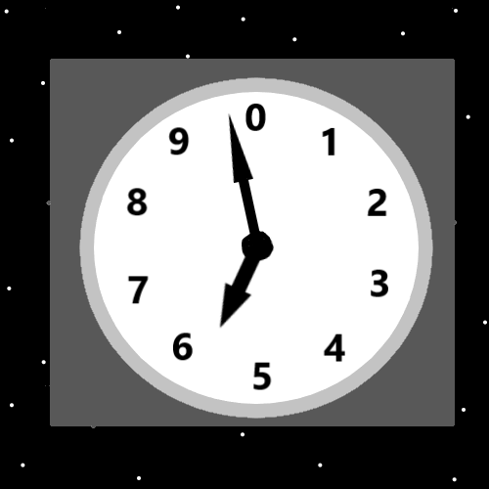
Item Group: Seeds
Principle: The Cosmic Clock Enchants the Mind…
Principle: The Cosmic Clock Map is good on a persons Mind.
X2 Principle: Good drawings do this as well.
Principle: If you rotate the 1-Pointed Seed Symbol you have an Infinite amount of Symbols. There are an Infinite amount of 1-Pointed Seed Symbols.
Principle: Every Energy has a 1 Pointed Seed Symbol. Pointing in a specific Direction.
Principle: It may be that all 1 Pointed Seed Symbols are Numbers from 1.0 to 1.999(repeating 9’s). This could be wrong.
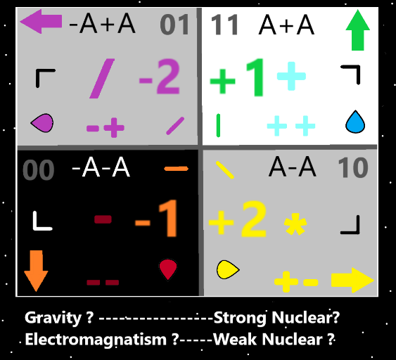
Item Group: The God Accelerator
Principle: His holiness Origin has a Particle Accelerator. His holiness used it to Make this Universe. His holiness could use it to make many more Universe’s if his holiness wanted to.
Principle: I named his holiness Origins Particle Accelerator. It seems the thing to do. I chose “The God Accelerator”.
Principle: The God Accelerator is bigger than his Holiness Origin.
Principle: Physicists think you have to zoom in to get to the Quantum Level. This is an error. The Human Level is actually the Quantum Level.
Principle: Since the theory is that every Number has a Direction. Then the Number Zero might be the Direction “Inward”. Then again Zero might be “Outward”. Perhaps there is a “Zeroward”.
Principle: Lifeforms killing and eating each other is “unnatural”.

