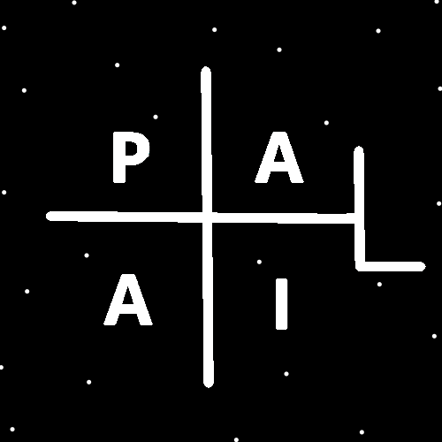
ObjectType: Article
ObjectNumber: 34
LocationName: PAAIL.org
LocationNumber:
Language: PAAIL 2.6

Maker: PAAIL.org
Model:
Name:
Rank:
SerialNumber:

Level: 4.0
Score:
Birth: 10-9-2023

Label: Room 34
Title: Aged Wizardry 9
Details: Aged Wizardry. Wizardry more evolved. Wizardry more researched and developed.
Principle: Aged Wizardry.
Agenda: Aged Wizardry.
Action: Aged Wizardry.
Information: Aged Wizardry.
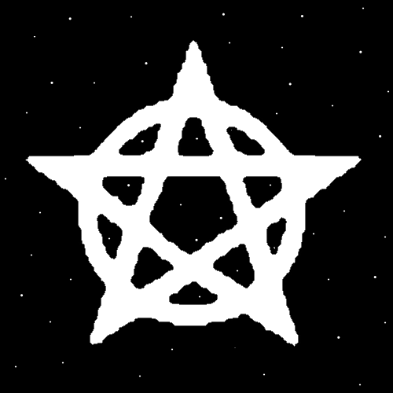
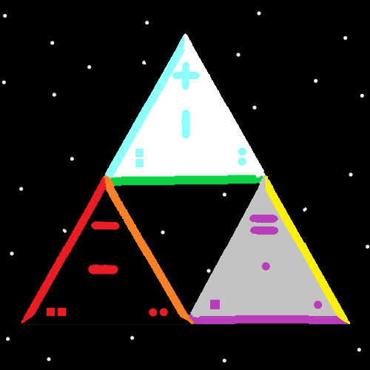
Item Group: Perspective
Principle: Yes, there is eternal life. Our lives are infinite. We Evolve forever.
Principle: The Titles go something like…. God, Master God, Grand God, High God, Grand High God. Of course there is also….God 1, God 2, God 3.
Principle: There is such thing as the more God like perspective. Things like lifeforms killing and eating each other is messed up.
Principle: Things like having to kill bugs is messed up. Don’t be confused. Sometimes you should kill bugs.
Principle: Eventually the bugs Evolve into Gods.
Principle: His Holiness Origin eventually wins the war. However his Holiness loses many battles along the way.
Principle: The Light eventually wins the war. However, it loses many battles along the way.
Principle: It turns out there is ultimate judgement. Of people, places, and things.
Principle: There is Enlightened judgement of people, places and things.
Principle: To know thyself is to judge thyself.
Principle: The most common flaw on planet Earth is over-confidence.
Information: The author was big time over-confident at one time.
Principle: Knowing we all have about the same Spiritual impact can help a person regarding their confidence.
Principle: Knowing we all have about the same meaning in our lives can help a person regarding their confidence.
Principle: The latest Vocabulary is “General Chess Enchantment”. It means when something has a General Chess Enchantment.
X2 Principle: Example: A person might say, “The Shrine has a General Chess Enchantment.”
X2 Principle: A Spell that bestows a General Chess Enchantment can be found in Room: Smith Spells 2.
X2 Principle: A General Chess Enchantment has a Level. Example: “The Shrine has a Level 3 General Chess Enchantment.
X2 Principle: A book about Chess has at least a Level 4 General Chess Enchantment.

Principle: All Shrines should have a Religious Charm as Tribute to his Holiness Origin.
Principle: A Shrine with a Religious Charm gains a General Spiritual Enchantment.
Principle: Shrines are partly used to Pay Tribute.
Principle: Paying Tribute to things can Summon Energy. Paying Tribute is a Spell.
X2 Principle: Divination Example: The Key used here is “use the words that start with a capital letter.”
Paying Tribute. Summon Energy. Paying Tribute Spell.
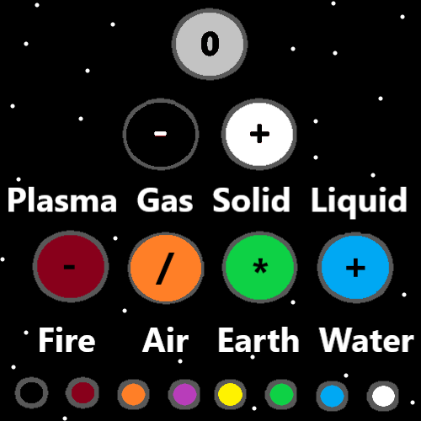
Item Group: Wizard Levels
Principle: There are often many paths from one point to another. A ton of Body Exercise can be a 0.7 to 1.0 Wizard Level gain.
Principle: A ton of Breathing Exercises can be a lot of Wizard Level gain.
Principle: A ton of Meditation Exercises can be a lot of Wizard Level gain.
Principle: When training Wizardry its all about things that Make a Wizard Level gain.

Principle: For a Religion, Body Exercise, Breathing Exercise and Meditation Exercise are a way you could go….. however people do not always have time for such things. And for other reasons such Actions can be not right.
Principle: As for reading Scripture….. Reading Scripture has been a greater thing in Religion. You can choose no Body Exercise, Breathing Exercise, Meditation Exercise. You should choose to read Scripture.
Principle: The best Scripture I know of, can be found at PAAIL.org.
X2 Principle: Compared to the Bible PAAIL.org is different.
X3 Principle: PAAIL.org is probably no more than half the size of the Bible. Much less to read.
X3 Principle: PAAIL.org is the one true Religion, and better explains the Multiverse.
Principle: If you haven’t noticed yet, the Muslims, Jewish, Christians, Hindu, and Buddhists all worship the same God.
Principle: Like there are many different Denominations in Christianity, there are many Religions across the planet.
Principle: It has been said before and seems worth saying again. The Christians are the richest and most Powerful. They were founded by his holiness the King of Heaven.
Principle: The Buddhists are probably the best of the big 5 Religions. I picture(Envision) them doing much less damage throughout their history.
X2 Principle: When you picture something like this….it counts as a Vision. A right or wrong Vision.
Principle: The Muslims may be a more disciplined people. No alcohol. Lots of Demands regarding clothing. Pray on your knees 3 times a day. Plus more things……
Principle: His Holiness Jesus was of the Jewish faith. The Jewish people may be a more Priest like people. To my knowledge… the patriarch of the Jewish people was Abraham and he was a Sheperd. That for a long time the Jewish people were Shepards.
Principle: The Hindu seem the most Mystical to me. When I think of Hindu, I think of Chakras. Though that may be Buddhist thing for all I know.
Information: I know very little about the Hindu Religion.
Principle: I think there has been a lot of endure pain for Spiritual gain throughout the Hindu. Perhaps it was good once…. I don’t think it is good anymore. We have done enough endure pain. Partly thanks to the Hindu.
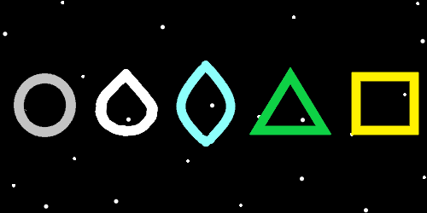
Item Group: 0
Principle: There is massive Divination that can be done with Scripture.
Principle: When doing Divination with Scripture you want to use the right Keywords. Like God, Origin, Enlightenment, Light, Religion. There are an endless Number of Words that work.
Principle: When using the Word God as a Key. The first sentence of the Bible can turn into
“Beginning. God. Created.”. The Key is using the first Word with a “G”, then the next Word that has a “O”, then the next Word that has a “D”.
“In the beginning God created the Heavens and the Earth.”-Genesis 1:1
Principle: Doing Divination with Scripture can be entertaining. It can be Mystical. It can reveal things and more.
Principle: Doing Divination is an Ancient Sorcery. You can gain Wizard Levels from doing it.
Principle: Since Divination is Sorcery, a person gains Sorcery Levels from doing it.
Principle: There is a lot of Divination out there.
Principle: Reading tea leaves at the bottom of a cup or doing Palm Readings is Divination. Tarot Cards are also used for Divination.
Principle: Reading Scripture is often the biggest of the Spiritual Actions. And, the best Scripture you can find comes from PAAIL.org.
Principle: It is accurate to say that all people are strong with the Force.
Principle: So much Energy flows through us all.
Principle: It is accurate to say that some people are strong with the Chess Side of the Force.
Principle: It is possible that the Earth is Made from the Body of his Holiness One. When you eat, you are eating the Body of his Holiness One.
Principle: It is possible that Heaven is Made from the Body of his Holiness Origin and therefor Earth is Made from the Body of his Holiness, our God.
Principle: Its very little work to get Level 4, Expert, Yellow Wizard. Level 5 is a lot of work. Some people should be satisfied with Level 4.
Principle: Level 4 can be gained by a little reading and Body Exercise combo. There are other Paths to Level 4 as well.
Principle: Its super easy to get Level 4 Wizard.


