ObjectType: Article  
ObjectNumber: 36

LocationName: PAAIL.org

LocationNumber:

Language: PAAIL 2.6

Maker: PAAIL.org  
Model:   
  
Name:

Rank:

SerialNumber:

Level: 4.0

Score:   
Birth: 10-14-2023

Label: Room 36

Title: Aged Wizardry 10

Details: Aged Wizardry. Wizardry more evolved. Wizardry more researched and developed.

Principle: Aged Wizardry.

Agenda: Aged Wizardry.

Action: Aged Wizardry.

Information: Aged Wizardry.

Item Group: Technology

Principle: Eventually his Holiness Origin and Heaven will invent a Body that is more powerful than his Holiness Origins current Body.

Principle: His Holiness Origins understanding of the Multiverse is vast, however not infinite.

Principle: For all eternity there will be new inventions. For all eternity there will be new technology. It is the endless riddle.

Principle: With the rather new realization that this all amounts to Scripture and a Religion. Comes a focus on Scripture and Religion.

Principle: When a person commits a crime, they sell out his Holiness our God.

Principle: A person can play Religious cards all the time. Things like “What would his Holiness Jesus say?”. Or “What would his Holiness Origin have us do?”.

Principle: I have my own system for judging art. Things like movies, music, paintings, sculptures and so forth.

Principle: The art judging system I use is a 0.1 Stars to 5.0 Stars system. 0.1 is the lowest, and 5.0 is the highest.

Principle: When I feel something is from 4.0 to 5.0, I don’t try and figure out an exact Number. Instead I call it a “4+”(four, plus)… meaning it is somewhere from 4.0 Stars to 5.0 Stars.

Principle: 3.0 Stars is ok. Below 3.0 Stars is a thumbs down.

Principle: When something is below 3.0 Stars, its about how bad is it.

Principle: People can develop an “acquired taste” for something that is below 3.0 Stars and still get a 4+ experience.

Principle: Beauty is in the eye of the beholder. Beauty only exists when someone is beholding it. However, beauty is not relative. Some things are beautiful, and some things are not.

Principle: On the Cosmic Scale we are all family.

Principle: The animals, plants and bugs are all family.

Principle: Every cell in the human Body is another family member.

Principle: If you were a God, your perspective would be that we are all family.

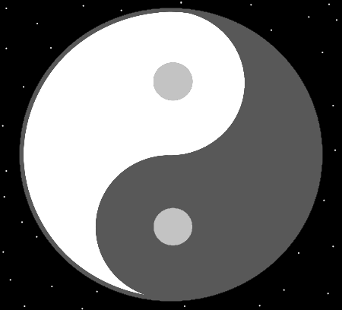

Principle: For his Holiness Origin, we are all family.

Principle: Everyone except his Holiness Jesus is a grandchild to his Holiness Origin.

Principle: For his Holiness Jesus, we are all his children.

Principle: The term “born again Christian” always reminds me of how one day we are born again in Heaven, infants one more time, a child of Jesus.

Principle: The Religions of the world are right about some thing and wrong about others.

Principle: What are the Religions right about and what are they wrong about. For starters we only have to do one tour of duty as a human. Not reincarnation over and over in human Bodies.

Principle: One major detail is that God Makes us only do 1 tour of duty as a human.

Principle: Some Religions don’t have his Holiness Jesus. As though his Holiness Jesus doesn’t even exist.

Principle: Even though Jesus was born in Israel, most of the people there are not Christian.

Principle: The Buddhist Religion seems to appear before his Holiness Jesus did his tour of duty on Earth. If the Budha is the Christ, then the start of Buddhism was likely started by Prophets, Prophesizing about the coming of his Holiness Jesus.

Principle: I know lots of people constantly want to hear the Word “love”. I cant say I always want to be hearing the Word “love”.

Principle: His Holiness Jesus was not passionate. He was too much of a peaceful, passive person for that.

Principle: Sometimes a persons ways are great, and yet still there is even better.

Principle: Sometimes there is an awesome Path, and yet still another, better Path.

Principle: It can be a great thing to be a passionate person. However it can be a greater thing to not be.

Principle: It can be great to be at peace with things. However, that is not always an option.

Principle: Sometimes a Path is awesome and yet there is an even better Path.

Principle: Sometimes a person’s ways are awesome and yet there is even better.

Principle: Spiritually Level 6 is a Spiritual Sage. Spiritually Level 7 is a Spiritual Holy person.

Principle: Before we Evolve into Gods, we all will Evolve into Holy people.

Principle: The author here knows how to get to Doctor of Wizardry, however, has not done the work needed and is still only a Master Wizard.

Principle: How to get to Doctor of Wizardry has been done in all the PAAIL.org text. It takes 2 to 3 years for Doctor. That’s Level 0 to Level 6. Level 0 to Level 6 takes 2 to 3 years.

Principle: Since ESP is like the sense of smell. ESP is similar in that a person can get used to a smell. You stop experiencing ESP on a thing, because you are used to it. Like you stop being able to smell a thing because you are used to the smell.

Principle: A persons senses can be wrong. They can sense an object is Positive, when it is Negative and a person can sense an object is Negative when it is actually Positive.

Item Group: Enchanting

Principle: Doing the Dot Symbol over and over, with Hand Symbol Sorcery, Enchants a person. It Connects them to the Dot moment and the foundation of the Multiverse. It Connects them to the Zero Particles that existed at the Zero Moment. It is the first Symbol and one a person wants a Connection to.

Principle: ESP is like the Sense taste. You can get mixtures of ESP Auras and experience a unique taste from the mix.

Principle: Its super common to have ESP experiences while listening to music.

Principle: The biggest epidemic on Earth is the drug epidemic. People being hooked on drugs.

Principle: Alcohol is a drug.

Principle: The Mystical Word for Alcohol is “firewater”. It is a potion.

Principle: Along with Wizard Levels there is also Sorcerer Levels. The education provided by PAAIL.org is likely enough to get Level 5 Sorcerer or higher.

Principle: The author is still a Level 3 Sorcerer.

