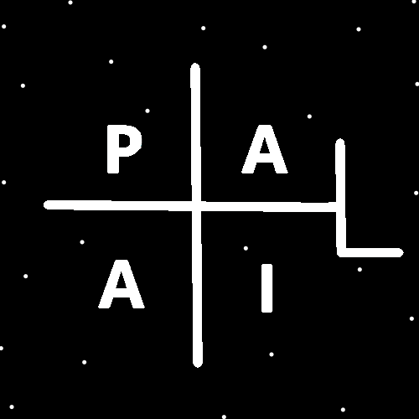
ObjectType: Article
ObjectNumber: 37
LocationName: PAAIL.org
LocationNumber:
Language: PAAIL 2.6

Maker: PAAIL.org
Model:
Name:
Rank:
SerialNumber:

Level: 4.0
Score:
Birth: 10-17-2023

Label: Room 37
Title: Aged Wizardry 11
Details: Aged Wizardry. Wizardry more evolved. Wizardry more researched and developed.
Principle: Aged Wizardry.
Agenda: Aged Wizardry.
Action: Aged Wizardry.
Information: Aged Wizardry.
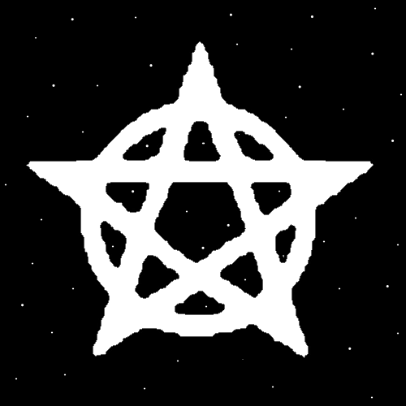
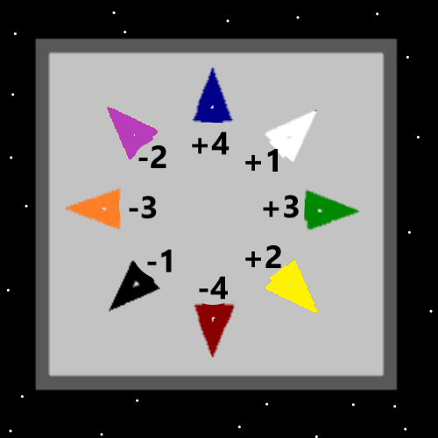
Item Group: Further More…
Principle: Speeches are below 3.0 Stars. A thumbs down. Though some have an acquired taste for them.
Principle: Lectures are under rated. Short lectures can be very nice. Making a short lecture is adding the Spell Part “short” to the lecture.
Principle: PAAIL.org Expert Wizards know that all Actions are Spells.
Principle: There is such thing as Wizards that do not know the ultimate Cosmic Knowledge. Cosmic Knowledge is just one part of Wizardry.
Principle: Most Wizards of the last 100 years were people doing Divination, Dream Interpretation, Astrology, Chakras and so forth.
Principle: We live at the beginning of time and it is a very serious time.
Principle: Since we all have a huge Chi. We all have an intense existence.
Principle: Peace and quiet is under rated.
Principle: Someone should invest 1 to 10 million on a better massage session.
X2 Principle: Medical Experts would be used.
X2 Principle: People that have been giving massage’s would be used.
X2 Principle: Tools should be designed and used. Including gloves and tables.
X2 Principle: Its better to not have skin on skin contact between the two people. This is partly where gloves comes in.
X3 Principle: Skin on skin contact increases the intensity of the session….which means less peace and quiet for the session.
X2 Principle: Its better if the people giving the massage work only 1 hour on, then 1 hour off. So, they are always rested.
X3 Principle: Drained people doing the work is less peace and quiet for the session.

X2 Principle: Its better to not use oils. Instead use that time to clean a person with soap and brush. Make them where shorts and top piece. Clean everywhere except those places a person should clean themselves.
X3 Principle: Washing someone’s back, legs, arms, doesn’t take much time with soap and a brush.
X3 Principle: The cleaning addition to the session is priceless. It does a lot of Positive things.
X2 Principle: There should be a waiver you have to sign before you get the massage. In case of accidental injury.
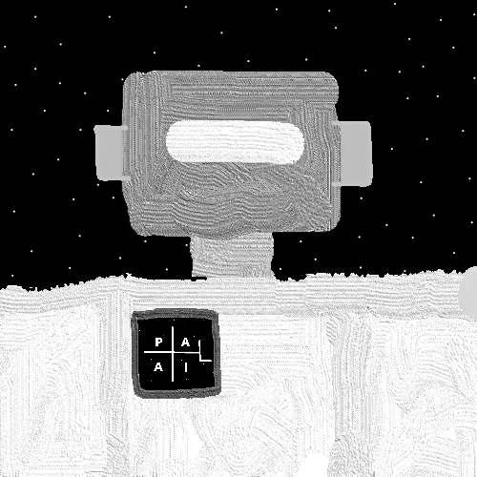
Principle: As for Artificial Intelligence.
X2 Principle: To me a calculator is a little robot with an AI. An AI that can do math.
X3 Principle: All Charms are like people. A calculator is like a robot because of this.
X2 Principle: It would appear that we may end up with robots like “C3P0”, from the movie Star Wars.
X3 Principle: Such robots would be a huge power and would change everything.
X2 Principle: 4 arms is more powerful than 2 arms. 4 legs is more powerful than 2.
X2 Principle: A robot with 2 legs can more easily be knocked over by a human.
X2 Principle: I see all programs as an AI. Like in the movie the matrix. The game “World of Warcraft” is an AI that can generate a game world and so forth for you.
Principle: The author has been doing Level 3 programming over the years. These days its often only one click to get a question answered when I have a programming question.
Principle: It would seem what is medicine for one person can be poison for another.
Principle: In last 70 years, intelligence has gone up a lot. Einstein would be average for these days. It is the primary cause of overconfidence.
X2 Principle: Radio, TV, music, art on the walls… it all boosts intelligence.
Principle: Intelligence is at Paranormal Levels right now. It’s one of the biggest Paranormal events going down on planet Earth. Since it’s so widespread.
Principle: Technology on Earth is at Paranormal Levels right now. It’s one of the biggest Paranormal events going down on planet Earth.

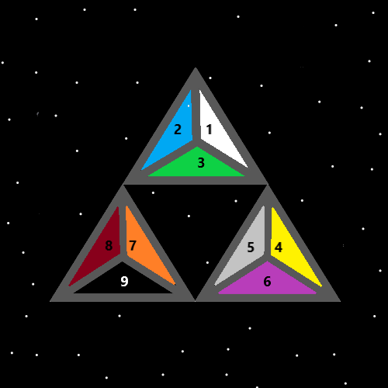
Item Group: Advanced Enchantments
Principle: Since there are always secrets in everything…. The game Dungeons and Dragons has secrets.
Principle: Some of the biggest human Attributes are… Dexterity, Strength, Constitution, Intelligence, Wisdom, and Charm.
Principle: Some of the biggest human Enchantments are… Dexterity, Strength, Constitution, Intelligence, Wisdom, and Charm.
Principle: Everyone has a Dexterity Level, a Strength Level, a Constitution Level, a Intelligence Level, a Wisdom Level, and a Charm Level.
Principle: Having done a ton of Body Exercise is a powerup that is as big as Level 1 Wizard, even Level 2 Wizard. Body Levels like Body Strength can have an improvement to a persons Sorcery Spells.
Principle: In the game D&D… Strength is good for warriors. In real world Science, Strength is actually super good for the Wizard. Though it has been known to help in a fight as well.
Principle: Body Strength is an ultimate Enchantment for a Wizard.
Principle: Increasing Body Strength can be an ultimate powerup for a Wizard.
Principle: Some people have a General Body Strength Level 4 Enchantment.
Principle: All of these Enchantments are ultimate in life. Dexterity, Strength, Constitution, Intelligence, Wisdom, and Charm. Note Strength could be the least of them, or the best.
Principle: All of these Enchantments are ultimate for a Wizard. Dexterity, Strength, Constitution, Intelligence, Wisdom, and Charm.
Principle: Currently…. On Earth…. there are huge, Paranormal Levels, of Dexterity, Strength, Constitution, Intelligence, Wisdom, and Charm.
Principle: There is a lot of Paranormal Levels on planet Earth right now.
Principle: When you go over all the Charms of a persons home and property you find there are a lot of Charms. A Paranormal lot of Charms. The Paranormal Part that there is so many of them.
Principle: Lots of things can be written regarding Dexterity, Strength, Constitution, Intelligence, Wisdom, and Charm.
Information: I Sense(Envision)(This counts as a Vision, right or wrong)( I could write a lot on the 6 Enchantments. Dexterity, Strength, Constitution, Intelligence, Wisdom, and Charm.
Principle: Spirituality is a Science. Spirituality is also an area of Science.
Principle: Spirituality is a Religion.

