
ObjectType: Article
ObjectNumber: 38
LocationName: PAAIL.org
LocationNumber:
Language: PAAIL 2.6
Maker: PAAIL.org
Model:
Name: Smith Spells 4
Rank:
SerialNumber:
Level: 4.0
Score:
Birth: 10-19-2023
Label: Room 38
Title: Smith Spells 4
Details: The latest in PAAIL.org Spells.
Principle: Real Sorcery.
Agenda: Real Sorcery.
Action: Real Sorcery.
Information: Real Sorcery.
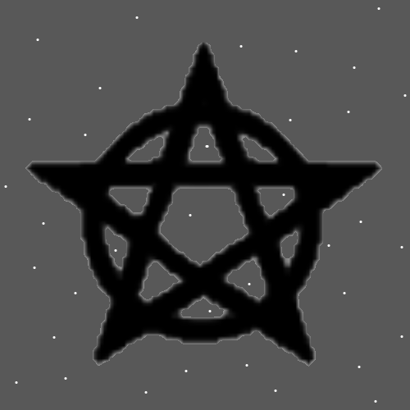
New Spells
Spell 00: Body Clean 0
Details: In some way…. Clean your Body.
Spell 00: Massage 0
Details: Get a massage. This counts as Body Exercise.
Spell 00: Smith Summons 6
Details: Do Spell Smith Summons 5, only add the Spell Part Visualize something during the Spell. This is adding the induce a Vision Spell Part.
Spell 00: Smith Summons 7
Details: Do Spell Smith Summons 6, only add the Spell Part with one Hand Make a Symbol in the air. This is adding a Hand Symbol Sorcery Spell Part to the Spell.

Recently Added Spells
Spell 00: Pay Tribute 0
Details: In some way…. Pay Tribute to something.
Spell 00: Repair Off Hand 0
Details: In some way…. Improve your Off Hand. Sometimes this means improve your Off Hand Dexterity.
X2 Principle: Improving your Off Hand can Make you more graceful.
X2 Principle: There is such thing as Grace Virtue Levels
Spell 00: Hydrate 0
Details: In some way…. Hydrate yourself. Many liquids like water work. Many liquids do not.
Spell 00: Consume Lifeforce 0
Details: Consume Lifeforce by eating food or drinking something.
Spell 00: Rest 0
Details: In some way rest…..

Spell 00: Repair Off Leg 0
Details: In some way…. Improve your Off Leg. Sometimes this means improve your Off Leg Dexterity.
X2 Principle: Improving your Off Leg can Make you more graceful.
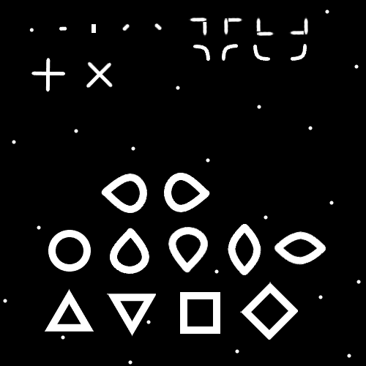
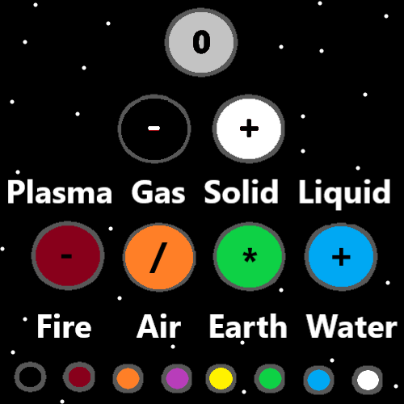
Basic Spells
Spell 0: Think Keywords 1x
Details: Think a Keyword or Keywords in your mind.
Spell 1: Repeat 1x
Details: Repeat a Spell or Spell Part over and over.
Spell 2: Breathe 1x
Details: Control your breathing and do a breathing exercise.
Spell 3: Pause 1x
Details: Pause for a moment.

Spell 4: Bow 1x
Details: Bow 1 time.
Spell 5: Fists 1x
Details: Make one fist or two fists.
Spell 6: Palms 1x
Details: Place the palms of your hands together.
Spell 7: Palm Fist 1x
Details: Make a fist and put it into the palm of your other hand.
Spell 8: Keywords Write 1x
Details: Write a Keyword or keywords.
Spell 9: Keywords Speak 1x
Details: Speak keywords or a keyword.
Spell 10: Vision 1x
Details: Envision something in your mind. Force a vision of something.
Spell 11: Symbol Write 1x
Details: With a writing utensil. On paper or something similar. Write a Symbol.
Spell 12: Hand Symbol Sorcery 1x
Details: With the palm of your hand. In the air. Draw a Symbol.
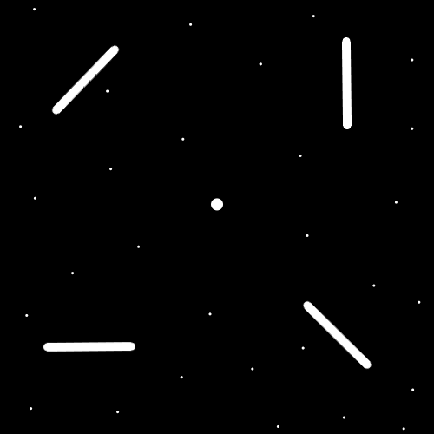
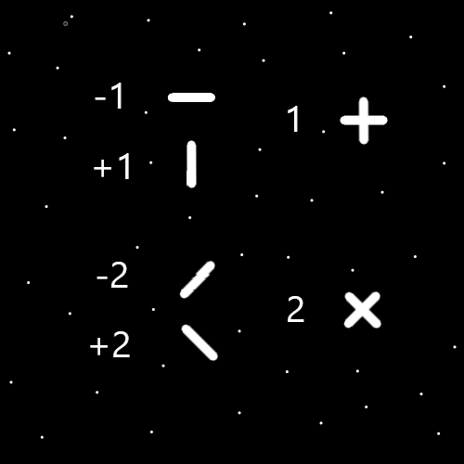

Standard Spells
Spell 0: Write Keywords 10x
Details: Write a Keyword or Keywords 10 times.
Spell 1: Smith Summons 1
Details: In your mind think a Keyword or Keywords 3 times. Pause for a moment, then repeat.
Spell 2: Smith Summons 2
Details: In your mind think a Keyword or Keywords 3 times. Then pause for a moment. During the pause do a breathing exercise. Then repeat.
Spell 3: Smith Summons 3
Details: Bow 3 times. Each time you bow think a Keyword or Keywords. Then Pause for a moment. During the pause do a breathing exercise. Then repeat.

Spell 4: Smith Summons 4
Details: Make a Fist or Fists. Then Bow 3 times. Each time you bow think a Keyword or Keywords. Then Pause for a moment. During the pause do a breathing exercise. Then repeat.
Spell 5: Smith Summons 5
Details: Make a Fist around an Energy Scroll. Then Bow 3 times. Each time you bow think a Keyword or Keywords. Then Pause for a moment. During the pause do a breathing exercise. Then repeat.
Spell 6: Symbol Write 50x
Details: With a writing utensil. On paper or something similar. Write a Symbol 50 times.

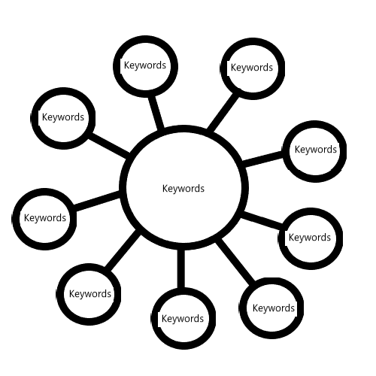Alchemy Spells
Spell 0: Simple Energy Scroll
Details: Use the map above to make a scroll. Replace Keywords with the right Keyword or Keywords. Roll up the paper so it is a scroll. Fold it so it stays rolled up or tie it with string or ribbon or rope.
Spell 1: Shrine Charm 0
Details: Make a Shrine.
Spell 2: Enchant Shrine 0
Details: Use the right Charm and leave it with a Shrine to Enchant the Shrine. The Charms Enchantments rub off on the Shrine.
Spell 3: Personal Charm 0
Details: Place a Personal Charm at a Shrine. The Shrines Enchantments will rub off on the Personal Charm. This is one path for making a Personal Charm.
Spell 4: Collectable Owner 0
Details: For major things you are least Level 4 on…..own at least 1 Collectable Charm of the subject.

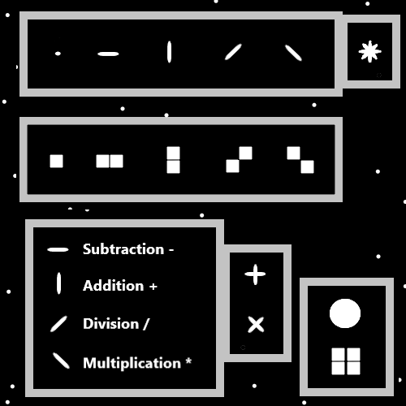
Advanced Spells
Spell 0: Smith Body Exercise 0
Details: Do a session of Body Exercises.
Spell 1: Smith Breathing Session 0
Details: Do a session of Breathing Exercises.
Spell 2: Smith Meditation 0
Details: Do a session of Meditation. The common type. Where you sit on the ground and whatnot.
Spell 3: Smith Group Meditation 0
Details: Join a Meditation Group and do group Meditation.
Spell 4: Smith Expert Blessing 0
Details: Bless a Charm with an Expert Blessing. Enchant a Charm with an Expert Blessing. If you’re a chess Expert you can Enchant things with a Chess Expert Blessing Enchantment.
Spell 5: Smith Custom Spell 0
Details: Make your own custom Spell.
Spell 6: Smith Add Part 0
Details: Add a Spell Part to a Spell.
