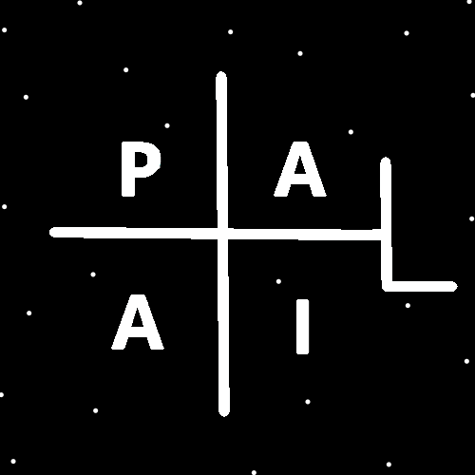
ObjectType: Article
ObjectNumber: 39
LocationName: PAAIL.org
LocationNumber:
Language: PAAIL 2.6

Maker: PAAIL.org
Model:
Name:
Rank:
SerialNumber:

Level: 4.0
Score:
Birth: 10-21-2023

Label: Room 39
Title: Aged Wizardry 12
Details: A General Science, Wizardry, PAAIL, and Scripture Fusion.
Principle: Wizardry Science Scripture.
Agenda: Wizardry Science Scripture.
Action: Wizardry Science Scripture.
Information: Wizardry Science Scripture.
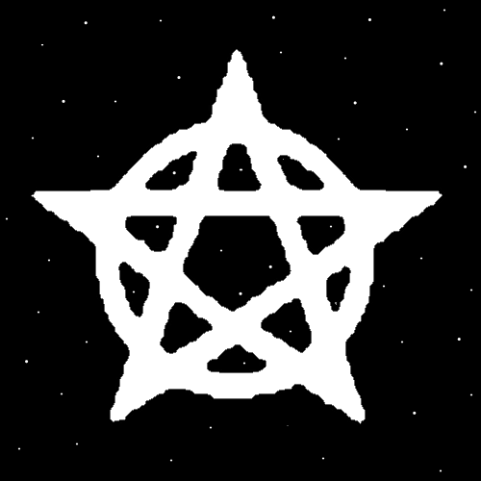

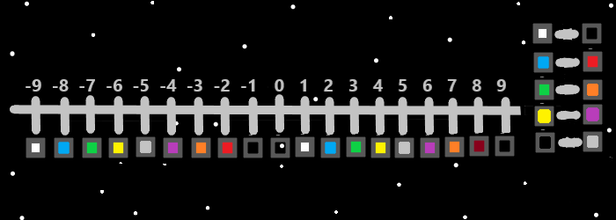
Item Group: Enchantments
Principle: All Level 5 Wizards should memorize these six major Enchantments. Dexterity, Strength, Constitution, Intelligence, Wisdom, and Charm.
Principle: Hand Symbol Sorcery can improve Dexterity and Strength. So can the Spell Word Write 10x, the Spell Symbol Write 50x, the Spell Part Make Fists, even the Spell Part Bow 1x.
Principle: Body Exercise that increases Strength can be priceless Body Exercise.

Principle: Endurance Actions can be done to train Constitution Levels. I imagine that Symbol Write 50x might be enduring and thus Constitution Level gain. Perhaps Symbol Write 100x would be better for the task.
Principle: You Drain Batteries to train Batteries. You Drain your Strength Battery to train your Strength Battery. You Drain your Dexterity Battery to train your Dexterity Battery.
Principle: As for Intelligence…. Training Wizardry is most of the Time going to be an Intelligence boost. Especially on the long term. A year or two later.
Principle: Since its all about Draining Batteries…Training Intelligence Levels can probably be done by Draining your Intelligence Battery.
Principle: Since Intelligence is likely a Mind Part. Training Mind Levels can likely be done by Draining the Mind Battery.
Principle: A persons Strength and Body Strength are 2 different things. You can train Strength by doing the Body Strength increase. Since they are so Connected.
Principle: There is such thing as “Inner Strength”. It is not a Body Level. Perhaps it is a Mind Level.
Principle: There is probably such thing as Spirit Strength, Mind Strength and Body Strength.
Principle: There is probably such thing as Spirit Dexterity, Mind Dexterity and Body Dexterity.
Principle: It may be that there is such thing as Chi Dexterity, and Chi Strength.
Principle: Wisdom sounds like it might be the same thing as Intelligence. However I doubt that is the Story.
Principle: The greatest rulers and Sages are typically associated with Wisdom. Not Intelligence.
Principle: Training Wizard Levels likely increases Wisdom a great deal. Especially on the long term.

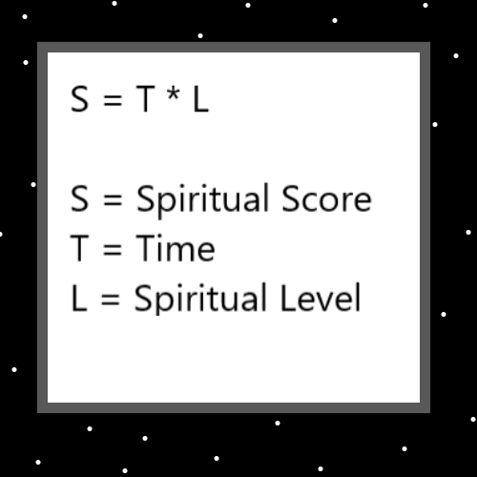
Principle: Actions that Drain the Intelligence Battery might often also Drain the Wisdom Battery. Such as Puzzles.
Principle: It may be that typically the bigger the Drain the bigger the Gain and you must do a lot of Drain to get any Gain.
Principle: Training Level 1 to Level 2 is a tiny Drain needed. Level 2 to Level 3 is also a tiny Drain needed. Level 3 to Level 4 is a lot of Drain needed.
Principle: To train big Levels of Dexterity, Strength, Constitution, Intelligence, Wisdom, and Charm, you have to do a lot of Drain. Years of Drain would likely be the biggest of Gains.
Principle: A person can get to Level 3 and then never get to Level 4. Because it requires special training.
Principle: A person can hit Level 3 computer gamer (like the author here) and stay at Level 3 for the rest of their lives. Training Level 4 often requires specific training.
X2 Principle: Sorcery can likely be used to boost a person’s performance by 0.5 to 1.0 Level. A Level 3 gamer would play as well as a 3.5 to 4.0 gamer.
Principle: Charm Levels are at super high Levels on Earth right now. Everyone is very Charming. Clever. Tricky and so forth. Everybody’s a comedian these days.
Principle: Charm is also a Word in Wizardry that means physical object. Because I chose that as the Vocabulary of Wizardry. I didn’t like the idea of saying physical object all the time.
Principle: The 6 D&D traits are a new subject. There is likely more that could be written about them.
Principle: At the end of the day, it is really all about your Spiritual Level and Spiritual Score.
Principle: There is the Spiritual Side of the Force, and it matters most.
Principle: There are only 9 Positive Spiritual Levels with humans. 1,2,3,4,5,6,7,8,9. People like Moses and Abraham were Level 9 when they died. They accomplished about 8 to 10 times more than your average 10 year old child.
Principle: Most humans only get Spiritual Level 6 before they die. Spiritually a Sage, not a Holy person, which is Level 7. The Holy person accomplishes about 17% more per year than the Sage.
Principle: It’s a famous phrase “Mind, Body, Spirit”. Body Exercise can be helpful for the Mind.
Principle: Body Strength Exercise is Chi Strength Exercise and can have an impact on the Mind.
Principle: “Its one for the money. Two for the show. Three to get you ready. Four, go cat, go.”. -Elvis Presley Song
X2 Principle: Its Jesus for the money. Michael for the show. Gabrial, Michael get you ready. Angel 4 go cat, go.
X2 Principle: His Holiness Jesus is about the money. The heads and tails.
X2 Principle: His Holiness Michaels about the show. How you make the money.
X3 Principle: His Holiness Michael and Gabrial get you ready.
X3 Principle: Then His Holiness Angel 4 gets the door for you.

