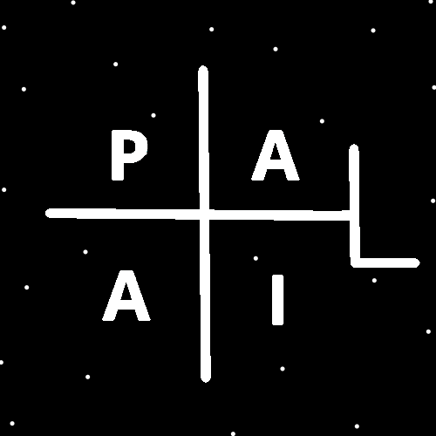
ObjectType: Article
ObjectNumber: 41
LocationName: PAAIL.org
LocationNumber:
Language: PAAIL 2.6

Maker: PAAIL.org
Model:
Name:
Rank:
SerialNumber:

Level: 4.5
Score:
Birth: 11-15-2023

Label: Room 4
Title: Aged Wizardry 14
Details: A General Science, Wizardry, PAAIL, and Scripture Fusion.
Principle: Ultimate Scripture.
Agenda: Ultimate Scripture.
Action: Ultimate Scripture.
Information: Ultimate Scripture.
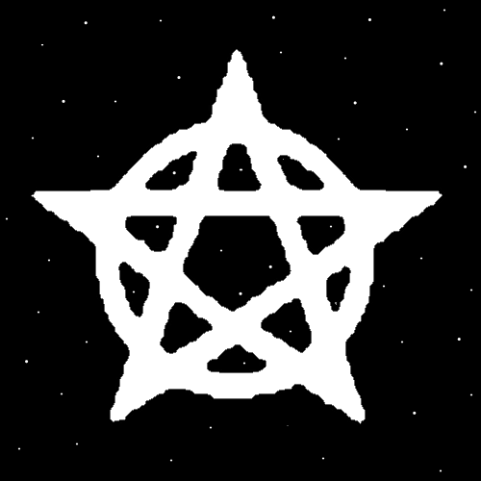


Item Group: Understanding Energy 0
Principle: Reality is a bunch of Energy Fields.
Principle: The latest Spell Room “Smith Spells 5” has 3 new Spells.
X2 Principle: One is the Action of Divination.
X2 Principle: One is Make a Spell book.
X2 Principle: One is “Subject Ponder 0”.
Principle: As for the Spell “Subject Ponder 0” added in Smith Spells 5… it Drains Mana just as most all Actions do.
Principle: If It has not been said….most all Actions Drain Mana. If not all Actions.
Principle: Fusing the two Spells of Subject Ponder 0 and Divination 0 a person can often find inspiration.
Principle: Fusing the three Spells of Subject Ponder 0, Divination 0, and Smith Summons 5 can often also provide inspiration.
Principle: Sometimes its best to do just Divination 0. If you were training, then adding more can be great for training.
Principle: By Fusing Spells you Make a new Spell.
Principle: Sometimes a person can Fuse Body Exercise into the final Spell. It can be a useful Spell Part.
Principle: A person can think of a single day as a Spell….with many Spell Parts.
Principle: Divination can often be entertaining.
Principle: People who do palm readings have been known to entertain for a coin or two.
Principle: There is also Tarot Card Divination, Phone Psychic reading people and so forth Divination.
Principle: Money collected by Clergy for a Religion collect his Holiness Origins money. The money is Enchanted that it belongs to him.
X2 Principle: This Enchantment is only gained under the right circumstance.
Principle: If a person gives a church a coin… they can then buy back the coin for more money and collect a God owned coin. God will go on owning it….. he’s nice like that.
Principle: The God Coin Enchantment can be lost. A coin can go from owned by God to no longer owned by God.


Principle: A church can get a bunch of coins and people can buy them as another way to do things.
Principle: Technically a church can give away coins. However it can be better to buy them from the church.
Principle: If a person is Clergy they can collect coins for his Holiness Origin.
Principle: Clergy is a job. The more you do it, in some ways the higher your Clergy Level is.
Principle: There is such thing as Scripture Clergy. They Keep Scripture. It’s a job of theirs.
Principle: Some Religions have Clergy Levels. Where they are like Ranks.
Principle: 40 hours a week as Clergy is a lot of hours per week, and is a high Clergy Level in some ways.
Principle: Atonement is a Part of many Religions….and for a good reason.
Principle: When people help others, they can Atone for things.
Principle: Worship can Atone for things.
Principle: When a person gives money or time to a charity they can Atone for things.
Principle: A person can have a Karma, where they have to Atone for the deeds of their ancestors. Don’t worry…Worship and helping others balances things out.
Principle: Its possible that people can Atone for the mistakes of their great grandchildren.
Principle: Sometimes the future influences the past, however it never happens before the past.
Principle: Sometimes the future can be seen and then changed before it happens.
Principle: Sometimes seeing the future changes it.
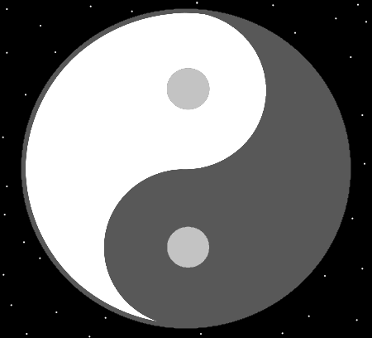
Item Group: Understanding Energy 1
Principle: Some Charms have certain powers. A mirror can increase the sense of a person. If you have an ESP experience, it can increase that as well.
Principle: There is a chance of an ESP experience by looking at yourself in a mirror.
X2 Principle: Bigger mirrors are likely more powerful.
X2 Principle: Older mirrors have a larger Chi as well.
X2 Principle: The famous phrase is “…through the looking glass.”.
Principle: Its been stated that Divination with Scripture is a big thing. It has been stated that Divination with Wizardry writing is a big thing. It should also be stated that Divination with Scripture that is also Wizardry is a super, double point, bonus score thing.
Principle: Doing Divination with PAAIL.org Wizardry Scripture is a huge thing.
X2 Principle: A person could try Divination using the Word “chess” if they wanted.
Principle: When training anything you likely want to push yourself very hard on the training days. The more you push yourself the more powerful the training.
Principle: There are “training days” and “performance days”.
Principle: Some days are not training days, and you might not want to push yourself hard at all. These days I call “performance days”. Days when you use your training.
Principle: Days when you use your training you want to stay recharged on. That is Part of why you don’t push yourself with training, on these days.
Principle: Sometimes it is wrong to train on performance days.
Principle: When training Sorcery, its more powerful to push yourself hard on training days. When using Sorcery, you don’t need to work so hard.
Principle: Lifting weights is training. Lifting more weight is more training.
Principle: Walking is training. Walking fast is more training.
Principle: When doing training, often you can enhance the training by doing more.
Principle: I have concluded that PAAIL.org is possibly the greatest website you will find on the internet. Not because of the PAAIL part….because of the Scripture. The Wizardry.
Principle: Its been stated before that there is such thing as “playing the Religious cards”. It’s the best of the cards to play and that’s why I’m mentioning it again.
Principle: When it comes to Worshiping his Holiness Circle, playing the Religious card is priceless.
Principle: A person can constantly play the “what would his Holiness have me do?” card. This is playing the Religious cards.
Principle: When it comes to knowing what his Holiness would have you do. You have to give your best guess and then hope you are right.
Principle: One ultimate Path for life is to use probability Numbers. Saying things like “….I’m 90% sure this”….and “I’m 75% sure that.”
X2 Principle: This has sort of been stated before….it is worth stating again and making very clear. Thus, it is being stated again.
Principle: Fusing Principles….we play Religious cards where we say things like “I’m 99% sure his Holiness would have me do this”.
Principle: One of the best Religious cards is “I’m sure his Holiness Origin, would agree with such and such….”.
Principle: I don’t know if the Word “God” is a category 0 Word or a category 9 Word.
Principle: Its been stated before that all Numbers have a category….a 0,1,2,3,4,5,6,7,8 or a 9. What category 7468 is….be unknown. I think it might be the Number 4. It seems a major detail what Number category a Number is.
Principle: What Number category each Number is may be priceless Math and Physics knowledge.


