ObjectType: Article  
ObjectNumber: 43

LocationName: PAAIL.org

LocationNumber:

Language: PAAIL 2.6

Maker: PAAIL.org  
Model:   
  
Name:

Rank:

SerialNumber:

Level: 4.5

Score:   
Birth: 11-23-2023

Label: Room 43

Title: Aged Wizardry 15

Details: A General Science, Wizardry, PAAIL, and Scripture Fusion.

Principle: Ultimate Scripture.

Agenda: Ultimate Scripture.

Action: Ultimate Scripture.

Information: Ultimate Scripture.

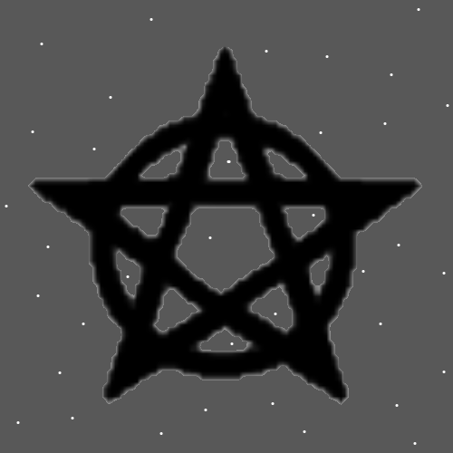

Item Group: Understanding Energy 0

Principle: The following Items may have been stated before. They are worth repeating and making clearer. If they have been stated before.

Principle: In regards to the Bible…. There is the “old testament” Part and the “new testament” Part. For good reasons they are called this….because the Word “Testament” is a major Vocabulary Word.

Principle: When reading Scripture, a person is reading a Testimony.

Principle: According to PAAIL.org theories the big bang began at the Zero moment. This is a Testimony.

Principle: A book Testifies about math if it is a math learning book.

Principle: All Charms have a Testimony.

Principle: A Testimony is a Story.

Principle: All people have a Testimony.

Principle: Often it’s hard to forgive….

Principle: Since all honest work has about the same Spiritual output, reading Scripture isn’t better than any other honest work.

Principle: Some people live a lifestyle of structure, organization, and routine.

Principle: Some people live a lifestyle of structure, organization, routine, and other discipline.

Principle: Three of the greatest Virtues are reasonable, rational, and objective.

Principle: There are endless Disciplines. Making a cheeseburger is a Discipline.

Principle: The author has not finished the Smith Summons Spell training, the Word Write 10x Spells, or anything else. The author has done a ton of Divination over the years. Level 4 Divination.

X2 Principle: Level 4 Divination can be a great thing. You get there by doing a bunch of Divination.

Principle: As for the Smith Summons training… eventually you end up at Level 4. Then your training is complete on that area.

X2 Principle: It is fair to call a person who has finished the training a Smith Summons Expert.

Principle: As for the Word Write 10x training… eventually you end up at Level 4. Then your training is complete on that area.

Principle: A person can go for Level 5 and Level 6 in things. It takes more training. Sometimes just Time doing the Spells over many years.

Principle: The theory is that people can be huge Intelligence and at the same time low Wisdom.

Item Group: Understanding Energy 1

Principle: Human existence has changed a great deal over the years. The world we live in now is nothing like 100 years ago.

Principle: The problem with old Scripture is that it is out of date and not fit for people of present Times.

Principle: One great way to use old Scripture is to use it in the Making of new Scripture.

Principle: One could Fuse Scripture from many different Religions and Make new Scripture.

Principle: Often a Religion has a book that is the book they follow. Often the whole Religion revolves around a book.

Principle: Ideally Scripture is G rated. Ok for children.

Item Group: Understanding Energy 2

Principle: The Viewing of the first 5 Symbols is good on the Mind. It Enchants a person. It Connects a person to the foundation of the Multiverse.

Principle: Knowing the first 5 Symbols is also good on the Mind. It Enchants a person. It Connects a person to the foundation of the Multiverse.

Principle: If you could prove these are the first 5 Symbols…we would probably teach it in the public schools.

Principle: One of the things that I find funny is that most/all 10 year olds probably could get to Master Wizard in 6 years. And it might be easy when you use 6 years to do it.

Principle: Another thing I find funny is the idea of Wizards everywhere. White Wizards, Blue Wizards, Green Wizards and of course Expert Wizards, Master Wizards and Wizard Doctors.

Principle: A 12 year old Green Wizard is an entertaining thought. Green Wizard is a huge thing.

Principle: I know its hard to believe… however it is the truth. All the major secrets revealed.

Principle: In the past it has been mentioned that cleaning Levels are awesome. Cleaning Levels Connect a person to the clean side of the Multiverse.

Principle: Cleaning can be super good for a person.

Principle: The author should add cleaning to the Smith Spells collection. Will be put in Smith Spells 6.

Principle: Cleaning Levels Connect a person to the clean Side of the Force.

Principle: Sometimes you want to be less Connected to something. It is best to have Low flaw Levels.

Principle: The “Levels” is a huge Part of Wizardry. Reality is all about Levels.

Principle: Levels Science is very Connected to Numerology.

Principle: All people have virtue Levels.

Principle: Intelligence virtue Levels are at a paranormal and supernatural height right now. All across the planet. Most of the world population. This has sort of been stated before.

Principle: There are virtue Levels and flaw Levels.

Principle: The belief in eternal life is true.

Principle: 2023 on Earth is a more paranormal, supernatural time.

Principle: Two major Details of Earth…. A huge population and a huge amount of technology.

Principle: Humans are more advanced than ever before. In many different ways.

Principle: Some ultimate psychology (understanding of the Mind) is understanding that people have virtue Levels and flaw Levels. Along with other Levels.

Principle: There should be a Spell in the Smith Spells collection that is a Disconnect Spell. I will attempt to have it in Smith Spells 6.

Principle: If it’s proven, then it is a Law. When it’s not, it is a theory.

Principle: There are an Infinite amount of Sides to the Multiverse. An Infinite amount of Sides to the Force.

Principle: A person can be strong with a Side of the Force. A person can be strong with a Side of the Multiverse.

Principle: A person can be strong with the cheeseburger side of the Force. By Making cheeseburgers, eating cheeseburgers, or a combination of the two.

Principle: A person can be strong with the Wizard Side of the Force by reading Wizardry. A person can be strong with the Wizard Side of the Multiverse by reading Wizardry.

Principle: A person can be strong with the Scripture Side of the Force by reading Scripture.

Principle: Keeping Scripture is another way of making a person stronger with the Scripture side of the Multiverse.

Principle: It may be that it’s the 8 Forces….not the 4 Forces….

Principle: There may be Positive and Negative gravity. Two Forces.

Principle: There may be Positive and Negative electromagnetism. Two Forces.

Principle: There may be Positive and Negative strong-nuclear Forces. Two Forces.

Principle: There may be Positive and Negative weak-nuclear Forces. Two Forces.

Principle: It’s a very Paranormal, Supernatural and Mystical thing, knowing all the major secrets and Wizardry. Most humans throughout human history did not know these thing.

