ObjectType: Article  
ObjectNumber: 45

LocationName: PAAIL.org

LocationNumber:

Language: PAAIL 2.6

Maker: PAAIL.org  
Model:   
  
Name:

Rank:

SerialNumber:

Level: 4.5

Score:   
Birth: 12-6-2023

Label: Room 45

Title: Aged Wizardry 16

Details: A General Science, Wizardry, PAAIL, and Scripture Fusion.

Principle: Ultimate Scripture.

Agenda: Ultimate Scripture.

Action: Ultimate Scripture.

Information: Ultimate Scripture.

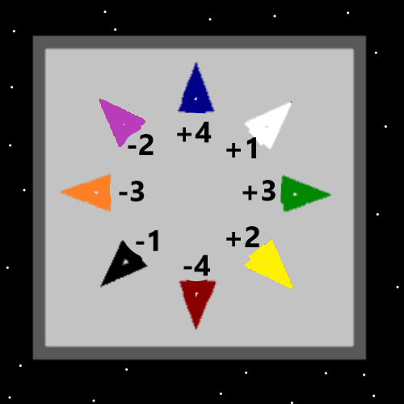

Item Group: Understanding Energy 0

Principle: All PAAIL.org Wizardry is Scripture, not just Parts of it.

Principle: PAAIL.org Wizardry in some ways is Basic Details about the Multiverse.

Principle: Its probably best Vocabulary to say that there are Universe’s within Universe’s.

Principle: The Map above may have errors.

Principle: Maps found at PAAIL.org may have errors.

Principle: “Maps” and “Views” are major Vocabulary Words of PAAIL Science.

Principle: Levels, Levels, Levels… its all about Levels…

Principle: There are Body Levels, Breathing Levels, and Meditation Levels.

Principle: Sometimes people use the Vocabulary Word Meditate and mean they are thinking about something. They Meditate on some subject.

Principle: Reading Scripture may count as a type of Meditation.

Principle: By reading Scripture you Meditate on the Multiverse.

Principle: Having to do a bunch of thinking is a not so quiet and peaceful form of Meditation.

Principle: Doing Divination may be good stimulation on the brain. Stimulation for the Mind.

Principle: Divination Levels may be a great thing to achieve.

Principle: Part of the Level 6 Doctor training is that you train up Divination Levels.

Principle: I don’t know how many pages PAAIL.org Wizardry is. I’m guessing 600 to 1000 pages. 600 pages is not so much to read. 1000 is a lot of pages to read.

Principle: Even if it is 1000 pages of Wizardry, it is worth it…since it counts as Scripture.

Item Group: Understanding The Cosmos 0

Principle: For the doctorate in Wizardry a person must train the Word Write 10x Enchantment to Level 4. A person can also go beyond Level 4 and it may be worth it.

Principle: Another Word for Reality is Multiverse.

Principle: The Word Multiverse is a more scientific Word for Reality than Dragon or Force.

Principle: Doing Hand Symbol Writing is very similar to doing Martial Arts training.

Principle: People with High Martial Arts Levels have a boost to their Sorcery Levels. Which means Wizardry Levels….perhaps 0.5 to 1.0 Wizardry Levels.

Principle: Body Levels in general can have a huge impact on Sorcery Levels.

Principle: A person can cover their ears with the Palms of their Hands and hear a sound of the Multiverse. It’s a primitive, primordial sound.

Principle: “Holy, Holy is the Lord God almighty, who is, and was, and is yet to come.”-The Holy Bible

Principle: His Holiness Origin is the Zero person. In some ways he’s there, and in some ways he’s not.

Principle: In Smith Spells 7 is a new Spell Titled “Stance Control 0”.

Principle: Always do we have a “current Stance”. Even when sitting and sleeping.

Principle: A person can control their Stances and benefit from doing so.

Principle: A person can train Stance Levels. A doctor of Wizardry should train Stance Levels.

Principle: There’s an Enchantment called “Better Breathing 4”. You have to do a bunch of Breathing Exercises to get it.

Principle: The doctor of Wizardry gets everything up to Level 4.

Principle: Expert Wizard as said before is only a bunch of reading to achieve. Being a Expert Wizard is a big thing.

Principle: “In the beginning was the word, and the word was with God, and the word was God. It was with him in the beginning.”-The Holy Bible

Principle: In the beginning was the energy, and the energy was with God, and the energy was God. It was with him in the beginning.-PAAIL.org Scripture.

Principle: Two people can have the same Level and different Scores. Winning a gold medal at the Olympics is a bunch of Score.

Principle: Being an Athlete in the Olympics is a bunch of Score.

Principle: Not much Wizardry about Scores has been done on PAAIL.org. Even though Score is a major Vocabulary Word.

Principle: Things with bigger Scores have bigger Auras.

Principle: Losing is Score gain. However winning is more Score gain.

Principle: Achieving Low Levels at things is easy. Levels, 1, 2, and 3.

Principle: The Higher the Level is the harder it is to get to the next Level.

Principle: There may be such thing as Positive, Negative and Neutral Gravity. Or just Positive and Negative.

Item Group: Understanding The Cosmos 1

Principle: Just like it is with many areas of Science, Wizardry has technology. There is what you would call “Wizard Tech”.

Principle: Current Wizardry Tech is much more Advanced than “Tome of the Yellow Wizard”.

Principle: Current Wizardry Tech is much more Advanced than “Wizardry Practice 0A” and “Wizardry Practice 0B”.

X2 Principle: In Numerology the Word Advanced is a Vocabulary Word. There is Beginner, Intermediate and Advanced.

Principle: The first bit of Wizardry Tech is the Cosmic Knowledge. This is what one gains when they train to Level 4, Expert Wizard.

Principle: The Cosmic Knowledge Tech helps a person better understand the Multiverse in a huge way. This can help in many ways.

Principle: Some other Wizardry Tech requires a person to do a bunch of Body Exercise and other Actions to achieve huge Enchantments.

Principle: Shrines and Temples are Wizardry Tech. As are Charms and more.

Principle: Energy Scrolls are Wizard Tech.

Principle: Spells are Wizard Tech.

Principle: