ObjectType: Article  
ObjectNumber: 47

LocationName: PAAIL.org

LocationNumber:

Language: PAAIL 2.6

Maker: PAAIL.org  
Model:   
  
Name:

Rank:

SerialNumber:

Level: 4.5

Score:   
Birth: 12-19-2023

Label: Room 47

Title: Aged Wizardry 17

Details: PAAIL.org Scripture….

Principle: Ultimate Scripture.

Agenda: Ultimate Scripture.

Action: Ultimate Scripture.

Information: Ultimate Scripture.

Item Group: Understanding The Cosmos 0

Principle: “…books will be opened, and the dead will be judged.”-The Holy Bible.

Principle: “…multitudes will rise from the dust of the Earth.”-The Holy Bible.

Principle: “…I will give them the morning star.”-The Holy Bible.

Principle: “In the beginning God created the Heavens and the Earth.” Genesis 1:1-The Holy Bible.

X2 Principle: Another fair translation is “In the beginning God made the Heavens and the Earth.”.

Principle: There are a lot of really good Bible quotes.

Principle: Jumping may be an ultimate Exercise.

Principle: Wizardry is mainly about Enchanting yourself. There is Enchanting others though.

Principle: Teachers are people that sometimes Enchant others.

Principle: Some of the biggest Wizardry Tech is all about Enchanting yourself and others.

Principle: Earth is 6.9 Cosmic days old.

Principle: The birth of Earth was probably two planets colliding. A major Fusion event in history.

Principle: Connect to a thing is Fusion. Disconnect from a thing is Division.

Principle: Connect to a thing is Addition. Disconnect from a thing is Subtraction.

Principle: It might be that the Four Elements are Made of the 3 Forces. Positive, Negative, and Neutral.

Principle: It probably is that the 8 Elements are Made of the 4 Elements.

Principle: It may be that the 10 Number Energies (0-9) are Made of the 8 Elements.

Principle: When your Spiritual Level goes up, that is called “Spiritual Accension”.

Principle: A good Map could be Made, where you have 4 Items…. A White square, a Black square, a Grey square, and a Transparent square.

Principle: If there is no such thing as Negative Gravity, then Gravity is the White Force, the Black Force, the Grey Force, or the Transparent Force.

Principle: If there is such thing as Negative Gravity, then the 4 Forces…Gravity, Electromagnetism, Strong-Nuclear, Weak-Nuclear are better described as the “4 Axis’s”….and there is the 8 Forces they Make.

Principle: If a Particle is found in nature, then it is a natural Particle. If it was Made by a lifeform then it is an artificial Particle.

Item Group: Understanding The Cosmos 1

Principle: The Bible refers to this Time as the “great tribulation”.

Principle: “…Hell will give up the dead in it, and then Hell and death will be tossed into the fire.”-The Holy Bible.

Information: The Fire Element

Force: Darkness

Element: Fire

Energy: Subtraction (Fission)

Numerology: (9) (8)

Colorology: (Black) (Red)

Symbols: ( - ) ( - )

Binary: 00

Winds: (South) (Southwest)

Information: The Air Element

Force: Twilight

Element: Air

Energy: Division (Fission)

Numerology: (0) (7) (6)

Colorology: (Transparent) (Orange) (Purple)

Symbols: ( / ) ( / )

Binary: 01

Winds: (West) (Northwest)

Information: The Earth Element

Force: Twilight

Element: Earth

Energy: Multiplication (Fusion)

Numerology: (5) (4) (3)

Colorology: (Grey) (Yellow) (Green)

Symbols: ( \ ) ( \* )

Binary: 10

Winds: (East) (Southeast)

Information: The Water Element

Force: Light

Element: Water

Energy: Addition (Fusion)

Numerology: (1) (2)

Colorology: (White) (Blue)

Symbols: ( | ) ( + )

Binary: 11

Winds: (North) (Northeast)

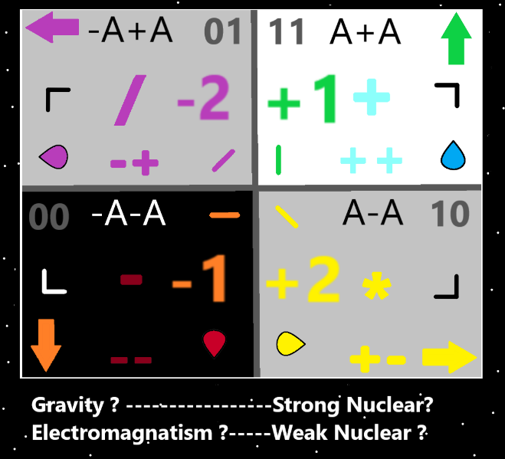

Item Group: Understanding The Cosmos 2

Principle: We have all been drafted by his Holiness Origin. We all do one tour of duty on Earth. Thankfully only one.

X2 Principle: I suppose this is partly “why we are here”.

Principle: Reality is a warzone, and his Holiness Origin needs your help! Sign up today!

Principle: One ultimate parable/metaphor/analogy is that all people are gems.

Principle: As for gems, its cut, color, clarity, and carat.

Principle: As for our lives….it probably goes that we want the right mixture of Earth, Air, Water and Fire.

Principle: Fire Spells are work Spells. Water Spells are rest Spells.

Principle: Fire is the work of our lives. Water is the rest we get in our lives.

Principle: I’m not to sure about the Air, and Earth of our lives. I know not the secrets of Earth and Air.

Principle: It is very possible that Stars are tiny little specs to his Holiness Origin.

Principle: The latest revelation is that there are Fire Spells and Water Spells. This discovery was Made minutes ago.

Principle: There are likely Earth Spells and Air Spells.

Principle: It may be that getting some fresh Air is a Air Spell.

Principle: Many plants grow from Fire (sunlight), Air(gas around them), Earth(the dirt) and Water(rain and so forth).

Principle: The latest theory is that every person has a Fire Level, a Air Level, a Earth Level and a Water Level.

Principle: Often the ultimate Exercise is to stretch yourself in the opposite direction. As an example……..People that use few hand gestures while talking, should Exercise by doing more hand gestures. People that use lots of hand gestures while talking should Exercise by not doing any.

