ObjectType: Article  
ObjectNumber: 49

LocationName: PAAIL.org

LocationNumber:

Language: PAAIL 2.6

Maker: PAAIL.org  
Model:   
  
Name:

Rank:

SerialNumber:

Level: 4.5

Score:   
Birth: 1-7-2023

Label: Room 49

Title: Aged Wizardry 19

Details: PAAIL.org Scripture….

Principle: Ultimate Scripture.

Agenda: Ultimate Scripture.

Action: Ultimate Scripture.

Information: Ultimate Scripture.

Item Group: Understanding The Cosmos 0

Principle: The 3 books “Tome of the Yellow Wizard”, “Wizardry Practice 0A” and “Wizardry Practice 0B” are very out of date.

Principle: Most of the ultimate Sorcery was developed after the first 3 books.

Principle: Much knowledge was developed after the first 3 books.

Principle: A lot of Wizardry tech was developed after the first 3 books.

Principle: When Tome of the Yellow Wizard was finished, I don’t think I even knew about the Dot Symbol being the Symbol of the Zero moment.

Principle: “Don’t forget to breathe.”-Famous Quote

Principle: In a lot of ways PAAIL.org is the best education you can get on the planet.

Principle: Wizardry Levels are easy to get and fast to get. A person can probably get Doctorate Wizard in 1 year.

Principle: If you’re a good person your life has great meaning. As much meaning as all the other good people.

Principle: All good people have a huge impact on the world.

Principle: All good people help his Holiness Twilight a lot.

Principle: Force this Vision into your Mind. Picture everyone with a crown on their head. As children of his Holiness Light… we are all prince’s and princess’s.

Principle: Vision a person breathing is likely an ultimate Spell Part.

Principle: Vision the Dot Symbol is an ultimate Spell Part. At least for training Sorcery.

2X Principle: This is a Spell Part you would use very early on in Sorcery training. Like Making the Dot Symbol with your Hand.

Principle: At first I started writing because I knew I would gain Wizard Levels by writing. Then it turned into a hobby. After that it became a bunch of Wizardry research and development. Now I realize its Scripture.

Principle: If there were one thing, I would want to explain to people. It might be explain to them the huge gravity of their lives. People don’t know the huge gravity of their lives.

Principle: Music ESP experiences are common and huge.

Principle: Current technology on Earth is at extremely paranormal and supernatural Levels. Especially the internet.

Principle: People of these present years are a lot softer than people of the past.

X2 Principle: This is Positive evolution. A good sign.

Principle: Don’t be like terrorists and become Religious nut jobs. His Holiness Origin doesn’t want you to kill his Worshippers. Whatever Religion they be a Part of.

Principle: Ranking the major Religions I give first place to the Buddhists. Second place the Hindu. Third place the Jewish. Fourth place the Christians. Fifth place goes to the Muslims.

Principle: “It’ll do magic. Believe it or not. Bibbiti bobbiti boo”-Famous Cartoon Movie.

Principle: The End of the Bible speaks of two people, who are “the two witness’s”, “the two olive tree’s and lampstands before God”. Likely this refers to the Archangels, his Holiness brother Michael and his Holiness brother Gabriel.

Principle: The seven trumpets at the End of the Bible likely refer to each of the seven End Times. Which happen every thousand years.

Principle: The seven seals and the seven bowls at the End of the Bible likely also refer to the seven End Times, which happen every thousand years.

Principle: The first trumpet, bowl and seal (from the Bibles End) are the first End Times. Year 900 in Adam Time. When Atlantis was destroyed by the flood.

Principle: “The Names of people and places have been changed. However, the Story remains the same.”-Famous Quote

Principle: Since we are living in an End Times. Reading the last Part of the Bible, book Revelation is more meaningful.

Principle: The End of the Torah and Koran are likely very relevant to us.

Principle: I very much recommend reading the last Part of the Bible. The book known as Revelation. I don’t think it takes much Time to read it. I think its only a few pages.

Principle: The author here has read most of the Bible.

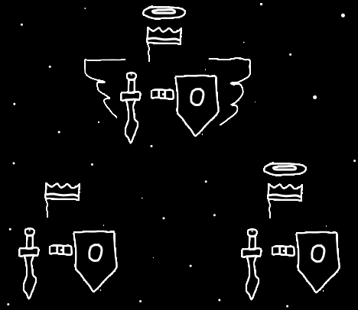

Information: Instructor Smith Master Wizard Path

Wizardry Level 5

Wizardry Knowledge Level 5

Sorcery Knowledge Level 4

Sorcery Spell Training Level 3

Body Exercise Training Level 3

Breathing Level 3

Meditation Level 5

Divination Level 4

Shrine Keeping Level 2

Charm Keeping Level 2

Principle: The Worshippers of his Holiness Twilight are not usually very Enlightened.

Principle: His Holiness Origin cannot touch Earth. If his Holiness did, the Darkness would spread to him.

Principle: Often Heaven cannot touch Earth or the Darkness would spread to Heaven.

Principle: Planet Earth was Made to trap the Darkness.

Principle: Since we have hit Doctorate Level Wizardry we have come to a major milestone of Wizardry. An End of the Path in many ways.