ObjectType: Article  
ObjectNumber: 50

LocationName: PAAIL.org

LocationNumber:

Language: PAAIL 2.6

Maker: PAAIL.org  
Model:   
  
Name:

Rank:

SerialNumber:

Level: 4.5

Score:   
Birth: 1-21-2024

Label: Room 50

Title: Aged Wizardry 20

Details: PAAIL.org Scripture….

Principle: Ultimate Scripture.

Agenda: Ultimate Scripture.

Action: Ultimate Scripture.

Information: Ultimate Scripture.

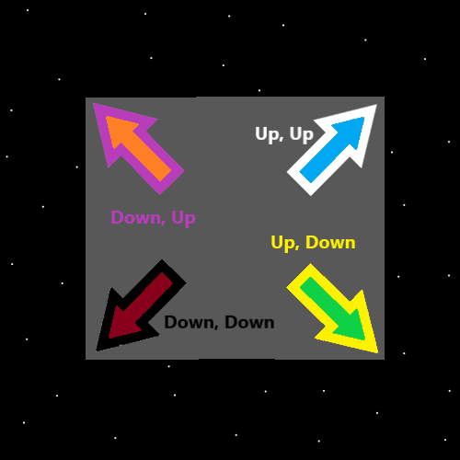

Item Group: Understanding The Cosmos 0

Principle: Moons and Stars are Symbols very associated with Wizardry. They are Cosmic Bodies.

Principle: The pentagram Symbol is so associated with things like Wizardry. It is a Symbol of Wizardry.

Principle: The pentagram Symbol is sort of a moon and a Star.

Principle: The pentagram Symbol is also his Holiness Origins Symbol mixed with a Star.

Principle: The pentagram Symbol is a sort of God and Heaven Symbol.

Principle: A person can gain Charm Keeping Levels by cleaning Charms.

Principle: A building is a Charm.

Principle: It can be quite good for a person to do cleaning. Cleaning Levels have been mentioned before.

Principle: Cleaning Levels are worth mentioning again in PAAIL.org writing.

Principle: A person can take a rock and polish it with a dry cloth. This is cleaning Levels gain.

Principle: Polishing is perhaps my favorite cleaning Action.

Principle: Remember that some things only cleaning Experts should clean. Meaning someone who went to college and is trained to clean the Charm properly.

Principle: Cleaning Connects a person to the clean Side of the Multiverse.

Principle: “One with the Multiverse” is the same as saying “Won with the Multiverse”.

Principle: The Agenda is to be Won with the Multiverse.

Principle: All people have a huge impact on the Multiverse. We are all beginning of Time Elementals.

Principle: Most people don’t understand how big an impact they have on the Multiverse.

Principle: On a Cosmic scale. Gods scale. The true scale. A 100-digit Number is a Small Number.

Principle: Only Small Numbers are Elemental Numbers.

Principle: The Bible states that one day the first will come last and the last will come first.

X2 Principle: One secret of this is that the Small Number people will come last and the Larger Number people will come first.

Principle: Many of these Principles have been stated before. It is worth Making these things very clear though. And worth mentioning again.

Principle: We Elementals do a tour of duty at the beginning of Time.

Principle: I’m running out of things to write. We are at a major milestone of Wizardry. A Level 6 amount of knowledge.

Principle: God be with you.

Principle: His Holiness Origin be with you.

Principle: There are many Religions of his Holiness Origin. Many peoples who have worshiped him.

Principle: Small is a Vocabulary Word because in Numerology it goes 1,2,3 Small.. 4,5,6 Medium, and 7,8,9 Large.

Principle: There are often many secrets in a single line from the Bible.

Principle: Peace and harmony are great things. However, they are not always an option.

Principle: Structure, routine, organization and other discipline is great. However not always an option.

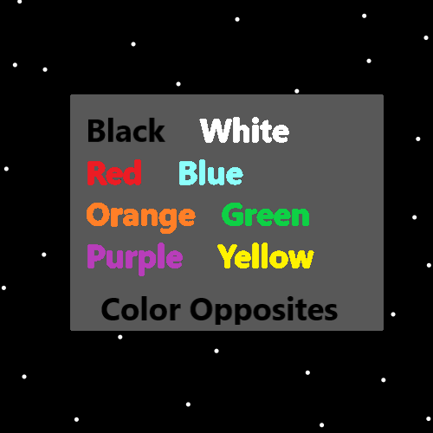

Item Group: Understanding The Cosmos 1

Principle: “… the power and glory forever and ever amen.” -The Holy Bible

Principle: “Amen” means “may it be so”.

Principle: “… the power and glory forever and ever. May it be so.” -The Holy Bible

Principle: Power and glory are among the greatest of things.

Principle: To his Holiness Origin…belongs the power and glory forever and ever.

Principle: In the Map above you see there are in some ways the 4 positive colors and the 4 negative colors.

Principle: A Expert Wizard is much more knowledgeable about his Holiness Origin.

Principle: Knowing his Holiness God is a lifeform, that one of his many names is Origin. This is good for the Mind, Body and Spirit.

Principle: Many things are good for the Mind, Body and Spirit.

Principle: Being even a Level 3 Wizard can be a huge powerup to a person’s Chi.

Principle: It turns out Wizardry has always been a real Science of the Multiverse.

Principle: Training Expert Wizard likely increases a person’s ESP Levels.

Principle: Training Master Wizard likely increases a person’s ESP Levels a lot more than Expert Wizard.

Principle: Even being a Level 3 Wizard is understanding the Multiverse a great deal.

Principle: A person can be a Level 3 Wizard and be Enlighted about the Story of the Multiverse.

Principle: There are a lot of different Paths to Level 3 Wizard. The best might be to read the right 200 to 300 pages.

Principle: “The right 200 to 300 pages” has not been Made by PAAIL.org. And can not be found at PAAIL.org.

X2 Principle: At PAAIL.org the theory is that you have to read about 400 pages.

Item Group: Understanding The Cosmos 2

Information: Doctorate Wizard Path 0B

Cleaning 3 Added

Wizardry Level 6

Wizardry Knowledge Level 5

Sorcery Knowledge Level 4

Sorcery Spell Training Level 4

Body Exercise Training Level 4

Breathing Level 4

Meditation Level 4

Divination Level 4

Shrine Keeping Level 3

Charm Keeping Level 3

Cleaning Level 3

Principle: A person can get beyond Level 4 on the various Wizard Enchantments.

Principle: The 10 Energies (0 to 9) are one of the biggest Maps because of the 10 single digit People. 0 to 9.

Principle: Often female instructors are better for female students and male instructors better for male students.

Item Group: Understanding The Cosmos 3

Principle: Sometimes Enchantments/Levels are like microchips implanted in your brain.

Principle: A person who is Level 3 at chess has a Level 3 chess microchip implanted in their brain.

Principle: A person who is Level 2 at Wizardry has a Level 2 Wizardry microchip implanted in their brain.

Principle: Because Wizardry is so profound, even a Level 2 Wizardry microchip is a major thing.

Principle: All you have to do is be a good person and your life is full of glory.