ObjectType: Article  
ObjectNumber: 52

LocationName: PAAIL.org

LocationNumber:

Language: PAAIL 2.6

Maker: PAAIL.org  
Model:   
  
Name:

Rank:

SerialNumber:

Level: 5.0

Score:   
Birth: 2-1-2024

Label: Room 52

Title: Aged Wizardry 21

Details: PAAIL.org Scripture….

Principle: Ultimate Scripture.

Agenda: Ultimate Scripture.

Action: Ultimate Scripture.

Information: Ultimate Scripture.

Item Group: Understanding The Cosmos 0

Principle: With 10 years of the Time Spell Part a person can probably get to Level 7 Wizard. I wouldn’t be surprised if a person can get there in 5 years.

Principle: Getting to Level 7 Wizard is all about getting your Wizard Enchantments to Level 5.

Information: Wizardry Level 7 Path 0A

This is an Educated Guess on Level 7

Wizardry Level 7

Wizardry Knowledge Level 5-6

Sorcery Knowledge Level 4-5

Sorcery Spell Training Level 5

Body Exercise Training Level 5

Breathing Level 5

Meditation Level 5

Divination Level 4-5

Shrine Keeping Level 3-5

Charm Keeping Level 3-5

Cleaning Level 3-5

Optional Skills

Astrology Levels 3-6

Principle: Wizardry Level 7 is not fully understood.

Principle: A person can gain Wizard Levels by getting Astrology Levels.

Principle: A person can gain massive cleaning Levels by becoming an Expert in cleaning things. People that can repair and restore antiques.

X2 Principle: These people sometimes are Level 6 cleaning. Sometimes Level 5 cleaning. Always they are at least Level 4.

Principle: There are all kinds of things like Chakras and Astrology that a Wizard can study.

Principle: The author here is about Level 1.8 Astrology. I know there are the 12 signs. The 12 animals…. I keep thinking there might be a bug…I know I am a Capricorn. I know that animal is the goat. I know a few more things. Not much though.

Principle: A person’s Spiritual Aura exists no matter what they are doing. For this reason, I don’t often get very ambitious.

Principle: We all have about the same impact. This is another reason why I often don’t get very ambitious.

Principle: A person can choose the passive Wizard learning Path. Where they take their Time and spread out the learning over 5 years.

Principle: The Multiverse is no longer mysterious to me. I barely remember the experience.

Principle: What are people’s biggest questions again?

Principle: Often Level gain and Enchantment mechanics is just like computer games.

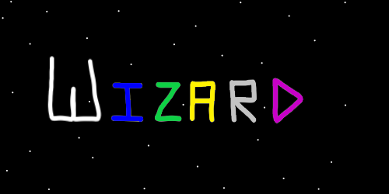

Item Group: Understanding The Cosmos 1

Principle: We are all very famous to God and Heaven.

Principle: For Heaven, 7 billion people is a small amount of people. To Heaven there are not a lot of humans.

Principle: Every angel knows every human name of us Earthlings.

Principle: Wizardry is all powerful when you Fuse it with other things.

Principle: The best Fusions come when you are an Expert at Wizardry and an Expert at something else.

Principle: Some Charms have special powers. A mirror can be used to sense people.

Principle: Education books come with huge Enchantments. Enchantments about their subject.

Principle: A major Part of understanding Charms is understanding their Enchantments.

Principle: Charms are like people. However they are super awesome people, that never Make mistakes and are full of Light.

Principle: I know much of this has been stated before. Since we are at an End of things in Wizardry it seems right to note these things again.

Principle: Shrines and education books are some of the quickest ways to get Enchantments to rub off on one another.

Principle: Two Charms having physical contact causes their Enchantments to rub off on one another.

Principle: To Enchant a Charm with a Wizard Enchantment is going to take a Wizard Charm.

Principle: Enchanting a Shrine with a Wizard Enchantment is going to take a Wizard book or some other Wizard Charm.

Principle: Some Wizard books have higher Wizard Enchantments than others. PAAIL inspired education books come with huge Wizard Enchantment Levels.

Principle: Tome of the Yellow Wizard starts with a Level 4 Wizard Enchantment. A good book about Astrology starts with a Level 1 Wizard Enchantment.

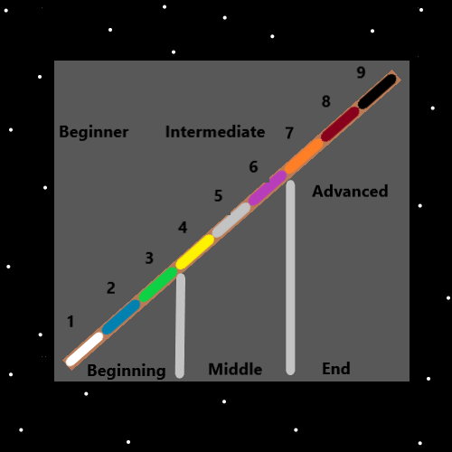

Principle: Owning a Shrine that has a Religious Charm Makes you think about his Holiness, our God, on a sub-conscious Level.

Principle: When holding an Energy Scroll. If you know what’s on the Scroll…the Scroll Makes you think about what’s on it, on a sub-conscious Level.

Principle: All Shrines should have 1 or more Religious Charms.

Principle: It can be said the author here is a Scientist.

Principle: As a Scientist…. Wizardry is very entertaining.

Principle: A ton of Wizardry tech was developed over the last 2 years.

Principle: Life has been evolving on this planet for millions of years. On a zoomed out View its likely not random mutations.

Principle: I like Meditation rugs more than yoga mats. It seems like the rugs might be better for yoga.

Principle: I know very little about yoga. It seems likely that it is a great tool.

Principle: The newest Spells in Smith Spells is Smith Summons 8 and Smith Summons 9.

Principle: Smith Summons 9 gains more Score per minute than Smith Summons 1. However there is a loss in the Peace and Quiet Enchantment Levels.

Principle: If all this could be proven. It would be taught in the public schools and every 18 year old would End up a Master Wizard.

Principle: Go figure. It turns out Wizardry is a real Science after all. I didn’t name all this Wizardry. It is Wizardry.

Principle: A person could likely learn fireballs power from Heaven. Fireballs Sorcery.

Principle: Some of the biggest provided Sorcery is understanding we live one ESP experience after another. A whole lot of ESP experience.

Principle: A person can have a ESP experience about ESP experiences.

Principle: Understanding your experiences are ESP experiences is a very good thing.

Principle: One of the biggest things Wizardry does is that it Enchants a person in a huge way.

Principle: The term ESP does not seem right. The Vocabulary should probably be different.

Principle: Twilight is found all throughout the Multiverse.

Principle: Light and Darkness are found all throughout the Multiverse.

Principle: Light, Twilight and Darkness are found all throughout the Multiverse.

Principle: The four Elements are found all throughout the Multiverse.

Principle: The eight Elements are found all throughout the Multiverse.

Principle: The 10 Energies (0 to 9) are found all throughout the Multiverse.

Information: “In the beginning was the word. The word was God. The word was with God. It was with him in the beginning.”-The Holy Bible.

X2 Principle: In the beginning was the Energy. The Energy was God. The Energy was with God. It was with him in the beginning.

X2 Principle: In the beginning was the Zero Energy. The Zero Energy was God. The Zero Energy was with God. It was with him in the beginning.

X2 Principle: “The Zero Energy was with God” means it was with the state of being a God.

Principle: The Zero Particles at the Zero Moment were creators. They Made his Holiness Origin.

Principle: The Zero Particles were Gods. Non lifeform Gods. No consciousness.

Principle: The Zero Particles no longer exist. All is Made of them though.

Principle: Zero Particles are also known as Twilight Particles.

Principle: In some ways Positive Energy Bits are Light Bits and Negative Energy Bits are Darkness Bits.

Principle: A person can do a bunch of Meditation in a place with a Meditation Shrine and the place will turn into a Meditation Chamber.

