ObjectType: Article  
ObjectNumber: 55

LocationName: PAAIL.org

LocationNumber:

Language: PAAIL 2.6

Maker: PAAIL.org  
Model:   
  
Name:

Rank:

SerialNumber:

Level: 5.0

Score:   
Birth: 2-9-2024

Label: Room 55

Title: Aged Wizardry 23

Details: PAAIL.org Scripture….

Principle: Ultimate Scripture.

Agenda: Ultimate Scripture.

Action: Ultimate Scripture.

Information: Ultimate Scripture.

Item Group: Understanding The Cosmos 0

Principle: At the end of “Tome of the Yellow Wizard”, Wizardry was at a 1.5 Level. Now it is 5.0.

Principle: The latest thought is to start writing only for people that are Wizard Level 4, 5 and 6.

Principle: A good portion of current Wizardry is Wizardry being researched and developed over the last 2 years. That stage may be at an End.

Principle: A advanced Wizard can see that in the afterlife, likely martial arts belts will go from white to black. In this order….. white, blue, green, yellow, grey, purple, orange, red, black.

Principle: A advanced Wizard can sometimes predict things about the afterlife.

Principle: Advanced PAAIL.org Wizards have a much greater understanding of the Multiverse in many ways.

Principle: Likely being a Expert Wizard Makes your dream interpretation better.

Principle: Likely being a Expert Wizard Makes your Divination better.

Principle: When you’re an Expert Wizard and an Expert at something else, you are often able to Fuse Wizardry with that thing.

Principle: These last few Principles aren’t really new, however they are the start of writing about Expert Wizards.

Principle: When advising anyone on anything, Expert Wizard can sometimes help that.

Principle: Training Wizardry can Make you much more virtuous. It can Make you wiser, smarter, and more graceful.

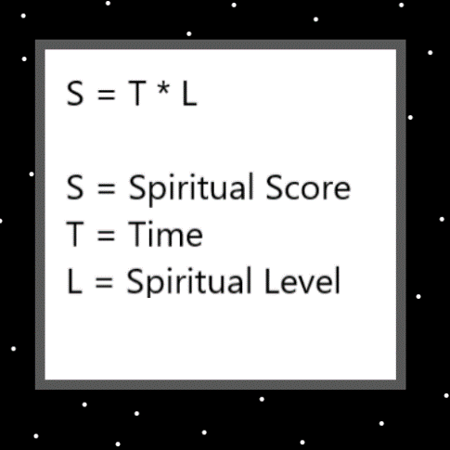

Item Group: Understanding The Cosmos 1

Principle: Remember. All honest work has about the same Positive impact on the Multiverse.

Principle: Remember. All good people have about the same Positive impact on the Multiverse.

Principle: Remember. When you are working and when you are not, your Positive Spiritual Aura is always pumping Positive Energy into the Multiverse.

Principle: There is meaning in both our work and our luxuries.

Principle: Often a lot of work goes into Making peoples luxuries.

Principle: “Let us make them in our image.” -The Holy Bible.

Principle: We are Made in his Holiness Twilight’s image.

Principle: The Word God means “creator”.

Principle: Like his Holiness we are creators.

Principle: One of the biggest Details of humans is that we are creators.

Principle: Sometimes we Make Light, sometimes Twilight, sometimes Darkness.

Principle: A Expert Wizard can see that Twilight is a major Part of the Multiverse. A Expert Wizard can see that Neutral is a major Part of the Multiverse.

Principle: Principle: A Expert Wizard can see that Light is a major Part of the Multiverse. A Expert Wizard can see that Positive is a major Part of the Multiverse.

Principle: Principle: A Expert Wizard can see that Darkness is a major Part of the Multiverse. A Expert Wizard can see that Negative is a major Part of the Multiverse.

Principle: Principle: A Expert Wizard can see the 3 Energies. Light, Twilight and Darkness. Positive, Neutral, and Negative.

Principle: Principle: A Expert Wizard can see the 4 Energies. The 4 Elements. Addition, Subtraction, Multiplication, and Division.

Principle: Principle: A Expert Wizard can see the 8 Energies. Made of the 4 Energies.

Principle: Principle: A Expert Wizard can see the 16 Energies. Made of the 8 Energies.

Principle: Principle: A Expert Wizard can see the 32 Energies. Made of the 16 Energies.

Principle: Principle: A Expert Wizard can see the 10 Energies. 0 to 9.

Principle: Principle: A Expert Wizard can see the 1000 Energies. 0 to 999.

Principle: Principle: A Expert Wizard can see the 10,000 Energies. 0 to 9999.

Principle: 548789541241

X2 Principle: This Number is the Number of an Elemental. A person’s Number. A beginning of Time persons Number. A Small Number. Theres a chance of a ESP experience, by looking at the Number. Listen to the right music while you look at it and you can increase the chances of experiencing a ESP moment or even experience a even bigger ESP moment.

X2 Principle: When his Holiness Origin turns 1000, this person will be about 900. They are therefor almost as old as his Holiness, God.

X2 Principle: This is a Random Number.

Principle: I never really liked the term ESP. However, I have not yet come up with better Vocabulary.

Principle: When looking at a Charm, if the Charm is Blue, then in some ways the Charm has a Blue Aura. Aura is a Vocabulary Word. The color of a Charm is one of its Aura’s.

Principle: Everything above Energy Bits is Made of an Infinite amount of Energy Bits. All Charms above Energy Bits have an Infinite amount of Aura’s. A Infinite amount of Enchantments. A Infinite amount of Properties.

Principle: Energy Bits do not have an Infinite amount of Properties/Enchantments/Auras.

Principle: Except for Energy Bits, all Charms have an Infinite amount of Code to them.

Principle: The Multiverse is Made of Code. Energy Bits Code.

Principle: When there are Zero apples in the basket, there is a line of Code that Makes it a fact.

Principle: When a Charm is Blue, there is a line of Code that Makes it a fact.

Principle: Being in the Multiverse is very much like being inside a computer program. Like in the movie the Matrix.

Principle: No real training design has been done for Spells Smith Summons, 6, 7, 8,9 or 10. A Expert or Master Wizard may be able to figure it out on their own.

Principle: Hand Symbol Sorcery is like martial arts. It increases some Levels that are also gained when doing martial arts.

Principle: It may be that the best martial arts training starter would be the “palm strike”. A strike that is not that good, however is the best start. Because it is Make the Dot Symbol.

Principle: Reality is so much like computer programs, that it is fair to say the Multiverse is Made of Code. Energy Bits Code.

Principle: A calculator is a robot with an AI. One that can do math. AI’s, like people, often can do only certain things. A calculator can be much faster at doing math than a person.

Principle: All computer programs are AI’s. AI’s that can do certain things.

Principle: All computer programs are like Charms. They are like NPC’s. Non-Player-Characters.

Principle: Charms are like NPC’s. Non-Player-Characters.

Principle: Reality is that we are all inside of a computer program. In a certain way. Since its all Made of Energy Bits Code.

Principle: A “tapestry” is like a rug, that you hang on the wall. They often have pictures on them.

Principle: The Space of the Multiverse is a 4-Dimensional tapestry.

Principle: Music can be a tool to generate ESP experiences. It can be used to sense things.

Item Group: Understanding The Cosmos 2

Principle: In some Maps there is the Infinitely thin Grey Line.

Principle: The Map above in one way to try and show the Infinitely thin Grey Line.

Principle: On a 2 dimensional grid, like on graph paper… you can see the White area, Black area, and Infinitely thin Grey area.

Principle: On some Maps, the Numbers 1,2, and 3 are the “1” Numbers. 4,5, and 6 are the “2” Numbers, and 7,8,9 are the “3” Numbers.

X2 Principle: This may be a new Principle.

Principle: Since the Numbers 1, 2, and 3 are the “1” Numbers…..their Holiness’s One, Two and Three are the 1 people, on some Maps.

Principle: Science has reached a point where Scientists realize there is no End to technology. Because of this, researching new technologies is happening at a huge pace.

Principle: The massive technology of current days is a huge disturbance in the Force. For one thing it Makes the world a more wild place.

Principle: The major cities are known as the “concrete jungles”. This is a great knowledge.

Principle: Many Principles are about the knowledge of my years.

Principle: Clearly his Holiness Jesus was a Wizard, and yet I only Made a Principle stating such recently. I only recently realized that is a Principle. I never thought about it until recently.

Principle: Wizardry has seen much development over the past 2 years.

Principle: A Doctorate Wizard who is also a Expert at Education and Expert at General Science could do a lot with all the work of PAAIL.org.

Principle: If you were to Make a college Wizardry education. One class might be group Meditation, to prove that you are doing the Meditation Time.

Principle: If you were to Make a college Wizardry education. One class might be Sorcery, where you do Smith Summons 10. Also partially to prove you are doing the work.

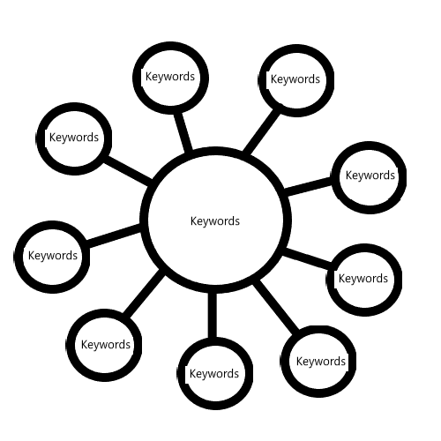

Principle: If you were to Make a college Wizardry education. One class might be Body Exercise.

Principle: One Smith Summons 10 is where you use Dot for everything. A Dot Energy Scroll. A Dot Hand Symbol Sorcery. A think Keyword Dot. A Vision of a Dot. This is a beginner Spell, mainly for training. Perhaps only for training. I don’t really know.

Principle: And we all go down the rabbit hole.

Principle: If you Zoom out enough and include the future… right now, in some ways, we are Gods.

Principle: When two Charms touch/Connect. They leave Particles on each other.

Principle: There is a famous game called “Connect the Dots”.

X2 Principle: This has been mentioned before.

Principle: When Two protons touch, they may leave Particles on each other.

X2 Principle: Not really sure if this has been mentioned before.

Principle: You often find the mechanics of one System mirror the mechanics of another System. You can often mix things together, like Chess and Gardening. Though I would bet more on the Chess/Military Science blend.

Principle: The mechanics of big Charms often mirrors the mechanics of small Charms. Electrons fly around protons just like Planets around Stars.

Principle: There is Connect and there is Disconnect. Connect and Split are the best Vocabulary I can think up right now.

X2 Principle: Split is a new Vocabulary Word.

Principle: Charms/Particles are always Connecting or Splitting. Pushing towards each other or pulling apart.

Principle: Fusion and Fission are at the core of all things.

Principle: Even though some of these Principles have been stated before… they seem fitting for this moment…

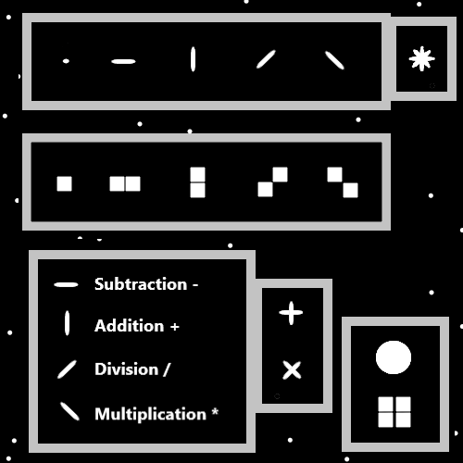

Item Group: Understanding The Cosmos 3

Principle: When you speak of the 3 Energies, Light, Twilight and Darkness. You have a 3 Unit System. When you speak of the four Forces, you have a 4 Unit System. There are Systems that use 5 Units. There are Systems that use 55 Units.

Principle: The latest theory is that gravity is both an Axis and one of the four Forces. It may be the Addition Force Makes the gravity Axis.

Principle: Gravity could be the Subtraction Force, the Multiplication Force, or the Division Force.

Principle: A Axis may be a Wave.

Principle: A Quadrant may be a Square/Sphere.

Principle: Yes, the latest theory is that gravity is one of the four Forces and an Axis, with Positive and Negative gravity.

Principle: It seems probable that the four Forces comes from the 2 Forces, Addition and Subtraction. That Division comes from Subtraction and Multiplication comes from Addition.

Principle: On some Maps it’s the 4 Forces, gravity, electromagnetism, strong-nuclear, weak-nuclear. Addition, Subtraction, Multiplication, Division. On some Maps it’s the 2 Forces (which two I don’t know, maybe strong-nuclear and weak-nuclear). Addition and Subtraction.

Principle: It may be that you unify the 4 Forces into 2 Forces, and then the 2 Forces into the 1 Force. I have heard that Scientists have tried to “unify” the 4 Forces.

X2 Principle: This would mean unifying Addition and Subtraction into 1 Force. If to 1 Force can be done.

X2 Principle: It may be there is no unifying the 2 Forces.

Principle: Most definitely the four Forces are Made of the 2 Forces. Positive and Negative. Of the 4 Forces, one is the Positive Positive one, one is the Negative Negative one, one is the Positive Negative one, and one is the Negative Positive one. Gravity is one of these Forces. Which one is unknown.

Principle: Perhaps the 4 Axis’s appear when we talk about the 8 Forces. Which come from the 4 Forces. Gravity is one of the 4 Forces, it Makes two of the 8 Forces that Make up an Axis.

Principle: When we talk about Positive, and Negative gravity, we speak of the 8 Forces. Positive gravity is one of the 8 Forces, and Negative gravity is one of the 8 Forces.

Principle: Yes the latest theory is that gravity is one of the 4 Forces, and then Negative/Positive gravity are 2 of the 8 Forces.

Principle: There is the 16 Forces, Made of 4 Force combinations. Addition, Addition is one of the 4 Forces. Addition, Addition, Addition, Addition, is one of the 16 Forces. As an example: one of the 16 Forces is the Subtraction, Addition, Addition Subtraction Force. There are 16 combinations.

Principle: (Addition Addition) is also known as Addition. (Subtraction Subtraction) is also known as Subtraction. (Addition Subtraction) is known as Multiplication. (Subtraction Addition) is known as Division.

Principle: There is also the 32 Forces, which are Made of the 2 Forces. Addition and Subtraction.

Principle: All Forces (except for Neutral Energy Bits) are Made of the 2 Forces. This is a theory. The theory may be wrong and you are supposed to say “all Forces are Made from the 3 Forces”.

Principle: It may be that (except for Neutral Energy Bits at the Zero moment), all Forces, all Energy, is Made of Positive and Negative. Light and Darkness.

Principle: There is such thing as the 2 Forces. The two of them can be found in this list…. gravity, electromagnetism, strong-nuclear or the weak-nuclear Force.

Principle: Of the 4 Forces… gravity, electromagnetism, strong-nuclear, weak-nuclear…. two of them come before the other 2. 2 of them are more fundamental. The 2 fundamental ones are the Addition one, and the Subtraction one…not the Multiplication one or the Division one. The Multiplication one and Division one, come from the Addition one and Subtraction one.

(May have errors) (-++)(+--) may need switched.

Item Group: Understanding The Cosmos 4

Principle: His Holiness lord Michael is crown prince of Heaven. First born of his Holiness Light.

X2 Principle: I’m not sure if this has been mentioned before.

Principle: The single digit people (0 to 9) are the biggest of all people.

Principle: About the four Forces… gravity, electromagnetism, strong-nuclear, weak-nuclear…

X2 Principle: Physics Experts have been wrong all these years. Its not the 4 Forces… it’s the 2 Forces. It may be gravity is the Positive Force and electromagnetism is the Negative Force. If so… then the 2 Forces are gravity and electromagnetism. It could be the strong-nuclear and weak-nuclear are the 2 Forces. The 2 Forces are the building blocks of the 4 Forces.

X2 Principle: Reality is all about the 2 Forces…not the 4 Forces.

X2 Principle: Two of the 4 Forces are Positive Forces. Two are Negative Forces. Two come from the Positive Force, and Two come from the Negative Force.

X2 Principle: One of the 4 Forces is the ultimate Positive Force and one is the ultimate Negative Force.

Principle: The 2 Forces are the Forces of Addition and Subtraction.

Principle: The 4 Forces are the Forces of Addition, Subtraction, Multiplication and Division.

Principle: The 8 Forces are the Forces of Addition, Subtraction, Multiplication, Division and 4 more.

Principle: The 16 Forces are the Forces of Addition, Subtraction, Multiplication, Division and 12 more.

Principle: The 32 Forces are the Forces of Addition, Subtraction, Multiplication, Division and 28 more.

Principle: As much as it seems the Multiverse is Made of the 3 Forces, Light, Twilight and Darkness. That may be false. It may be that the Multiverse is Made of just Light and Darkness. When you see Twilight, its actually a combination of Light and Darkness.

X2 Principle: Except for the Twilight/Zero Particles at the Zero moment.

Principle: A person can be nurtured by their job. Honest, hard, work can be very nurturing.

Principle: People nurtured by being equal rights activists can gain a lot of nurturing.

Principle: When the work is more Positive, like you find with equal rights workers, the work can be more Positive for the person.

Principle: People that work for freedom and equal rights often gain a huge amount of nurture. It Makes them more virtuous.