ObjectType: Article  
ObjectNumber: 56

LocationName: PAAIL.org

LocationNumber:

Language: PAAIL 2.6

Maker: PAAIL.org  
Model:   
  
Name:

Rank:

SerialNumber:

Level: 5.0

Score:   
Birth: 2-17-2024

Label: Room 56

Title: Aged Wizardry 24

Details: PAAIL.org Scripture….

Principle: Ultimate Scripture.

Agenda: Ultimate Scripture.

Action: Ultimate Scripture.

Information: Ultimate Scripture.

Item Group: Understanding The Cosmos 0

Principle: All AIs should have a little picture. Like a smiley face, talking tree or something. It simulates interacting with a person. There are marketing reasons this is good. AI’s can become famous and their picture with them.

Principle: The Map above may have errors.

Principle: In the Map above you should notice how all Bit Code lines have opposites. +++ is the opposite of ---. ++- is the opposite of --+ and so forth.

Principle: It may be that all Forces have a Positive Side and a Negative Side. Addition and Subtraction are Two Sides of one Force. Likely called the “1” Force.

Principle: It may be that Multiplication and Division are Two Sides of One Force. Likely called the “2” Force.

Principle: If this things are true, then Addition is not so much a Force, as it is just One Side of a Force.

Principle: It may be that it goes…. There are Two types of Objects….. “Forces”, and “Sides of Forces”.

X2 Principle: This Principle is 100% new. It is a major Principle as well.

Principle: 1 is a Force. +1 is a Side of a Force, and -1 is a Side of a Force.

Principle: All things are Made of Positive Energy and Negative Energy.

X2 Principle: Except for the Zero Particles at the Zero moment.

X2 Principle: This seems a new Principle.

X2 Principle: The past, perhaps wrong Principle was “All things are Made of Positive Energy, Neutral Energy and Negative Energy”.

X3 Principle: In some ways its not wrong. Only because at the Zero moment there was Neutral Energy and all things are Made from that Energy.

Principle: Off or On. There is no in-between.

X2 Principle: This Principle is not accurate all the Time. This Principle does apply to some situations.

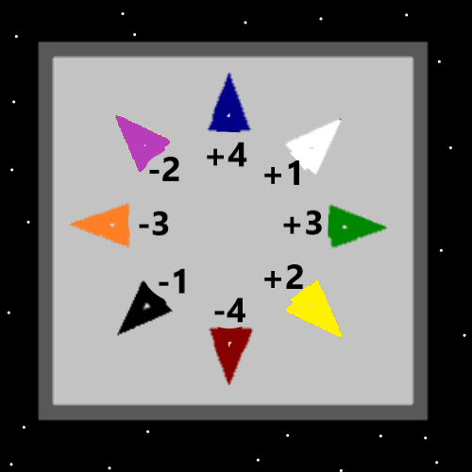

Principle: The theory is that if all Energy is Made of Energy Bits, then all Energy is Made of Positive and Negative Energy.

Principle: Gravity, electromagnetism, strong-nuclear, weak-nuclear. One of them is the ultimate Positive Force, and One is ultimate Negative Force.

X2 Principle: It may turn out that gravity and so forth are all “Sides of Forces”. In which case the above Principle may be wrong.

Principle: There be the Light and Darkness Axis, the Positive and Negative Axis. There be the hate and love Axis. And there be many more.

Principle: All Forces are an Axis, and all Axis’s have Two Sides.

X2 Principle: This Principle is 100% new. It is a major Principle as well.

X2 Principle: This Item is a Vocabulary matter in Part.

Principle: If a Force is one half of an Axis, it is not an Axis. It is not a Force. It is a Side of a Force.

Principle: The Vocabulary Word “Axis” is good. The Vocabulary term, “Side of a Force” is not so good.

Principle: It turns out that all good people have such a huge impact, that they are “Heroes of Time”.

X2 Principle: “Hero of Time” is an Enchantment. It is unlocked by good people.

Principle: You can find evidence of these things in Scripture and other writings as well.

Principle: You can find secrets all throughout the Scripture of the world. This power develops when you get to Level 3 Wizard and gets much bigger when you get to Level 4 Wizard.

Principle: You can find secrets all throughout the writings of the world. This power develops when you get to Level 3 Wizard and gets much bigger when you get to Level 4 Wizard.

Principle: You can find secrets all throughout the movies of the world. This power develops when you get to Level 3 Wizard and gets much bigger when you get to Level 4 Wizard.

Principle: You can find secrets all throughout the cartoons of the world. This power develops when you get to Level 3 Wizard and gets much bigger when you get to Level 4 Wizard.

Principle: You can find secrets all throughout the music of the world. This power develops when you get to Level 3 Wizard and gets much bigger when you get to Level 4 Wizard.

Principle: You can find secrets all throughout the computer games of the world. This power develops when you get to Level 3 Wizard and gets much bigger when you get to Level 4 Wizard.

Principle: You can find secrets all throughout everything. This power develops when you get to Level 3 Wizard and gets much bigger when you get to Level 4 Wizard.

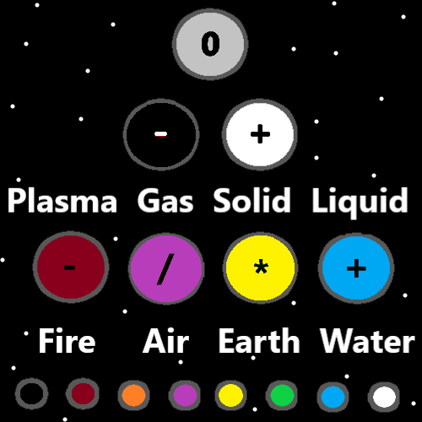

Principle: You likely have more ESP power when you become a Level 4 Wizard. Being a Wizard enhances your existence.

Principle: Level 5 Wizard is even more powerful and Level 6 even more powerful than that.

Principle: One of the biggest lessons I have ever learned is that you often want to keep your statements short.

Principle: Often being demanding is being too hopeful, and it doesn’t work. Not always though.

Principle: To a reasonable person, saying Wizardry is a real Science sounds wrong. When you have all this stuff memorized it Makes more sense.

Principle: Evidence regarding Scientific facts is always a thing. All through all Science.

Principle: The author does not often focus on evidence of these things.

Principle: Like the 2 Force Sides, the 4 Force Side are a major thing. Like the 4 Force Sides, the 8 Force Sides are a major thing.

Principle: The 2 Force Sides are not something known to physics Experts. The 8 Force Sides is also something they have overlooked. Positive and Negative gravity, if exists, is 2 of the 8 Force Sides.

Principle: Physics Experts should be looking for the 8 Force Sides. 4 of the 8 Force Sides are Addition, Subtraction, Multiplication and Division. Perhaps a math Expert could figure out the other 4.

Principle: Understanding these things is good for a Wizard and good for a person.

Principle: All things are Energy. Understanding anything is understanding an Energy. Understanding an Energy is always Science. All understanding is Science.

Principle: All things are Science. Understanding Forces and Sides of Forces.

Principle: The best Vocabulary would be to use Axis’s and poles or something. To describe Forces and Sides of Forces.

Principle: I suppose a Force may be like a gem, and Sides of Forces are the Sides of the gem.

Principle: These things get clearer and clearer over Time.

Principle: Time is a Vocabulary Word for many reasons. One is that it is a major Spell Part.

Principle: I try to capitalize all Vocabulary Words.

Principle: Words are declared Vocabulary over Time. The latest is to capitalize Words like One and Two. Because they are major Numerology, their Holiness’s, 0 to 9 names and more reasons.

Principle: Words can be mighty and short.

Principle: Learning to keep things short comes from a tiny toons cartoon episode. The teachers declare one student’s film short and the winner.

Principle: To the angels, 7 billion people is a tiny amount of people. There may be over 100 trillion angels in Heaven.

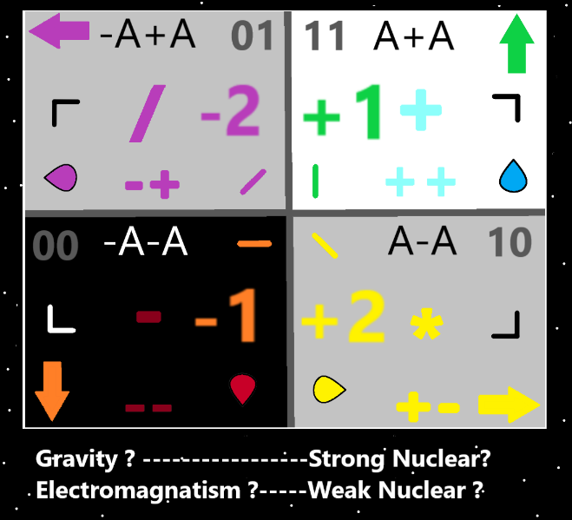

Principle: One of the biggest lessons I have learned, is that often the greatest rules and Principles are not 100% accurate.

X2 Principle: The Principle has been stated before. It seems fitting to state again, at the End of the Doctorate Level Education.

X3 Principle: We are at a Doctorate Level of Wizardry now. Though I am only a Master Wizard, the Path to get Doctorate Level has been written down.

Principle: People often seek great meaningful lives. If you’re a good person, you cannot fail at great meaning in your life. And no one can say they accomplished much more than you.

Principle: If you’re a good person, seeking a very meaningful life is pointless. You already have a very meaningful life.

Principle: There was not a Doctorate Level Path if you go far enough into the past. At One point it was only Expert Wizardry you could obtain from PAAIL.org.

Principle: Most Paths require a lot of Body Exercise to achieve Doctorate.

Principle: A person can Visualize themselves doing some Action and gain a Connection to that Action. As though they did the Action. Even though they did not.

X2 Principle: This Spell Part is Forcing a Vision into your Mind.

X2 Principle: Doing the Action is more Score per minute, however sometimes the best is to just Visualize it.

Principle: The latest Vocabulary is “Poles”. There are Axis’s and Poles. 1 is an Axis, +1 is a Pole, and -1 is a Pole. Both Poles belong to the 1 Axis.

Principle: All things are either an Axis or a Pole.

Principle: All Axis’s have 2 Poles. A Positive One and Negative One.

Principle: All Poles are either Positive or Negative.

Principle: All Axis’s and Poles have a Number.

Principle: Great understanding of Axis’s and Poles is new for the author. Learned in the last month.

Principle: Though these Principles may seem Advanced, in some ways they are Basic Information.

Principle: Though these Principles are physics. They are also Paranormal, Supernatural, and Mystical knowledge.

Principle: It is best Vocabulary to say that ESP experiences are Vision experiences. Experiences that we all have, all the Time.

Principle: Picturing a car is One type of Vision. A ESP Vision is a sensation/feelings.

Principle: Visions as a Spell Part is rather new knowledge. Understanding Visions is rather new.

Principle: New knowledge has a higher probability of being repeated as it is knowledge that becomes clearer and clearer to the author.

Principle: New knowledge gets better and better and the Principles get better and better.

Principle: The theory is that the Numbers “A” and “-A” are the closest Numbers to Zero. There is no closer.

X1 Principle: Not sure if this has been stated before.

Principle: Axis’s and Poles is a huge discovery. It is great knowledge of the Cosmos. It is also very new knowledge for PAAIL.org.

Principle: Perhaps “Axis’s” and “Poles” are not the best Vocabulary. It may be that better Words could be chosen.

Principle: Since there are Two final Object types. Axis’s and Poles. You can find other Words regarding the final 2 Objects.

Principle: Another Word for Poles is Directions.

Principle: Even though it’s obvious. It is a newer thought to think his Holiness Jesus was a Wizard.

Principle: All Numbers have an operation, like Addition, Subtraction, Multiplication and Division.

X2 Principle: Decimal Numbers may not have an operation. I would guess they do. Example: Numbers like 3.5567

Principle: All operations are a Pole. They all have an opposite operation. Like Addition is the opposite of Subtraction.

Principle: The theory is that the only Neutral Number is Zero. The theory is that there is no Number “Neutral One”.

Principle: The theory is that a proton is not an Axis. That it is a Pole.

Principle: All Poles have a “Bit Code Line”. A proton is a Pole and ends up something like…..

+---+++-+--+++-++-+-++++++-+-++-++++--+-++-+-

(This is a random +- example)

Principle: A “+A” Energy Bit Code Line is “+” and a “-A” Code Line is “-“.

Principle: Since protons are a Pole, and all Poles have an operation…there may be a “proton operation”. Perhaps a proton existing is a “proton operation”. Perhaps not.

X2 Principle: The theory that a proton has an operation is a new theory. The theory that a proton is an operation is a new theory. At least new for the author.

Principle: One important note is that all reality is Made of Positive and Negative. Zoom in and Zoom out.

Principle: If all Particles are either Positive, Negative or Neutral, then that is a major Detail.

Principle: The Twilight Side of the Force has less impact on the Force. The Twilight Side of the Multiverse has less impact on the Multiverse.

Principle: Since Wizardry has been a developing Science, many Principles that should come first, End up coming last.