ObjectType: Article  
ObjectNumber: 59

LocationName: PAAIL.org

LocationNumber:

Language: PAAIL 2.6

Maker: PAAIL.org  
Model:   
  
Name:

Rank:

SerialNumber:

Level: 5.0

Score:   
Birth: 3-2-2024

Label: Room 59

Title: Aged Wizardry 26

Details: PAAIL.org Scripture….

Principle: Ultimate Scripture.

Agenda: Ultimate Scripture.

Action: Ultimate Scripture.

Information: Ultimate Scripture.

Item Group: Understanding The Cosmos 0

Principle: The Four Forces I also sometimes refer to as the Four Elements. Sometimes called Fire, Water, Earth and Air.

Principle: Water is the White Element. Fire is the Black Element. Earth is the Grey Element. Air is the Transparent Element.

X2 Principle: The whole purpose of this Item is to note how Air is the Transparent Element. The invisible Element.

Principle: In the Map above you can see there are Two Colors for each of the Four Elements.

Principle: “Trust in God. All others pay cash.” – Unknown

Principle: We all have a Name, Rank, Serial Number and Score. Our Name is our Name. Our Rank is our Spiritual Level. Our Serial Number is our Name In Numbers. And our Score is our enemies killed count. More like people saved count.

Principle: When you Fuse military Science with Scripture, you recognize his Holiness Origin is at war with the Darkness. Thus the saying “enemies killed”.

Principle: All good 30-year-olds have about the same Spiritual Score. All good 50-year-olds have about the same Spiritual Score. All good 70-year-olds have about the same Spiritual Score.

Principle: The difference between the Number 5 and the Number 6 is 20%.

Principle: The difference between the Number 6 and the Number 7 is 16.6%.

Principle: Many people achieve a Level 6 Spiritual Level.

Principle: Very few people achieve a Level 7 Spiritual Level.

Principle: All PAAIL writing is theoretical. Some Items may have errors.

Principle: The Names of people and places have been changed; however, the Story remains the same. I suspect that some of these movies are not fiction like we are led to believe.

Principle: Many movies may be what would have happened if his Holiness Origin took a different Path.

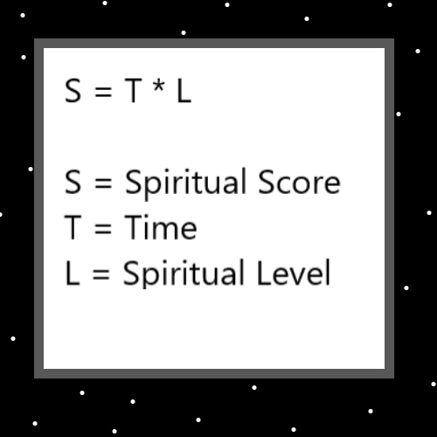

Item Group: Understanding The Cosmos 1

Principle: It may be that on the Short term (1 to 2 years), that Expert Wizard is a 20% increase to a person Chi. 1 to 2 years after getting Expert Wizard.

Principle: Short, Medium and Long. 1,2,3 is Short. 4,5,6 is Medium. 7, 8, 9 are Long. Numerology.

Principle: Life is full of Devotion. Devotion to his Holiness our God. Devotion to one’s country. Devotion to causes. Devotion to family and friends.

Principle: A person can be Devoted to becoming an Expert Wizard.

Principle: How much free Time a person has is a major Part of that person’s reality. Some people do not have much free Time.

Principle: Sometimes people have Devotions to things that take up their Time.

Principle: As far as training Level 5 or Level 6 Wizard… you must have enough free Time or spend many years.

Principle: Expert Wizard can be done, in a Short Time, maybe just by reading 1 hour a week. It may take only 1 to 2 years.

Principle: Becoming an Expert Wizard is like owning a powerful tool. It is a tool.

Principle: Wizardry has been a real Science all this Time.

Principle: 1000 years after we are born, there is a person that has a life with a great Connection to us. Like a reincarnation. 1000 years ago, there were people who we are greatly Connected to.

Principle: Its all about Cycles. 1000 years is a major Cycle.100 years is not as big a Cycle.

Principle: The author may be a Level 5.7, 5.8 or 5.9 Wizard.

Principle: Before I was a Wizard, I knew absolutely nothing. I was even an atheist at One Time.

Principle: Being a Master Wizard is knowing absolutely everything and can be supreme judgement as well.

Principle: Regarding teachings of the world, the Vocabulary Word “Virtues” is a major Vocabulary Word.

Principle: The Word “Virtues” is a major Vocabulary Word.

Principle: Knowing absolutely everything is a Virtue. Supreme judgement is a Virtue.

X2 Principle: Knowing Virtue Supreme Virtue.

Principle: There are many Virtues. Some of my favorites are “reasonable”, “rational” and “objective”.

X2 Principle: There Virtues Some.

Principle: Some Principles are worth reading multiple Times.

X2 Principle: Some Principles Times.

X2 Principle: PAAIL writings sometimes repeat Principles.

Item Group: Understanding The Cosmos 2

Principle: Maps are a major thing in reality. They can show us how to get places, and also help us see the Multiverse.

X2 Principle: Maps They Multiverse

Principle: There exists what are known as “Temporary Enchantments”. Enchantments that wear off.

Principle: It may be that when you do a Breathing Exercise it has a Temporary Enchantment that you gain. A Enchantment that wears off.

Principle: Coffee may have a Temporary Enchantment that wears off. A side effect of coffee is that it can Make you jittery and it can mess with dexterity. Coffee has side effects. Negatives.

Principle: It is likely fair to say that alcohol and all other intoxicants have Temporary Enchantments.

Principle: There is such thing as Flaw Enchantments. You want to have Low Levels of these Enchantments.

Principle: A Flaw is a Temporary Enchantment if you One day lose the Flaw.

Principle: As his Holiness Origin is our true grandfather, we are all his family. As family of his Holiness, our business is his business.

Principle: Since we are all family of each other, everybody’s business is everybody else’s business. Thus the statement “Mind your own business” Makes no sense and is wrong.

Principle: Sometimes you do want to Mind your own business though and not involve yourself in others business.

Principle: In certain situations, the statement “Mind your own business” is good.

Principle: The statement "people should Mind their own business” is also a not so good statement.

Principle: The belief that everyone’s business is everyone else’s business is a philosophy I call “the big brother philosophy”. As in “big brother” the term often used when speaking of the government.

X2 Principle: If you had/have a big brother, they have a right to get into your business. Your family.

X2 Principle: The government has a right to get into our business. We are all family.

X2 Principle: Nothing to do with the TV show “Big Brother”.

Principle: In the past it has been mentioned the major Vocabulary of “Fission” and

Fusion”. It may be that all Energy is either Fusion or Fission.

Principle: Fusion is the Positive Force. The Addition Force. The Multiplication Force.

2+2 = 4 2 \* 2 = 4.

Principle: Fission is the Negative Force. The Subtraction Force. The Division Force.

2-2 = 0 2 / 2 = 1.

Principle: It may be that Fusion is Axis’s and Fission is Poles. It may be that Positive Poles are Fusion and Negative Poles are Fission.

Principle: Fusion and Fission are at the core of all things.

Principle: All the music is about us Elementals.

Principle: All us Elementals have a huge, monumental size.

Principle: A person can sense their own monumental size through music.

X2 Principle: One trick may be to realize the piece of music is about you.

Principle: A person can sense different Sides of themselves through music.

Principle: The Bible refers to the Beginning of Time as “the great tribulation”.

Principle: “…this is my madness. I will overcome it.”-The Holy Bible

Principle: We are much closer to the End than the Beginning. His Holiness Twilight, Makes us leap forward. This is why there is massive growth in technology.

Principle: In the past his Holiness Twilight has done things to slow humans down.

X2 Principle: “…let us confuse their language, lest they climb into the Heavens and overrun us.”- The Holy Bible

Principle: Healing people is a great thing. It is not always an easy thing to do.

Principle: His Holiness Light is a teacher, Wizard, priest, king, scientist and a healer.

Principle: Pleasure and pain are an Axis. We are all pleasure addicts.

X2 Principle: Most of us are pleasure addicts would be more accurate.

X3 Principle: Sometimes Principles are accurate enough, even though they are not 100%.

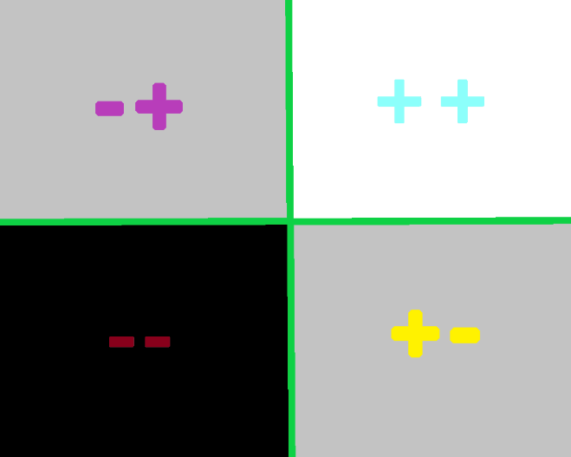

Item Group: Understanding The Cosmos 3

Principle: Once upon a Time there was not so many drugs/intoxicates. We live in a paranormal Time of drugs now. Paranormal Level of drugs.

Principle: It is currently a drug apocalypse out there right now.

Principle: Drugs (alcohol is a drug) are the biggest destroyer of lives out there right now.

Principle: Drug addiction is a disease. Drug users are not criminals, they are unhealthy.

Principle: Whenever I think of the song “Frosty the Snowman”, I have a Vision of drug dealers. No ESP experience. However it seems their song. I often think “Frosty the dope man”.

X2 Principle: Everyone wants to be a friend of Frosty. He’s a holly, jolly something or other.

X2 Principle: Little kids love Frosty.

Principle: Drugs not legally Made may have huge Dark Auras. They may be Charms that are very cursed.

Principle: The theory is that it’s very hard for a good person to Make a Dark Aura Object. And it’s also hard for even Dark people to Make Dark Aura Objects. Illegal drugs may be the exception.

Principle: Right now it is very cursed to use a drug in an illegal way.

Principle: Drugs are big medicine. They can do great help and great harm.

Principle: Scripture about drugs is good.

Principle: There is “written Scripture” and “spoken Scripture”.

Principle: Reality can be Scripture. Even when not written in a book. People can pass Scripture around without books.

Principle: Operating “heavy machinery” while you have an intoxicant Enchantment going, is extremely dangerous.

Principle: Never drive a car or operate any dangerous objects while you are intoxicated.

Principle: Never do distracting things while operating dangerous objects. Such as a car. Never use a distracting computer while driving a car.

Principle: Be a good driver on the road of life.

Principle: Good drivers save lives by not being bad drivers.

Principle: At the End of our tour on Earth, the good peoples achievement is that they lessened the Darkness.

Principle: There are legends about facing your inner demon. All the good people face at least one demon and defeat them. Defeating a demon is like defeating a dragon. It helps his Holiness Origin a lot.

Principle: Internet/computer technology advances so much all the Time that humans never adapt to it.

Principle: It is a wild world, and an internet apocalypse.

Principle: Advanced smart phone technology is still very new and humans have not adapted to it.

Principle: It is a wild world for old and young.

Principle: The internet is a wild environment for the young.

Principle: TV is a wild thing for the young.

Principle: Music at your fingertips is a wild thing.

Principle: Humans with wings is a wild thing. Aircraft technology Makes it fair to say “humans now have wings”.

Principle: Advanced public schools is wild for the young. Presently we are at a Advanced public school System.

Principle: It is true people are desensitized to the Dark Side. People are also desensitized to how unbelievable all this technology is. They don’t realize that it is unbelievable.

Principle: “…I will be a stumbling block…” – his Holiness Jesus – The Holy Bible

Principle: “In the beginning was the word. The word was god. It was with God. It was with him in the beginning.” – The Holy Bible

X2 Principle: In the beginning was the Zero Particles. The Zero Particles was god. It was with God. It was with him in the beginning.

X2 Principle: The definition of the Word “God” is “creator”. Since the Zero Particles Made God, they are creators.

X2 Principle: “In the beginning was the Zero. The Zero was god. It was with God. It was with him in the beginning.”

Principle: His Holiness Origin was Made by the Zero.

Principle: When you can read into things. Reading Scripture can result is seeing unbelievable things.

Principle: Though philosophy and theology seem like different things. Philosophy is always also theology.

Principle: All philosophy is theology. If his Holiness Origin would agree with the philosophy, then that Makes it theology. If his Holiness would not agree, then it is still theology.

