ObjectType: Article  
ObjectNumber: 60

LocationName: PAAIL.org

LocationNumber:

Language: PAAIL 2.6

Maker: PAAIL.org  
Model:   
  
Name:

Rank:

SerialNumber:

Level: 5.0

Score:   
Birth: 3-9-2024

Label: Room 60

Title: Aged Wizardry 27

Details: PAAIL.org Scripture….

Principle: Ultimate Scripture.

Agenda: Ultimate Scripture.

Action: Ultimate Scripture.

Information: Ultimate Scripture.

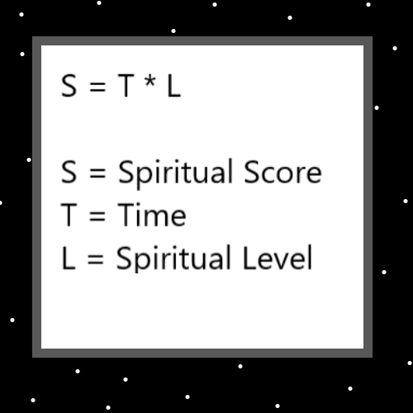

Item Group: Understanding The Cosmos 0

Principle: The Detail that all things are either a Axis or Pole is a major Detail of the Multiverse. Though it is a theory and not 100% certain to the author.

Principle: If everything is a Axis or Pole, then matter, space, and everything else is a Axis or a Pole.

Principle: If space is an Axis, then there is Positive and Negative space. If space is a Pole, then there is an opposite to space.

Principle: If matter is an Axis, then there is Positive and Negative matter. If matter is a Pole, then there is an opposite to matter.

Principle: If heat is an Axis, then there is Positive and Negative heat. If heat is a Pole, then there is an opposite to heat.

Principle: If Time is an Axis, then there is Positive and Negative Time. If Time is a Pole, then there is an opposite to Time.

Principle: Energy may be an Axis, with Positive and Negative Energy. The Energy Axis. The first Axis.

Principle: It is notable that Energy Bits look like Poles. Or rather Energy Bits are Poles.

Principle: Energy Bits belong to the Energy Bit Axis. Positive Energy Bits are a Pole and Negative Energy Bits are a Pole to.

Principle: All Energies have a Energy Bit Code to them. “+--+++-++--+-+-++-++--" is a Energy.

Principle: All Particles have a Energy Bit Code to them. “+--+++-++--+-+-++-++--" is a Particle.

Principle: It may be that one of the biggest Details is that all Energies are either Positive, Negative or Neutral. All Particles are either Positive, Negative or Neutral.

Principle: Likely electrons are Negative Particles. They likely have Bit Code lines that start with the Negative Symbol or have a lot of Negative Symbols in it.

Principle: It’s possible that protons and electrons are Particle opposites, that they both belong to the same Axis.

Principle: All throughout the Multiverse is Levels. Of course there must be ESP Levels.

Principle: Some people have higher ESP Levels than others. Though all people likely have enough Levels that they experience ESP sometimes.

Principle: A person can do Variations of Smith Summons Spells. Mix different Parts together.

Principle: A person can do a Smith Summons 3 Variation and add the Vision Spell Part, where they picture the Keyword in their Mind.

Principle: Human Bodies are huge Chi Charms.

Principle: It may be the whole human Story is only minutes to his Holiness Origin or even seconds. 7000 Earth years can’t be long on a Cosmic scale.

Principle: A Cosmic day is about….the Age of Planet Earth divided by 6.99.

Principle: The Earth was born likely from the Fusion event of Two Planets colliding.

X2 Principle: “…and the Earth was a void. And Darkness was over the surface of the deep.”. -The Holy Bible-The Book of Genesis Chapter 1 Verse 2

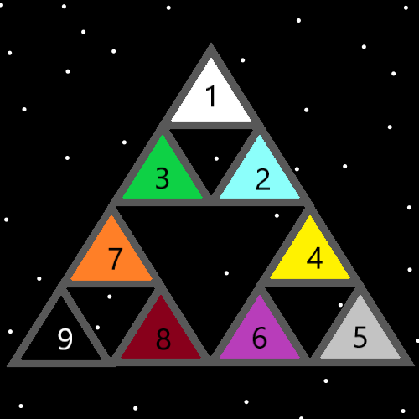

Item Group: Understanding The Cosmos 1

Principle: Often speaking in a statistics format is great. Speaking statistics can be great.

X2 Principle: This Item is a statistic.

X3 Principle: The X2 Item Item is a statistic about a statistic.

Principle: The Spell Smith Summons 10 is the fastest Sorcery Level gain for Smith Summons Spells. Not long ago there was no Smith Summons 10.

Principle: Smith Summons 10 is much less passive than Smith Summons 4.

Principle: Some major Vocabulary Words for your fellow humans are…. personality, mentality, psychological state, Virtues and Flaws.

X2 Principle: This is not a new Principle; however it seems right to write again.

Principle: Spirituality is a Science. Some Spirituality is correct, some is incorrect.

Principle: Smith Summons 2 is likely quite powerful. Think a Keyword over and over. Breathe while doing it. One variation is Breathe while thinking the Keywords. Not necessarily during the Pause.

Principle: A person can sense the power of a Spell. Like one can sense martial arts training benefits. A person can sense the martial arts training is good for them.

Principle: A person can sense Enchantments that will be gained by doing a Spell.

Principle: It is possible to have an ESP experience while holding a Charm. For instance, a Energy Scroll.

Principle: It is possible to sense the power of Smith Summons 10. Sense how much it Enchants a person.

Principle: All Energy is a Particle. Space and matter are Particles.

Principle: It may be that space and matter are of the same Axis. That space is the opposite of matter.

Principle: Space may be bend in Particles and matter is bend out Particles.

Principle: Space may be the Negative Force and matter the Positive Force.

Principle: Whenever you have a Two Unit System it often aligns with the Positive Force and the Negative Force.

Principle: Whenever you have a Four Unit System it often aligns with the 4 Elements.

Principles 57.4: The thought is to possibly use the Word “Principles”, unless it is one Principle.

Principle: Smith Summons 1 may be quite powerful. Especially if you have done many hours of training it.

Principle: High Levels on Smith Summons 1 may be quite powerful.

Principle: Athletes often can sense the benefits of individual exercises.

Principle: A person can sense the Positive benefits of water while drinking it.

Principle: A person can sense a Spell. Sense a Aura of the Spell.

Principle: A person can sense the Enchantments gained from a Spell.

Principle: A person can have a ESP experience on a cup of water.

Principle: There is regular feelings, like happiness, unhappiness, and sense things feelings. ESP is feelings. We all have ESP feelings all the Time.

Principle: A person may be able to focus on something by using Smith Summons 1.

Principle: Taking a long Wizard training Path is slower but can be more passive.

Principle: If you could prove all these theories it would be taught in public schools and all kids would graduate high school with a Doctorate in Wizardry. The public schools would have an easy Time teaching it. It would be easy to get kids to Doctorate Level by the End of high school.

Principle: Spiritual Science is probably the greatest of all Science.

Principle: The Spiritual Side is often a serious Side.

Principle: Philosophy has shaped the world. Spirituality has shaped it much more.

Principle: The United States has only ever had Christian presidents. Religious people rule the world.

Principle: A persons Religion is Part of their Spirituality.

Principle: All people have a Spiritual Level. This is Part of their Spirituality.

Principle: A person’s philosophy is Part of their Spirituality.

Principle: Darkness sometimes is a Positive tool.

Principle: Sometimes a person can destroy Darkness and it’s a good thing. Its known as Darkness unto the Darkness. Darkness becomes a Positive tool.

X2 Principle: In math -2 \* -2 = 4

Two Negative Numbers multiplied by each other always Ends Up Positive.

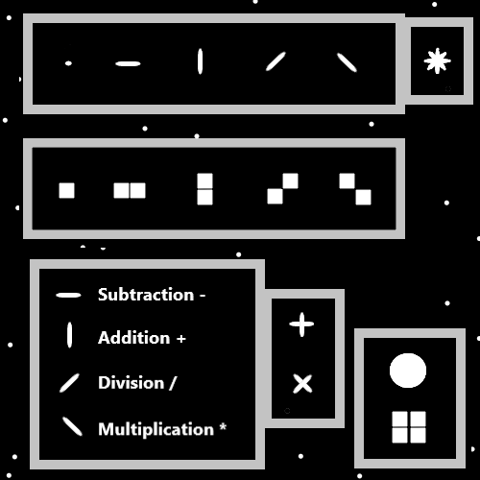

Item Group: Understanding The Cosmos 1

Principle: Sometimes you can Make a Fist and sense the power of it.

Principle: When a Battery is not at its max, it means it is Drained some. When a Battery is Drained it is often Recharging. When a Battery is Recharging it can mean gaining Recharge Levels.

Principle: Draining Batteries can mean gaining Recharge Levels.

Principle: It may be that all chess players have a “chess Battery”.

Principle: Draining Batteries is also the most common way to Grow bigger Batteries.

Principle: All people have a Food Battery, a Drink Battery, a Sleep Battery and a Entertainment Battery.

Principle: Expert Wizards likely have a huge Wizard Battery.

Principle: Level 3 Jr. Wizards likely have big Wizard Batteries.

Principle: Level 3 chess people likely have big chess Batteries.

Principle: When a Wizard does some Action, Part of their Wizard Battery flows through the Action.