ObjectType: Article  
ObjectNumber: 63

LocationName: PAAIL.org

LocationNumber:

Language: PAAIL 2.6

Maker: PAAIL.org  
Model:   
  
Name:

Rank:

SerialNumber:

Level: 5.0

Score:   
Birth: 3-21-2024

Label: Room 63

Title: Aged Wizardry 29

Details: PAAIL.org Scripture….

Principle: Ultimate Scripture.

Agenda: Ultimate Scripture.

Action: Ultimate Scripture.

Information: Ultimate Scripture.

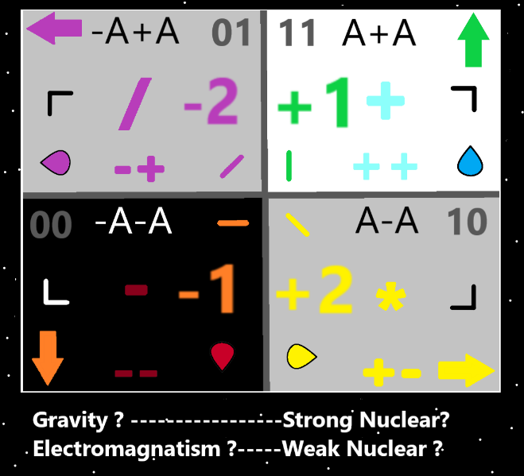

Item Group: Understanding The Cosmos 0

Principle: One of the newest Spells in the Smith Spells Collection is “Symbol Vision 0”.

Principle: Doing the Spell Symbol Vision 0 and using the Dot Symbol is likely a powerful Spell. At least powerful for training, perhaps more.

Principle: Some ultimate Sorcery training involves using Symbol Vision 0. Where you do the Dot Symbol, then train the horizontal line Symbol. Also known as the Fire Symbol. Then train the Water Symbol. The vertical line Symbol. Then train the Earth Symbol. Then train the Air Symbol. “ \ “ “ / “.

Principle: After doing a bunch of Symbol Vision 0, with the Air Symbol, then you move onto the 2-line arrows. There are 4 of them. Up, Down, Right, Left.

Principle: After the 4 arrows, then you do the Circle. Then the plus, the cross Symbol. Then the X Symbol. Then the 1-pointed Seed Symbol. Next is the 2 pointed Seed Symbol. Then the triangle Symbol. Then the Square Symbol.

Principle: A person can do training where they do Smith Summons 3 and Smith Summons 4 and they add the Spell Part Symbol Vision 0. This a Variation on Smith Summons Spells.

Principle: A person can mix Smith Summons Spells in while training Symbol Vision 0.

Principle: Before a person does any training of a Spell they are often Low Level on that Spell.

Principle: Once you have a done a ton of Symbol Vision 0, you have a higher Level on Spell Symbol Vision 0. Your Symbol Vision 0 Level may be Level 4.

Principle: A person has Levels on all their Spells. A Level for each individual Spell.

Information: “One day you’ll be a God. Today you’re my food.” – The Enlightened Hunter

Principle: Sometimes there is a situation where there is no fix. No 100% fix. Instead you can only help the situation.

Principle: “…there will be wars and rumors of wars…” -The Holy Bible

X2 Principle: The author may be remembering the Bible wrong.

Principle: A bunch of Meditation in a Room with a Shrine, turns the Shrine into a Meditation Shrine. It gains a Meditation Enchantment.

X2 Principle: There are other ways to Enchant a Shrine with a Meditation Enchantment.

Principle: A bunch of Meditation in a Room with a Meditation Shrine turns the Room into a Meditation Chamber. The Room gains the Meditation Chamber Enchantment.

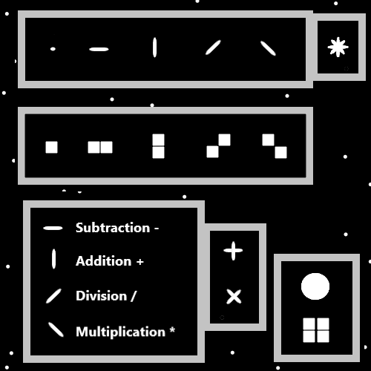

Item Group: Understanding The Cosmos 1

Principle: There is an endless Number of fine things. Little nicknacks are fine things. Copper coins are fine things. Little candy wrappers are fine things.

Principle: People are desensitized to luxuries. They don’t realize how luxurious things are.

Principle: Being desensitized to a luxury can reduce the pleasure Level from that luxury.

Principle: High Levels of Symbol Vision 0 should be Part of Doctorate training. It should be added to the list of required training for Level 6.

Principle: There are good Variations of the Smith Spells collection that can be devised.

Principle: “… and don’t forget to Breathe.” – Willow from the Willow TV Series.

X2 Principle: Coincidently the character Willow is a Wizard.

Principle: Likely there are secrets to see by going over Wizards from fiction movies and fiction books.

Principle: Symbol Vision 0 with the Dot Symbol is a newer Principle. It seems very likely it is a powerful Spell.

Principle: The greatest revelations in the recent articles are Symbol Vision 0 and the 4 Object Types.

Principle: Again the 4 Object Types are “Axis’s”, “Poles”, “Axis Groups” and “Pole Groups”.

Principle: The Earth Force is Made of One Positive Pole and One Negative Pole. A Pole Group.

Principle: The Earth Force is also a Pole on its own.

Principle: Poles Make Poles or something like that. This material is harder on the brain and I’m not a physicist.

Principle: Two of the biggest revelations lately are that all Poles have an opposite and all Axis’s have a Positive and Negative Side.

Principle: Energy Bits A and -A are Poles. They are Part of an Axis.

Principle: It seems that if you could Zoom in on an Energy Bit, it would look like a stick.

Principle: Even not being able to see a Energy Bit, it may be fair to say they are sticks.

Principle: The dynamics of Energy Bits are likely to be just like the dynamics of a computer program. We all live in a computer program. Made of 1’s and 0’s.

Principle: All of Reality is one big computer.

Principle: Space may be very like circuitry in a computer.

Principle: Space may be the circuitry of the computer motherboard.

Principle: Symbol Vision 0 with a Sphere shape is good training and possibly more.

Principle: There is currently a apocalypse amount of firearms problems out there. It be a firearms apocalypse.

Principle: The children are raised in a wild apocalypse.

Principle: It be a technology apocalypse.

Principle: Good parenting knowledge is that it is a wild world.

Principle: It seems possible that Expert Wizards can sense huge things with music.

Principle: It is possible that the Earth is Made of his Holiness Lights Body. That when you eat, you eat the Body of Christ.

Principle: Good is Connected to power. Like Darkness is Connected to no power.

Principle: Spiritual Accension is among the greatest of quests.

Principle: The Cosmic year 99 is a primitive and primordial Time.

Principle: At the End of the great tribulation, the credits will roll and we will all be in the credits.

Principle: For his Holiness Origin, the Stars are tiny Dots.

Principle: Humans have to consume Life Force to live. Eating lifeforms is how we consume Life Force.

Principle: It is not natural to be eating other lifeforms.

Principle: Tattoos are Runes. Marks on paper are Runes. Letters on paper are Runes. Many things are Runes.

Principle: When a person Makes a painting they are Runing the canvas with a picture.

Principle: Runing is Alchemy. People who can paint very well have High Levels of Runing.

Principle: A person could Rune paper with the Dot Symbol (or some other Symbol) and they would gain Runing Levels from doing it.

Principle: All Sorcery is Enchanting.

Principle: Making a fireball would be Enchanting the Room so that is has a fireball. Making a blast of lightning would be Enchanting the room with a blast of lightning. The Room would gain the Property/Enchantment of having a lightning blast in it.

Principle: Smith Spells Enchant a person.

Principle: All Spells are Summon Energy.

Principle: It may be right to say all Particles have a Shape.

Principle: It may be that all Particles are either bend in, bend out, or flat.

Principle: The theory is that Space/Time are bend in Particles. Or rather the Space/Time Axis Group is a bend in Axis Group.

Principle: Remember that often knowledge is theoretical. A persons theory.

Principle: The theory is that the God Body is a 4-Dimensional bend out Particle. The theory is that you would call the God Body a Axis Group.

Principle: It may be accurate to say all Axis Groups are also Pole Groups.

Principle: In the afterlife all people 10 or older will be turning into Expert Wizards within the first six months. Wizardry is Basic knowledge like reading and math.

X2 Principle: Training Expert Wizard will only require 4 hours a week for 6 months. It may be even easier.

Principle: Everyone should train Expert Wizard. It is Low difficulty doing so.

Principle: Being a Expert Wizard Makes you truly understand the Multiverse.

Principle: The Expert Wizard Enchantment is a grand Enchantment.

Principle: The Level 3 Wizard Enchantment is a grand Enchantment.

Principle: At the End of Tome of The Yellow Wizard, you had to read it and do a ton of Body Exercise, and Meditation Exercise to get Expert Wizard. Now you only need to read enough.

Principle: Tons of new Wizardry has been developed over the last 3 years.

Principle: The author is still only a Master Wizard.

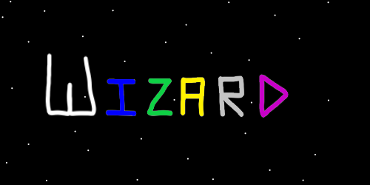

Principle: Adding the Spell Part Symbol Vision 0 can be done to many Spells, including the Smith Spells.

Principle: It may be powerful adding Symbol Vision 0 to “warmup” Exercises.

Principle: It may be powerful adding Vision 1x to “warmup” Exercises.

Principle: It is reasonable, rational, and objective to talk about being reasonable, rational and objective.

Principle: Talking about politics sometimes divides people.