ObjectType: Article  
ObjectNumber: 65

LocationName: PAAIL.org

LocationNumber:

Language: PAAIL 2.6

Maker: PAAIL.org  
Model:   
  
Name:

Rank:

SerialNumber:

Level: 5.1

Score:   
Birth: 3-29-2024

Label: Room 65

Title: Aged Wizardry 30

Details: PAAIL.org Scripture….

Principle: Ultimate Scripture.

Agenda: Ultimate Scripture.

Action: Ultimate Scripture.

Information: Ultimate Scripture.

Item Group: Understanding The Cosmos 0

Principles 01: Throughout human history new Religions are Made. It turns out it is quite easy to Make a Religion.

Principles 02: Making a Religion is an Action, a Spell.

Principle: The Word “Orders” is a major Vocabulary Word of Scripture.

Principles 03: Sometimes a Religion has multiple Orders. Subgroups within the Religion.

Principle: It can be said that Religions are “Order Groups”.

Principle: In some ways there is only 1 Religion with many Orders.

Principle: Orders are a great Part of Religion. When a Religion succeeds it is an Order that is succeeding.

Principle: It is good that new Orders show up sometimes.

Principle: One of my favorite Orders Systems is the Catholic System. They have multiple Orders as a Part of the Catholic Religion.

Principle: The Word Religion is a major Vocabulary Word of Scripture.

Principle: Virtue is a major Vocabulary Word of Scripture.

Principle: There are endless Virtues. Knowledge is a Virtue. Knowing chess is a Virtue. Knowing math is a Virtue. Being able to read is a Virtue.

Principle: Virtues are Positive Properties. Virtues are Positive Enchantments.

Principle: Flaws is also a major Vocabulary Word of Scripture.

Principle: Flaws are Negative Enchantments. They are Negative Score on a person’s Chi.

Principle: Virtues are Light Enchantments and Flaws are Dark Enchantments.

Principle: Some Maps may have only Light, and Dark Enchantments…. No Twilight Enchantments.

Principle: Patience is One of the most powerful Virtues.

Principle: Patience is more than a Virtue. It is an all-powerful Virtue.

Principle: It is easy to lose patience. Demanding to demand it.

Principle: Wisdom is a most famous Virtue. This Virtue is the Virtue of the old people. The young are seldom Wise.

Principle: I’m sure Dexterity, Strength, Constitution, Intelligence, Wisdom, and Charm are major Vocabulary Words when speaking of Virtue.

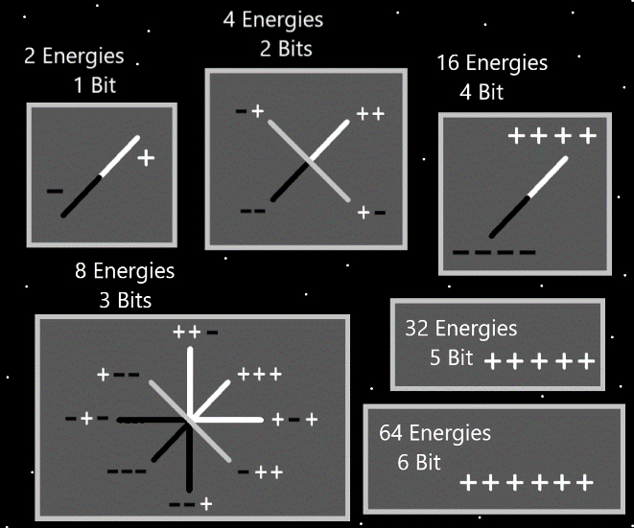

Principle: There is outer physical Strength and inner mental Strength possibly. Mental Strength would be like will power.

Principle: It may be that there is Body Strength, and then there is Mind Strength. Likely then also a Spirit Strength.

Principle: It may be that there is Body Dexterity, and then there is Mind Dexterity. Likely then also a Spirit Dexterity.

Principle: The pattern may continue with Constitution, Intelligence, Wisdom, and Charm.

Principle: A person has a Fire Virtue Level, a Water Virtua Level, a Earth Virtue Level and a Air Virtue Level.

Principle: To much Fire is bad. Much worse than too much Water.

Principle: A person wants most a great balance of Virtues. The right amount of Fire and Water for instance.

Principle: Intelligence is overrated. Wisdom is far greater. Often Intelligence is not really needed at all.

Principle: It’s what you’re an Expert at that Makes you powerful. Not your Intelligence Level.

Principle: Intelligence is faster learning power and pattern recognition.

Principle: We all have around the same Level on Intelligence. Though some people are the slightly above average, and some people are the slightly below average.

Principle: We are all around 2x Times more Intelligent than the people of 150 years ago.

Principle: The High Levels of Intelligence on Earth right now, is a huge disturbance in the Force, and contributes to the apocalyptic Reality.

Principle: Many things are a huge disturbance in the Force and contribute to the apocalyptic Reality.

Principle: The apocalypse is a very intense Time.

Principle: The apocalypse is also known as the “End Times”.

Principle: It’s been said before… an apocalypse happens every 1000 years.

Principle: The most powerful Spell Part may still be the think Keywords Spell Part.

Principle: When you Zoom In to see Energy Bits you are at “Infinity Zoom in” Level. The theory is that looking at 4 Energy Bits at a Time is still Infinity Zoom In. Infinite magnification.

Principle: In the Time before Time there was the “Zero Math Moment”.

Principle: Every form of Energy has a Number. All Reality is math.

Principle: The Word demanding is a demanding Word. There is such thing as too demanding and also not demanding enough.

Principle: I can’t tell if the Word demanding should be a Vocabulary Word.

Principle: It may be a powerful Enchantment to do a ton of Meditation where you focus on the Origin Moment. Reach back and Connect to it.

Item Group: Understanding The Cosmos 1

Principle: “Some people can’t manage that.” – Unknown

Principle: All power is “Wielding power”. Wielding is a major Vocabulary Word.

Principle: Some people know how to Wield a musical instrument. Some do not.

Principle: There is such thing as Wielding Levels. How well you Wield the Object.

Principle: Wielding has been gone over before. Its worth going over some more and it is a clearer subject these days.

Principle: In many games you cannot Wield a Charm because your Level is not High enough.

Principle: Spells are a thing you Wield. We all have a Level for each individual Spell.

Principle: One theme of the latest Wizardry articles is some major things that should be repeated. Such as individual Spell Levels for each individual Spell.

Principle: When you do a Spell often you Grow your Level on that Spell.

Principle: To focus on a person, you can probably think their Name over and over again, in your Mind.

Principle: To focus on a Object you can probably think their Name over and over again, in your Mind.

Principle: The author is still only Level 3 Sorcery. Level 4 requires some training.

Principle: Being a Level 3 Wizard is huge.

Principle: Level 2 Wizard is pretty awesome. It also takes very little Time to get to.

Principle: A person can be passive in their Wizardry training. Spending years to do it. This Path can be more peaceful and quiet. Add a peace and quiet Enchantment.

Principle: PAAIL.org Wizardry is much more Advanced now than it was 2 years ago.

Principle: Instead of things known, then written out. This all has been a bunch of research and development of Wizardry.

Item Group: Understanding The Cosmos 2

Principle: Team building is a major thing. People can build their team Levels by doing team building Spells.

Principle: It may go that there is Spirit Dexterity, Mind Dexterity and Body Dexterity. It may also be that there is the combination of the 3, a persons final Dexterity Level. A person has a final “Chi Dexterity Level”.