ObjectType: Article  
ObjectNumber: 66

LocationName: PAAIL.org

LocationNumber:

Language: PAAIL 2.6

Maker: PAAIL.org  
Model:   
  
Name:

Rank:

SerialNumber:

Level: 5.1

Score:   
Birth: 4-6-2024

Label: Room 66

Title: Aged Wizardry 31

Details: PAAIL.org Scripture….

Principle: Ultimate Scripture.

Agenda: Ultimate Scripture.

Action: Ultimate Scripture.

Information: Ultimate Scripture.

Item Group: Understanding The Cosmos 0

Principles 01: One worthwhile training may be to do focus on the Origin Moment. Reach back and Connect to it. You don’t even have to reach very far. 99 Cosmic years is not very far.

X2 Principles: Doing this Enchants a person. Maybe 10 hours to get a decent Level on the Enchantment.

X2 Principles: Focus on the Origin moment. Go back there in your Mind.

X2 Principles: The author tends to have a Vision of a rotating coin.

X2 Principle: Since the Origin moment was not long ago it is easy to Connect to it.

X2 Principle: This would be a Meditation Spell.

Principle: All Enchantments have Levels.

Principle: Gravity may be both One of the 4 Forces and 1 of the 4 Axis’s.

Principles: The Origin moment is Two Particles occupying the same place at the same Time. When Two Particles occupy the same place at the same Time you get a huge explosion.

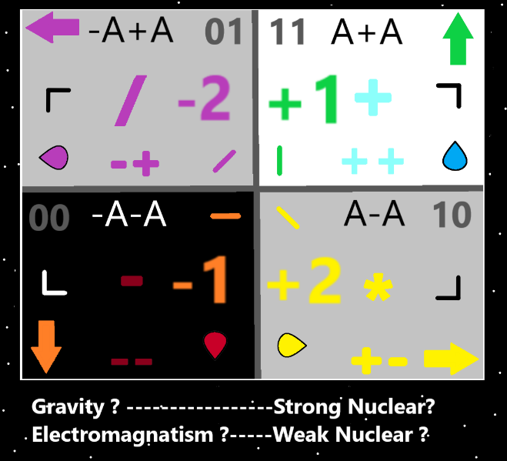

Item Group: Understanding The Cosmos 1

Principle: First there was Twilight. Light and Darkness were created by the Twilight.

Principle: It may be accurate to say all Energy is Made of Light and Darkness.

X2 Principle: Except for the First Twilight Force. That existed before Light and Darkness.

Principle: There are Infinite Sides of the Force. People who are great at chess are strong with the chess Side of the Force.

Principle: Alcohole is a drug.

Principle: Most troubled people have drug problems.

Principle: Most troubled people… one of their biggest problems is their drug addiction.

Principle: Drug addiction is perhaps the greatest plague on the Planet.

Principle: Using drugs is often outright “cursed”.

Principle: Alcohole, THC, caffeine and nicotine are the only drugs that should be legal without a prescription.

Principle: Drugs are powerful Charms.

Principle: Though drug Principles have been done before. I think it’s worth going over them again.

Principle: People who know about drug addiction can tell you that often people spend huge amounts of their money on their drug habit. It is a Drain on their existence.

Item Group: Understanding The Cosmos 2

Principle: Reality is a Object. All Objects are either Axis’s, Pole’s, Axis Groups, or Pole Groups. Reality is a Axis Group. The Force is a Axis Group. The Multiverse is a Axis Group.

Principle: All Axis Groups are also Pole Groups. Not all Pole Groups are Axis’s.

Principle: All Axis’s are also Pole Groups.

Principle: ++ is a Pole Group. +- is a Pole Group. -+ is a Pole Group and - - is a Pole Group.

Principle: There are an Infinite amount of Axis Groups, Pole Groups, Axis’s and Poles.

Principle: All things are Made of plus Poles and minus Poles. Poles likely Make Axis’s and other Poles.

Principle: Understanding there is the 2 main operations (Addition and Subtraction) is major physics/math.

Principle: Understanding there is the 4 main operations (Addition, Subtraction, Multiplication, Division) is major physics/math.

Principle: Understanding Multiplication comes from the Addiction operation is major physics/math.

Principle: Understanding Division comes from the Subtraction operation is major physics/math.

Principle: Understanding there is the 8 main operations is major physics/math.

Principle: Understanding there is the 16 main operations is major physics/math.

Principle: Understanding there is the 32 main operations is major physics/math.

Principle: Understanding there is the 64 main operations is major physics/math.

Principle: Understanding there is the 128 main operations is major physics/math.

Principle: Understanding every Number has a corresponding operation is major physics/math. +1 is Addition. -1 is Subtraction. +2 is Multiplication and -2 is Division.

Principle: It may be there are 2 Types of operations. Fusion operations and Fission operations. Also known as Addition operations and Subtraction operations.

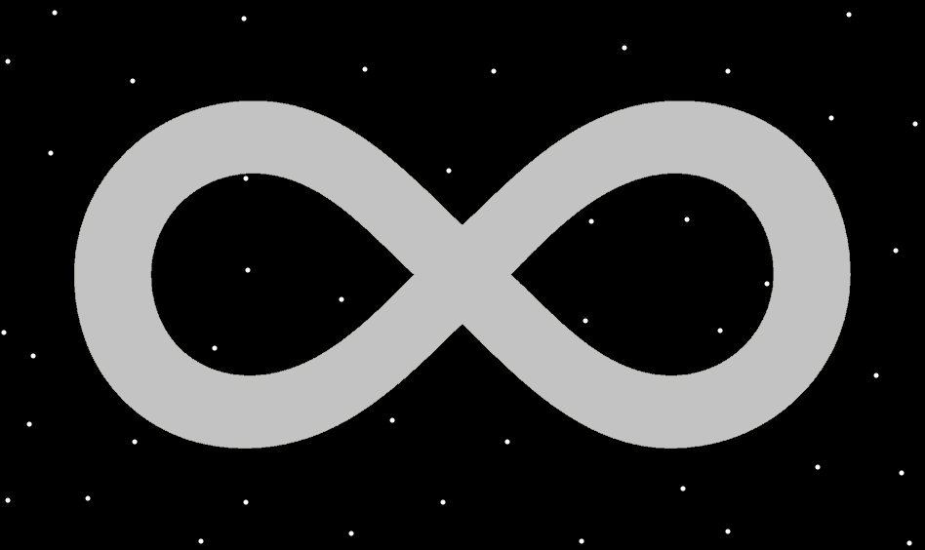

Principle: Understanding major/basic physics is Cosmic Knowledge. Thus it is Wizardry. Wizard Physics.

Principle: Mathematicians and Physicists would greatly benefit from reading PAAIL.org Wizardry.

Principle: The guess is that PAAIL.org Wizardry is 600 to 1000 pages. At most that is like 3 books. Reading 3 books doesn’t take that long.

Principle: All scholars and people would greatly benefit from reading PAAIL.org Wizardry.

Principle: When you are Level 3 at Wizardry and Expert at something else, the Wizardry can enhance the other skill.

Principle: “Our father who is in Heaven. Holy be his name. His kingdom come. His will be done. On Earth, as it is in Heaven. And give us this day our daily bread, and forgive our trespass’s as we forgive those who trespass against us.” – The Holy Bible.

X2 Principle: This is perhaps the most famous Biblical prayer. I think its known as the “lords prayer”.

X2 Principle: This is evidence of a person in Heaven who is “our father”.

X2 Principle: This is evidence there is a Heaven.

X2 Principle: This is evidence that Heaven is a kingdom.

X2 Principle: This is evidence that our “fathers” will is done in Heaven.

Principle: The evidence is out there!

X2 Principle: The evidence is out there! It can be found.

X2 Principle: The evidence is out there! Some evidence is unbelievable.

Principle: When you know all of this as well as the author, it becomes much more believable.

Principle: I am 100% certain that there are the 2 operations, the 4 operations, the 8 operations, the 16 operations and so forth.

Principle: Using a 0 to 100 percent System for certainty is a great System.

Principle: Sometimes in life we are only 90% certain.

Principle: Sometimes in life we are only 70% certain.

Principle: Sometimes in life we are only 50% certain.

Item Group: Understanding The Cosmos 3

Principle: Our lives are intense and monumental.

Principle: There are many Religions that worship the One God. PAAIL.org Religion is a 100% Religion.

Principle: Through Maps we see the Multiverse.

Principle: Read enough and you can get to Level 4.5 Wizard.

Principle: On some Maps. 0.1 equals Tiny. 1 equals Small. 10 equals Medium. 100 equals Large. 1000 equals Huge.

Principle: There are an Infinite Number of Maps to the Multiverse.

Principle: His Holiness Origin is 99 Cosmic Years old. When his Holiness is 1000 Cosmic Years old, he will be much more powerful.

Principle: There is some major math and physics to be found in PAAIL.org Scripture.

Principle: Why is all the physics Wizardry? Because it is Core Information of Reality. Its understanding things like the 4 Forces. Fire, Water, Earth, and Air. It is Cosmic Knowledge.

Principle: It turns out Reality is Made of Fire, Water, Earth and Air. Like the legends.

Principle: Understanding Fire is the Subtraction Force, Water is the Addition Force, Air is the Division Force, and Earth is the Multiplication Force is understanding Cosmic Knowledge.

Principle: Why is physics Wizardry Scripture? Because his Holiness Origin Makes things out of, and uses the powers, Fire, Water, Earth and Air.

X2 Principle: This is understanding a Detail about his Holiness Origin. In that way alone it Makes it Scripture.

Principle: All Humans have a Huge Chi and a Huge Chi Level.

Principle: The Chi Level is the final Level. A combination of all other Levels.

Principle: The Spiritual Side of a person’s Chi is the meaningful Part of a person’s Chi.

Principle: All humans have a monumental Chi.

Principle: Since his Holiness Origin is only 99 Cosmic Years, we are not much younger than him.

Principle: I can’t tell if for sure Chi and Karma should be said to be the same thing. Sometimes the Word Chi is best, and then sometimes the Word Karma is.

Principle: The theory is that Karma and Chi are the same thing. Both Words are Vocabulary Words of Wizardry.

Principle: Sometimes it’s best to use the Word Karma. Sometimes it’s best to use the Word Chi.

Principle: A person’s Spiritual Aura is always on. No matter what they are doing.

Principle: Most of the Time people gain Spiritual Score a little at a Time.

Principle: A person’s Spiritual Score is usually Made up of many small moments.

Principle: Often a person’s Spiritual Aura flows through their honest work.

Principle: It may be that all Actions have a Spiritual Side.

