
ObjectType: Article
ObjectNumber: 69
LocationName: PAAIL.org
LocationNumber:
Language: PAAIL 2.7

Maker: PAAIL.org
Model:
Name:
Rank:
SerialNumber:

Level: 5.1
Score:
Birth: 4-18-2024

Label: Room 69
Title: Aged Wizardry 32
Details: PAAIL.org Scripture….
Principle: Ultimate Scripture.
Agenda: Ultimate Scripture.
Action: Ultimate Scripture.
Information: Ultimate Scripture.
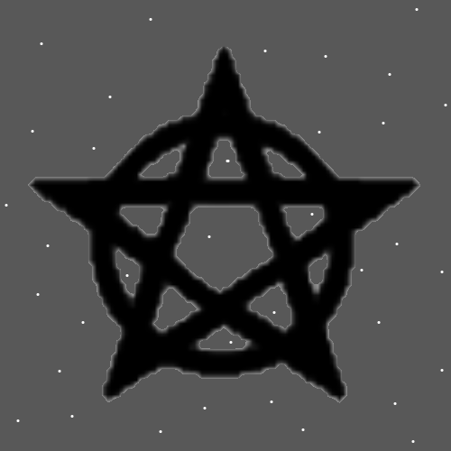
Item Group: Understanding The Cosmos 0
Principles 00: Most of the Time it’s a little Spiritual Score at a Time. Our Spiritual Aura outputs a little Spiritual Score each second.
X2 Information: Here be some Divination with the Word “Scripture”. The Key is the first Word with a “S” then the next Word that has a “C”. Then the next Word that has a “R” and so forth, until the last letter “E”.
X3 Information: Cosmos Principles. Spiritual Time. Spiritual Outputs. Spiritual. Score Each.
X3 Principle: The next Items were inspired by the Divination.
X3 Principle: Learning Cosmos Principles is Spiritual Time. It has a Spiritual output. Its Spiritual Score gained by each lesson.
X3 Principle: Learning chess is also Spiritual Time. It has a Spiritual output. Its Spiritual Score gained by each lesson.
Principles 01: It can also be said our Spiritual Level outputs a little Spiritual Score each second.
Principle: His Holiness Origin wants us to understand the Cosmos.
Principle: His Holiness Jesus was a Wizard.
Principle: In the afterlife all people will be turning into Expert Wizards within the first 6 months. Its one of the first Sciences children will learn.
Principle: His Holiness Origin wants people to know Reality. His Holiness wants people to understand things like it’s Made of Positive and Negative Energy.
Principle: Reality is Made of the Two Forces. Fire and Water. Negative and Positive.
Principle: Some Body Actions influence a person’s consciousness. They shape a person’s Mind.
Principle: Making Fists can shape the Mind. Lifting weights can shape the Mind. Walking/running can shape the Mind. Sometimes you can sense the Action shaping your Mind.
Principle: Sometimes you can sense a Spell shaping your Mind.
Principle: When you mix things together, they often enhance each other.
Principle: When you mix chess with military Science. The chess enhances the military Science and the military Science enhances the chess.
Principle: When you mix Wizardry with other things the Wizardry enhances the other things.

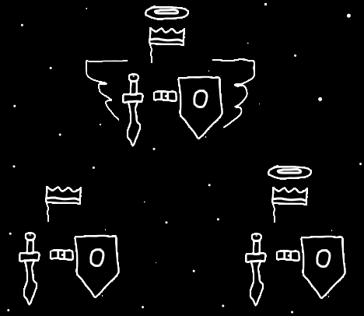
Principle: The latest realization is that the Wizardry writing has been reading tons of notes.
Principle: The notes have been research and development of Wizardry.
Principle: Understanding his Holiness Origin is understanding his Holiness has many Religions.
Principle: Its called “Aged Wizardry” because PAAIL Wizardry has had Time to “Age”. As stated in the past, Ageing things is a Part of Wizardry.
Principle: All things that exist are Energy and there is a Science for every Energy. All things have a Science.
Principle: Many things bombard the Mind. TV’s, music, audio, pictures, paintings, even candy wrappers bombard the Mind.
Principle: Social activity bombards the Mind.
Principle: The biggest of Mind bombardment comes from TV’s, phones, things with electric screens, like virtual reality goggles. Internet and videos are a huge bombardment.
Principle: Current technology, the many Charms, (and more) bombard our Minds all the Time. This increases Mind activity. It Makes people more Intelligent, however it can have Negative Sides too.
Principle: The biggest Flaw of Mind bombardment is that it can Make a person overconfident. Even for older more experienced people.
Principle: “…A flaw more and more common among Jedi these days. Too sure of themselves. Even the older, more experienced ones.” -Yoda from the movie “Star Wars”
X2 Principle: I tried to remember the line. I may have gotten it slightly wrong.
Principle: There is a song Titled “Rebel Music” by Bob Marley. One of its Auras is the “music about music Aura”. It’s a song about “rebel songs”, such as heavy metal music and so forth.
Principle: Level 0 to Expert Wizard can happen in a blink of an eye. Very, very fast.
Principle: Level 0 to Level 3 Wizard can happen in a blink of an eye. Very, very fast.
Principle: Actions sometimes Enchant a person. Spells sometimes Enchant a person. Music can Enchant a person.
Principle: Its been the End of an Age apocalypse since at least World War II.
Principle: All the music is Beginning of Time music. Elemental music. It all has a huge Chi.
Principle: Wizardry was always a real Science. Few people knew much. In past history people have known about the 4 Forces. The 4 Elements.
Principle: These days Scientists understand the 4 Forces/4 Elements more than ever before.
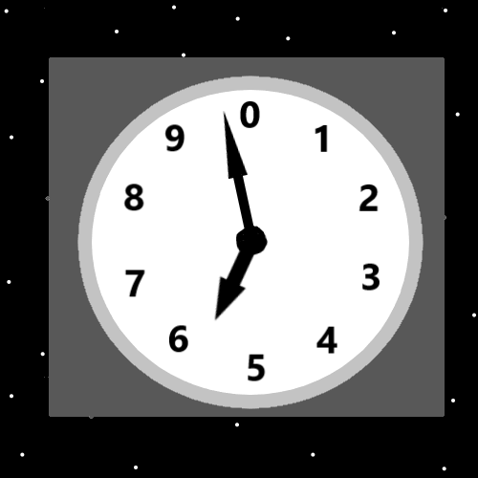
Principle: The technology Charms of present Times are likely the most powerful Charms ever Made.
Principle: Humans Wield the 4 Forces more than ever before.
Principle: If the Divination goes wrong, you can do many things. More Time is always a big Spell Part. Also, you can alter the Key or change to a whole different Key.
Principle: Divination is listening to a radio channel. And of course the Key is the channel Number.
Principle: Some Keys are better than others. Also you want to pick the right tools for Divination. If you want to do Divination about chess, you might want to use a chess book.
X2 Principle: This Item is not 100% right. Using a chess book would be Part of the Key.
X2 Principle: Divination Science.
Principle: If you want to do Divination on physics, it might work well to use a physics book. One Word that might work well is “physics”. Great Words may be Words only physics Experts really know.
Principle: Doing Divination may stimulate the Mind. It likely has Enchantments beyond just good inspiration.
Principle: Divination is on the Mind lately. I have been thinking about doing some. For more Scripture writing.
X2 Principle: Right away Making a Key with the Word “Scripture” sounds right.
Principle: When you toss coins onto a surface to do Divination…. too few coins does not work well and too many coins does not work well either.
Principle: There is the ancient parable/metaphor/analogy of being “asleep” or “awake”. Good people are mostly “awake” and the other people mostly “asleep”.
Principle: Music can Enchant people.
Principle: I went and used the Word “Scripture” and did some Divination at the Beginning of this article. It worked out very well. I wrote Principles inspired by it.
Principle: Saying “its about the journey, not the destination” is demanding of others. Its demanding they say, “it’s about the journey, not the destination”. The truth is that sometimes it’s about the destination.
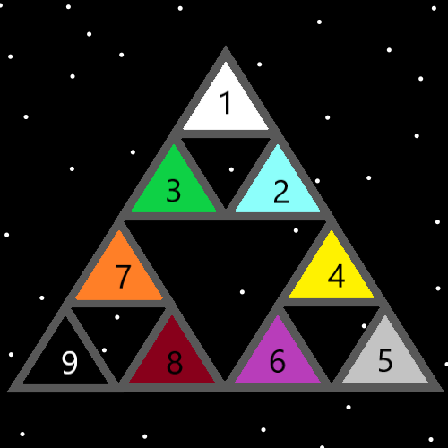
Item Group: Some Enchanting Music 1
Information: Title “Looking Glass” by Northcore
Information: Title “Sleeping Woman” by Luis Perez
Information: Title “Valley In The Clouds” by David Arkenstone.
Information: Title “Washingtons Men / Indy’s Home” by John Williams.
Information: Title “I. Montagues and Capulets” from Prokofiev: Romeo and Juliet Suites Nos 1 and 2 - Pushkin….
Information: Title “Spock” by James Horner.
Information: Title “A Curious Happening” by Hiroki Kikuta from “The Secret of Mana Soundtrack”.
Information: Title “TVA” by Natalie Holt.
Information: Title “Catch Up” by Natalie Holt.
Information: Title “Introduction and Main Title (From “Mars Attacks”)” by artist-Unknown-Sorry.
Information: Title “Tannot Grooves” by Subvision.
Information: Title “Into The Thick of It” by Hiroki Kikuta.
Information: Title “Dancing Animals” by Hiroki Kikuta.
Information: Title “Distant Thunder” by Hiroki Kikuta.
Information: Title “It Happened Late One Evening” by Hiroki Kikuta.
Information: Title “The Wind Never Ceases” by Hiroki Kikuta.
Information: Title “Prophecy” by Hiroki Kikuta.
Information: Title “Whisper and Mantra” by Hiroki Kikuta.

