ObjectType: Article  
ObjectNumber: 70

LocationName: PAAIL.org

LocationNumber:

Language: PAAIL 2.7

Maker: PAAIL.org  
Model:   
  
Name:

Rank:

SerialNumber:

Level: 5.1

Score:   
Birth: 4-28-2024

Label: Room 70

Title: Aged Wizardry 33

Details: PAAIL.org Scripture….

Principle: Ultimate Scripture.

Agenda: Ultimate Scripture.

Action: Ultimate Scripture.

Information: Ultimate Scripture.

Item Group: Understanding The Cosmos 0

**Principles** 00: Since the legend of Fire, Water, Earth and Air is true, then many other legends are true.

**Principles** 01: The latest PAAIL is to think that perhaps “Principles” could be a Type of Item. Instead of just Principle. Some Items should be “Principle” Items. Some Items should be “Principles” Items.

Principle: The first book of the Holy Bible is Titled “Genesis”. Genesis translates as “Beginning”/”Beginnings”. The first book of the Holy Bible is Titled “Beginning”.

Principle: Reality is a endless series of books. The first book is Titled Genesis. 0 to 100 Cosmic Years.

Principle: 100 to 200 Cosmic Years is Titled Exodus. The 2nd book of the Holy Bible is also Titled Exodus.

Principle: Exodus translates as “journey”.

Principle: Why throughout art do you find angels with wings? Because they float around in Heaven.

Principle: Why throughout art do you find angels with halos? It is the Symbol of God, stamped on their heads.

Principle: It seems I remember the Bible saying that there will be a Time when the Stars will fall from the sky. This Time has come. The Stars have fallen from the sky. Its called “light pollution”. It Makes it so you can’t see the Stars at night. This happens in large cities.

Principle: Again, I want to say that jumping is likely an ultimate Exercise. An ultimate Spell. Jump ropes may be ultimate tools.

Principle: The greatest of Energies is Consciousness. Even greater than his Holiness our God. Without Consciousness there would be no God.

Principle: The 2nd greatest Energy is his Holiness our God.

Principle: Conscious beings are the greatest Energies of Reality.

**Principles**: Sometimes Energy cannot be gained or destroyed, only transferred. In the case of the Darkness, his Holiness Twilight Made Earth so that he could transfer the Darkness from Heaven to Earth. That is why his Holiness Made Earth.

Principle: One of the biggest Spell Parts is Time. Doing a large Time amount on a Spell is going to be a more powerful Spell.

Principle: “Warm up” Spells are powerful Spells.

Principle: Meditation is a powerful Spell.

Principle: Body Exercise is a powerful Spell.

Principle: Breathing Exercise is a powerful Spell.

Principle: Reading PAAIL.org Scripture is a powerful Spell.

Principle: Say you have to read all 1000 pages to become a Doctor of Wizardry. 1000 pages to become a doctor is not very many pages.

Principle: The Wizardry Doctorate is very easy to gain, compared to other Doctorates.

Principles: I went to the store. “to” is a category 2 Word. I went 2 the store. 2 in Numerology is Growth. I went growth the store. I went to the store to buy bananas. I went growth the store growth buy bananas. It always works using the Word Growth. Growth is One of the Basic ingredients of the Multiverse. Growth is a Vocabulary Word of Wizardry. One use of it is in Numerology.

Principle: +1 is Energy. +2 is Growth. +3 is Law. +4 is Solid. +5 is Balance. +6 is Change. +7 is Solution. +8 is Infinity. +9 is End.

Principle: +1 is Beginning. +2 is Growth. +3 is Law. +4 is Solid. +5 is Balance. +6 is Change. +7 is Solution. +8 is Infinity. +9 is Off.

Principle: For sure there is the ultimate 10 Energy Words 0 to 9. I bet Growth is one of them. Maybe Law is as well.

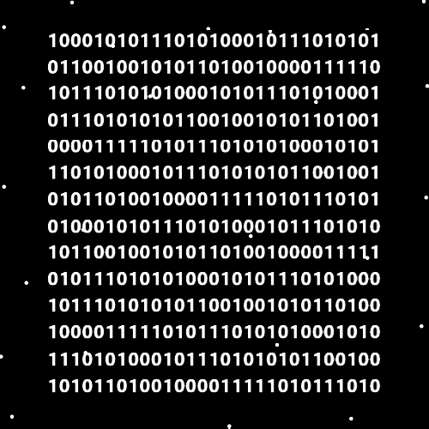

Item Group: Understanding The Cosmos 1

Principle: A human Age is 1000 human years.

Principle: The End of every Age is a Time of apocalypse. The last book of the Bible, Titled “Revelation”, is about those Times.

Principle: The Beginning of each Age has a Connection to the first book of the Bible, Titled “Genesis”.

Principle: There are viruses of Reality. His Holiness Twilight Made Earth as a Part of fighting Reality viruses.

Principle: Wizardry is learning the final truth of it all.

Principle: All good people slay a dragon for his Holiness Twilight.

Principle: Slaying a dragon is a huge thing.

Principle: Each good human slays One dragon, and only one dragon. Angels slay multiple dragons.

Principle: Everyone should Devote themselves to unlocking the Enchantment Expert Wizard. Even if you choose a Path that takes 4 years or more.

Principle: This mostly has not been a book or books. This has been Wizardry being researched and developed and the researcher writing out the notes of the research and development.

Principle: There was a ton of new Wizardry Science developed over the last 3 years.

Principle: If you want a Spell bigger than Smith Summons 10… the first trick might be to add a Spell Part that increases the difficulty of the Spell.

Principle: We really have reached a huge milestone in Wizardry. The Doctorate Level finished off.

Principle: Like in martial arts training a person can continue to train Wizardry for years and years. Growing Enchantments more and more.

Principle: When you have been a Expert Wizard for multiple years it likely has a huge impact on you.

Principle: The difference between a normal person and a Wizard is that the Wizard is a more paranormal creature. Even a Green Wizard.

Principle: There is the famous phrase “turning Blue”. This likely has a Connection to Blue Wizards.

Principle: There is the famous term “Green” like a person is a Green Wizard. Meaning un-experienced Wizard.

Principle: In Spanish the Word “Dose” means “Two”. In English the Word “Dose” means “a dose of something”. The Word Dose is a category “2” Word. There are secrets to be seen when you mix multiple languages together.

Principle: PAAIL.org discipline is less demanding that many others. It demands reading over the next 10 years, a little here and there. The demand is getting to Level 4, Expert Wizard.

Principle: Expert Wizard is easy to achieve and takes very little Time. These are Two main reasons why everyone should achieve it.