ObjectType: Article  
ObjectNumber: 71

LocationName: PAAIL.org

LocationNumber:

Language: PAAIL 2.7

Maker: PAAIL.org  
Model:   
  
Name:

Rank:

SerialNumber:

Level: 5.1

Score:   
Birth: 5-5-2024

Label: Room 71

Title: Aged Wizardry 34

Details: PAAIL.org Scripture….

Principle: Ultimate Scripture.

Agenda: Ultimate Scripture.

Action: Ultimate Scripture.

Information: Ultimate Scripture.

Item Group: Understanding The Multiverse 0

Principle: Knowing the final truth of it all is Enlightenment.

X2 Principle: Level 3 Wizard is Enlightenment.

Principle: If you write a person’s Story, you Make a Map of their lives.

Principle: Another Word for Multiverse is Reality.

Principle: What is Reality? All that is real.

Principle: Martin Luther King Jr. only ever slayed One dragon. He accomplished no more than any other good person.

Principle: Sometimes a Principle is accurate enough.

Principle: In life there is the right Balance of Recharge and Drain.

Principle: The biggest Symbol of them all is the Dot Symbol.

Principle: The following is Partly PAAIL Science.

X1 Principle: Believing in a Principle is an Action.

X1 Principle: Believing in an Agenda is an Action.

X1 Principle: Believing in any Information is an Action.

X1 Principles: Actions are a huge thing. The Word “Action” is the biggest PAAIL Vocabulary Word.

Principle: The Zero Moment can be described as Two Particles slamming into each other. Like in a Particle accerator. It may be that they are slamming into each other at an Infinite speed.

Principles: The Laws of physics can change. At the Zero moment it may be that Zero plus Zero equals 1.

0 + 0 = 1

Now the Laws of physics may be that Zero plus Zero equals Zero.

0 + 0 = 0

Principle: Its also possible at the Zero moment Zero plus Zero equals Four.

0 + 0 = 4

Principle: Zero Times Infinity may equal One. Or did equal 1.

0 \* Infinity = 1

Principle: Zero is the Number of an Energy Bit. One of the Three Energy Bits.

Principle: Like the other Two Energy Bits, the theory is that the Twilight Energy Bit is Infinitely Small.

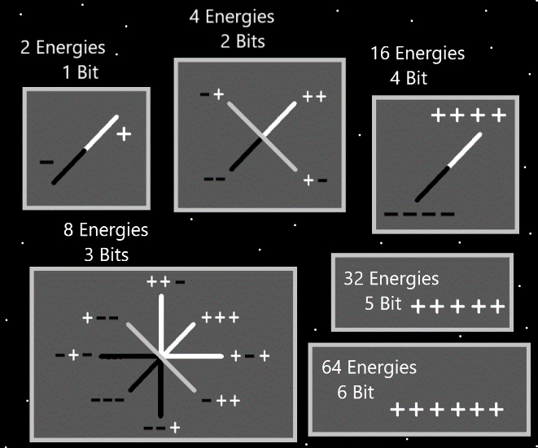

Principle: Math is Infinite. There is always a bigger Number and for each Number there is another operation. Like the operations Addition, and Subtraction. +1 and -1.

Principle: There are an Infinite amount of operations.

Principles: Everyone “owns” an Infinite amount of Numbers. Jesus’s are 1.0 to 1.999 (repeating 9’s).

Principle: Infinity has got to be Numerology category Eight. The Word Infinity is a 8 Word.

Principle: Note the Infinity Symbol is a 8 Symbol turned. This is called a “Sign”. It’s a Sign that Infinity and Eight have a Connection.

Principle: Signs are a major Part of Reality. Evidence is a Sign.

Principle: PAAIL.org Wizardry is the final truth of it all.

Principle: Its easy to see the Number 7 is a Elemental Number. 7,000,000,000,000 though is also a Elemental Number.

Item Group: Understanding The Multiverse 1

Principle: A person can find tips and tricks from books and the internet. A tips and tricks Item is a collection of Spells. A Wizard would call it a Spell book or Spell Tome.

Principle: Since Actions are the biggest Part of PAAIL…. Spells are one of the biggest Parts of Wizardry.

Principle: The biggest Part of Wizardry is the “Cosmic Knowledge”. The major secrets revealed. This knowledge is Enlightenment for a person.

Principle: In life Actions are a major thing. In life Spells are a major thing.

Principle: One way to Make ultimate training Spells may be to increase the difficulty on the Spell. Add a Spell Part that Makes it harder.

X2 Principle: Memorizing a 2-punch combination is Infinitely easier than a 10-punch combination.

Principle: One way to Make ultimate training Actions may be to increase the difficulty on the Actions. Add a Part that Makes it harder.

Principle: There are lots of ways to increase the difficulty of Spells.

Principle: Increasing the difficulty of a Spell can increase the power of the Spell.

Principle: The best martial arts strike to begin with is the “palm strike”. Though it is a bad strike and mostly to be used in training, it is also doing Hand Symbol Sorcery, where you Make the Dot Symbol.

X2 Principle: Since palm strike is a simple strike, that too adds to its early training value.

Principle: We live in a technology apocalypse. People have sensed the Dark Side of the technology.

Principle: Eventually humans adapt to each technology. Then that technology stops being as Dark a Force.

Principle: It may be fair to say new technology has a huge Negative Side Aura. Using new technology can be dangerous and Negative. Using new technology can come with a sacrifice.

Principle: It may be fair to say PAAIL.org Wizardry is new technology.

Principle: Wizardry is ultimate technology.

Principle: In the Bible, his Holiness Twilight commands humans to go forth and Make all the plants and animals “foot stools” of the humans. Something like a command to conquer and tame the world.

Principle: Right now, there is a huge temporary separation between his Holiness Twilight and humans. This is Partly why there are so many different Religions worshiping the same God.

Item Group: Understanding The Multiverse 2

Principle: A person can do Variations on Smith Summons Spells. Such as doing Smith Summons 3 and add the Spell Part Force a Vision of Symbols, or Words.

Principle: A person’s Spiritual Aura is always on. When asleep or awake. When working or watching a movie and eating popcorn.