ObjectType: Article  
ObjectNumber: 72

LocationName: PAAIL.org

LocationNumber:

Language: PAAIL 2.7

Maker: PAAIL.org  
Model:   
  
Name:

Rank:

SerialNumber:

Level: 5.1

Score:   
Birth: 5-25-2024

Label: Room 72

Title: Aged Wizardry 35

Details: PAAIL.org Scripture….

Principle: Ultimate Scripture.

Agenda: Ultimate Scripture.

Action: Ultimate Scripture.

Information: Ultimate Scripture.

Item Group: Understanding The Multiverse 0

Principle: It turns out that the Religions of the world didn’t get everything right all the Time.

Principle: Some Religious beliefs are incorrect.

Principle: For this Wizard all philosophy is also theology.

Principle: “Training Spells/Actions” are Spells/Actions only for training.

Principle: I think if someone does years of training they can get to Level 7 Wizard. Get to Doctor of Wizardry and then do 5 more years of “Training Spells” maybe. Time would depend on how much training you do.

Principle: One of his Holiness Jesus’s Names is Energy.

Principle: The shadow of his Holiness Jesus is Named Darkness.

Principle: On some Maps the shadow of His Holiness Jesus is Named Negative.

Principle: Being Level 4 at chess is “having a Level 4 chess View”. “View” is a major Vocabulary Word of PAAIL and Wizardry.

Principle: We all have a Positive Number and we all have a Negative Number.

Principle: Every Number has a person. There is a person for every Number.

Principle: Because the author is not an Expert at Teaching/Education there may be many errors in Principles about the Teaching/Education Part of PAAIL Wizardry.

Principle: Since thinking a Keyword is a huge Spell Part, probably picturing the Keyword in your Mind is a huge Spell Part. Force a Vision of it in Letters.

Principle: Reality is 100% a computer program without the computer. Reality is a program. The Reality of Energy Bits Makes it this way.

Principles: Some Particles are found in nature. Other Particles have to be artificially created.

Principle: There is a Number for every Word, and a Particle for every Number. Thus, there is a Particle for every Word.

Principle: There are chess Particles. There are football Particles. They are physical Particles, like protons, neutrons and electrons.

Principle: There are Body Particles, Mind Particles and Spirit Particles.

Principle: Most of the Time if you do enough Body Exercise you become soaked in Body Particles.

Principle: In Wizardry Particles are also known as Charms.

Principle: Most of the Time if you do enough Body Spells you become soaked in Body Charms.

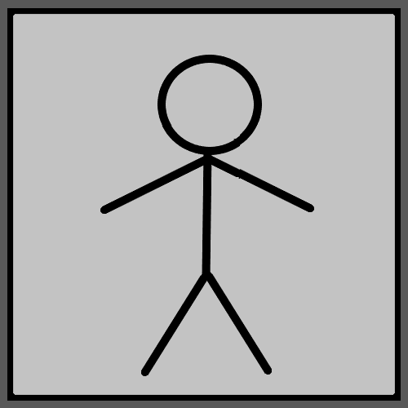

Principle: Play chess and you Grow an Aura of Chess Charms.

Principle: When a person does Meditation Exercise, they build up an Aura of Meditation Particles.

Principle: There is physical Particle for every Word.

Principle: Everything people do with their hands has a Sorcery to it. It is the same with all Body movements.

Principle: His Holiness Origin lives at the center of Reality.

Principle: Another Name for his Holiness Origin is Orb.

Principle: All the little coins, trinkets and other Charms are major artifacts of Reality. This is Partly because they are from the Beginning of Time.

Principle: In the afterlife everyone is 100 trillion dollars rich. No one is ever going to sell any antiques they own. The coins and trinkets Made before the afterlife will be priceless.

X2 Principle: This is more understand the Charms around us. Perhaps it’s fair to call this Alchemy. Perhaps it’s right to call Charm Science, Alchemy.

Principle: Energy Bits are also known as Light Particles, Darkness Particles, and Twilight Particles. Positive Energy Bits are Light Particles, Negative Energy Bits are Darkness Particles, and the Neutral Energy Bits were Twilight Particles.

Principle: There are many “Big Bang Events” that happen. Each person on Earth is a Big Bang Event. As said in the past, all humans are a huge disturbance in the Force.

Principle: The visit of his Holiness Jesus was a huge, big bang event.

Principle: Body Exercise, Breathing Exercise and Meditation Exercise is lots of Sorcery Levels. They are ultimate Sorcery.

Principle: Like everyone else, this author be desensitized to many things. It is the fate of us all.

Principle: One physical Law of the Zero Moment is that its Two Particles slamming into each other.

Principle: All Words are Positive, Negative, or Neutral Words.

Principle: All Words are Bend In, Bend Out, or Flat.

Principle: All Words come from 1 of the 4 Elements, Fire, Water, Earth and Air.

Principle: All Words come from 1 of the 10 Numbers. 0 to 9.

Principle: All Words come from 1 of the 8 Elements.

Principle: All Words come from 1 of the 16 Elements.

Principle: All Words come from 1 of the 1000 Numbers. 0 to 999.

Principle: For all Words there is a physical Particle.

