ObjectType: Article  
ObjectNumber: 73

LocationName: PAAIL.org

LocationNumber:

Language: PAAIL 2.8

Maker: PAAIL.org  
Model:   
  
Name:

Rank:

SerialNumber:

Level: 5.1

Score:   
Birth: 6-16-2024

Label: Room 73

Title: Aged Wizardry 36

Details: PAAIL.org Scripture….

Principle: Ultimate Scripture….

Agenda: Ultimate Scripture….

Action: Ultimate Scripture….

Information: Ultimate Scripture….

Item Group: Understanding The Multiverse 0

Principles: The big picture is the Positive picture. The big View is the Positive View. The small picture is the Negative picture. The small picture is the Negative View.

Principles: One ultimate Spell Part is to increase the difficulty of the Exercise. Instead of lifting a 2 pound weight, lift a 3 pound weight.

Principles: One ultimate Spell Part is to increase the difficulty of the Spell. This has been stated before. It is a important training Principle.

Principles: Spells Summon Particles. Spells Summon Charms.

Principles: There is a Physical Particle for every Word. There is a Charm for every Word.

Principles: There is such thing as the “chess Particle”. A very real physical Particle. Also known as a “chess Charm”.

Principles: Every person who has played chess has a “chess Aura”. Their chess Aura is Made of chess Charms.

Principles: Hydrogen is not Made of protons, neutrons and electrons. It is Made of protons and neutrons. Electrons are like Moons around a Planet. They are separate from the Planet.

Principles: Zoom out and things are peaceful. Zoom in and everything is crashing into each other.

Principles: It may be fair to say that you can have Hydrogen with just One proton. No neutron.

Principles: People do a ton of Hand Sorcery when they use their touch screens, tablets and phones. We live in a very paranormal/super-natural Time. People Grow Sorcery Levels while using their phones.

Principles: From the 1 Force(Twilight) comes the 2 Forces(Light and Darkness). From the 2 Forces comes the 4 Forces(Addition, Subtraction, Multiplication, Division. From the 4 Forces comes the 8 Forces. From the 8 Forces comes the 16 Forces. From the 16 Forces comes the 32 Forces. From the 32 Forces comes the 64 Forces. This pattern is Infinite.

Principles: It may be that “dividing a Number by 2 and then adding 1” is a Operation.

Principles: It may be that “adding 53.44 to a Number” is a Operation.

Principles: It may be doing Body Exercise is a Operation.

Item Group: Understanding The Multiverse 1

Principles: The latest theory is that if you Zoom in on a Pole you have a Axis. It may be that with Energy Bits this is not true.

Principles: It may be that if you Zoom in on a Positive Energy Bit that it is Made of Two Positive Energy Bits. And they too are Made of Two Positive Energy Bits if you Zoom in on them.

Principles: The main opposite of Large Light is Large Darkness. Small Light is also a opposite of Large Light in some ways.

Principles: +1 is a Pole. If we Zoom in on +1, we have a new Axis. Small Light and Large Light are the Two Poles of the new Axis.

Principles: Gravity is likely both 1 of the 4 Forces and 1 of the 4 Axis’s.

Principles: Of the Four Forces, gravity, electromagnetism, strong-nuclear and weak-nuclear…. Two of them are the ultimate 2 Forces. The other Two Forces come from the ultimate 2.

Principles: These Principles have become super clear recently.

Principles: Physicists speak of the 4 Forces this and the 4 Forces that. They should speak of the 2 Forces this and the 2 Forces that. The 4 Forces come from the 2 Forces.

Principles: One of the 4 Forces may be the “1 Axis”. That Makes that Force the ultimate Force of them all. It would mean that One of the 4 Forces is a ultimate Force.

Principles: It may be that all Poles are also an Axis. This may not be true of Energy Bits.

Principles: Energy Bits may follow different rules.

Principles: The theory that A / 10 = A\*10 is a theory. It may be that Energy Bits can Divide and become more Energy Bits. It always equals an Infinitely Small amount of Energy. 137/A = Infinity. A = Infinitely Small amount of Energy. A\*10 = Infinitely Small amount of Energy. A \*137 = A. A/137 = A

Principles: Another possibility is that a Positive Energy Bit can be Zoomed in on and you find Two Positive Energy Bits. Then they can be Zoomed in on and you find Two more Energy Bits for each of them. The pattern would be an Infinite One.

Principles: The 1 Axis is the ultimate Force. It may be gravity, electromagnetism, strong-nuclear or weak-nuclear. It may be that the other 3 Forces come from that 1 ultimate Force.

Principles: One Name of the 1 Axis is the "Energy Axis". In Numerology +1 means Positive Energy, while -1 means Negative Energy.

Principles: In Numerology +2 means Growth and -2 decay. One Name for the 2 Axis is the Growth Axis.

Principles: Of the 4 Forces, Fire, Water, Earth and Air. One may be the ultimate Force that the other 3 are Made of. It might be Fire or Water. I lean toward Water. In math the absolute value of -1 is +1. This may have something to do with it.

Principles: One of the 4 Forces may also be known as the Energy Force. It does sound Positive. "Energy Force". It could be gravity, electromagnetism, strong-nuclear, weak-nuclear. If it were gravity, then it may be all things are Made of Positive and Negative gravity.

Principles: The 4 Forces may also be known as the 4 Axis’s.

Principles: It may be that the Multiverse is Made of the Two Waters. The Dark Water and the Light Water.

Principles: “It will do magic. Believe it or not. Bibbity, bobbity, boo.”-Disney Cartoon

Principles: Self-improvement is One way of Worshipping his Holiness Orb.

Principles: All things come from the 1 Axis. The 1 Axis is the +1 Pole and the -1 Pole. The 1 Axis is the Energy Axis, the 1 Axis is the Water Axis. All Energies are either Positive Water, or Negative Water. Negative Water is the Fire Force.

Principle: All Spells are either a Positive Water Spell or a Negative Water Spell.

Principle: All Spells are also either a Water Spell or Fire Spell.

Principle: Also all Spells are either a Water Spell, a Fire Spell, a Earth Spell or a Air Spell.

Principle: All Spells are either a 0, a 1, a 2, a 3, a 4, a 5, a 6, a 7, a 8 or a 9 Spell.

Principle: All Spells sort into 0 to 999. The 1000 core Numbers.

Principles: All Numbers have a Operation. A Operation is also a Spell. All Numbers have a Spell.

Principles: More awesome knowledge gained is a bunch of Numerology, Colorology, and Symbology. Sorcery, Spells, Alchemy, Enchanting, and Charms are covered. The definition of Wizardry is "Paranormal, Supernatural and Mystical Science." Paranormal, Supernatural and Mystical knowledge.

Principles: Likely there is Positive and Negative gravity. Though One may never be found in nature. The Story is the same for the electromagnetism, strong-nuclear and weak-nuclear Forces.

Principles: Likely all Poles can Divide, and gravity is both a Pole and an Axis. Thus, ending up with Positive and Negative gravity.

Principles: Likely Positive gravity is a Pole and can Divide into Two Poles.

Principles: It may be fair to call Dream Interpretation Divination.

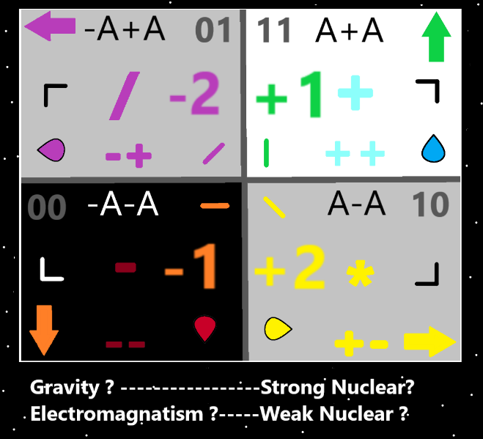

Item Group: Understanding The Multiverse 2

Principles: The latest theory is that all Poles are an Axis Made of Two Poles. You Zoom in on a Pole and get a Axis, always Made of Two Poles.

Principles: The latest theory is that all Poles are also a Pole Group. Made of Two Poles.

Principles: All things are a Pole. All things are a Axis. All things are a Pole Group. All things are Made of Two Poles. Energy Bits may follow different Laws.

Principles: These things have only become super clear recently.

Principles: These things are new and not totally understood. The Body of his Holiness Loop is Made of 4 Axis’s. It is a group of Axis’s and therefore an Axis Group. How do Axis Groups come into the picture? It is the unknown.

Principles: Because of the Divide pattern, 2, 4, 8, 16, 32,64, 128 and so forth. It seems all Poles can Divide an Infinite Number of Times. Poles Divide forever as the Multiverse evolves.

Principles: Often life is theories. Not all theories End up correct.

Principles: Time is a Pole. The Zero Moment was before Positive Time and Negative Time.

Principles: Height, width, depth and Time. One is the Water dimension, One is the Fire dimension, One is the Earth dimension, One is the Air dimension.

Principles: There is the Up, Up quadrant, the Down, Down quadrant, the Down, Up quadrant and the Up, Down quadrant.

Principles: The latest theory is that Axis Groups are Poles. A proton is a Axis Group and a Pole. It has an opposite, the anti-matter proton, or some other opposite Particle.

Principles: A Star Body is a Axis Group and a Pole. The God Body is an Axis Group and a Pole. The Universe around God may be the opposite of the God Body.

Principles: Reality is in some ways simple. Theres his Holiness Origin, the empty Universe around him, this Universe orbiting him, a bunch of Stars and Galaxies, and then finally Planet Earth. No other mention worthy Planets or anything else.

