ObjectType: Article  
ObjectNumber: 74

LocationName: PAAIL.org

LocationNumber:

Language: PAAIL 2.8

Maker: PAAIL.org  
Model:   
  
Name:

Rank:

SerialNumber:

Level: 5.1

Score:   
Birth: 7-1-2024

Label: Room 74

Title: Aged Wizardry 37

Details: PAAIL.org Scripture….

Principle: Ultimate Scripture….

Agenda: Ultimate Scripture….

Action: Ultimate Scripture….

Information: Ultimate Scripture….

Item Group: Understanding The Multiverse 0

Principles: One ultimate thing is “Self-Improvement”.

Principles: Sense yourself through music. Hear the Story of your life in the music.

Principles: Sense the Multiverse through music. Hear the Story of the Multiverse in the music.

Principles: His Holiness Origin is our true grandfather.

Principles: Our lives are Scripture to our grandfather his Holiness Origin. His Holiness knows all our Stories.

Principles: His Holiness Jesus is our true father.

Principles: Our lives are Scripture to our father his Holiness Jesus. His Holiness knows all our Stories.

Principles: Our lives are Scripture to the One true family. The Angels of Heaven. They know all our Stories.

Principles: Some of these things have been gone over before. However, they are worth reading again, and are written in better Detail these days.

Principles: And we all live happily ever after. The End.

Principles: Training can be all about Level gain per minute.

Principles: Before there was Positive and Negative Time, there was Neutral Time.

Principles: Time is likely a Loop. Height, width, and depth are likely Loops.

Principles: His Holiness Origins Universe is likely round, and not Infinite in size. It’s a bubble with nothing beyond the walls.

Principles: The theory is that all Axis’s have exactly Two Poles. One Positive and One Negative.

Principles: Sometimes the author is not sure if something has been covered.

Principles: The theory is that an Axis Group is also a Pole. A proton is an Axis Group and a Pole. There is an opposite to a proton. Perhaps an anti-matter Particle is its opposite.

Principles: The Beginning of Time (now) has a huge Twilight Aura. This is because it’s so close to the Zero Moment/Twilight Moment.

Principles: The Beginning of Time is in many ways a Twilight Zone. Physics can be backwards. You would think there would be no life until far down the road. Nope. Cosmic Year Zero is when his Holiness Origin was Born. You would think the Number 10,000 is bigger than Zero. Nope. In a lot of ways Zero is a bigger Number than 10,000.

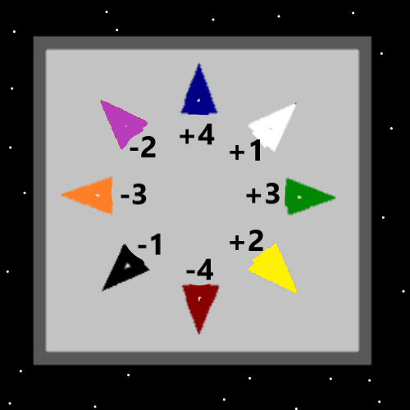

Principles: Resurrection Day, when we spend 30,000 human years with family and friends, can be described by saying we become all powerful, the Angels our servants, we command the Heavens.

Principles: The 1 Axis is likely on some Maps the “Light Axis”. There is Positive and Negative Light.

Principles: Why photons are called “Light”, I do not know. I would think a Wizard who is also a Expert is physics might be able to see the secrets of the matter.

Principles: It may be that “Darkness” is also known as “Negative Light”.

Principles: Why are we here? -Because his Holiness Origin, sent you here.

Principles: Why did his Holiness Origin send me here? -Because he had to send somebody.

Principles: His Holiness Origin drew on the well of souls and sent them unto this Planet.

Principles: Most humans are not from Heaven. Their first life is this One on Planet Earth now.

Principles: It is likely that all of us and this Universe are Made from the Body of his Holiness Origin and all Bodies in this Universe are Made from his Holiness Light.

Principles: The latest theory is that there are “1 dimensional Numbers” and “2 dimensional Numbers”. Also 3 and 4 and 5 and 6, on and on for Infinity.

Principles: 53 or 3 or 172, would be 1 dimensional Numbers. On a 2D grid, it looks as though Two Numbers represent the Location/Object.

Principles: It seems there may be single dimensional Numbers, like a Number line, and Multi-dimensional Numbers like on a 2D grid.

Principles: His Holiness Origin would own all Multi-dimensional Numbers that start with Zero.

Principles: His Holiness Light would own all Multi-dimensional Numbers that start with 1.

Principles: His Holiness 53 would own all Multi-dimensional Numbers that start with 53.

Principles: We all have a main 1-dimensional Number. Owned only by one person.

Item Group: Understanding The Multiverse 1

Principles: “Location” is a major Vocabulary Word of PAAIL.

Principles: It may go that the Zero Moment is known as the “Zero Object”. The empty Universe after the Zero Moment is the “One Object”, and the God Body is known as the “Two Object”. The God Body would be the Growth Object then. The God Body would be the “expansion Object”.

Principles: The Third Object may be Heaven, and the Fourth Object the Body of his Holiness Light.

Principles: The newest Vocabulary Word is “Incantations”.

Principles: One definition of the Word “Incantations” is: a series of Words said as a Part of a magic Spell.

Principles: Examples of ultimate Incantation mechanics exist, however are hard to find. One is from the movie “Dune”. At One point a person says something like….” It is by will alone I set my Mind in motion. It is by the juice of saphroo, the thoughts acquire speed. The lips become stained. The stains become a warning. It is by will alone I set my Mind in motion”. They also add the Spell Part Repeat, say it over and over.

Principles: Another good example of Incantation is the character “Rocky” in One of the Creed movies saying things to the main star character, just before a fight, as a Part of warmups.

Principles: