ObjectName: Room ObjectNumber: 10

Maker: Tome Of The Yellow Wizard

Model: 0

Name: Sorcery 0

Rank: 0

SerialNumber: 0

Level: 0

Score: 0

Birth: 6-9-2021

Label: Room 9

Title: Sorcery 0

Details: Sorcery…

Principle: Sorcery Basics.

Agenda: Sorcery Basics.

Action: Sorcery Basics.

Information: Sorcery Basics.

Room 10: Sorcery

Sorcery…

Principle 20.2; Sorcery

Sorcery is special items, hand gestures/body movements, words spoken, words thought, words written down, and rituals.

Principle 20.3; Sorcery

Sorcery is items, gestures, words, and rituals.

Principle 20.4; Sorcery

There is also the sixth sense in sorcery. A third eye. The eye of the mind.

Principle 20.5; Sorcery

Everyone has the sixth sense, some people bigger than others.

Principle 20.6; Sorcery

These days with the higher minds, you have lots of people that have it already rather increased.

Principle 20.7; Sorcery

The ultimate exercises to develope your sixth sense are, Body Exercise, Breathing Exercise, and Meditation. Body exercise is most important, breathing second most important and meditation 3rd.

Principle 20.7; Sorcery

The mixture is something like 10 parts, 5 parts body exercise, 3 parts breathing exercise, and 2 parts meditation exercises.

Principle 20.8; Sorcery

Doing 20 hours a week of the three exercises, for 2 years, will in most cases develope the sixth sense a supreme amount.

Principle 20.9; Sorcery

Once developed, the sixth sense grows like a muscle. As years go on, it will increase all on its own.

Principle 21.0; Sorcery

As a sense, it can be in off mode, but typically its just always on.

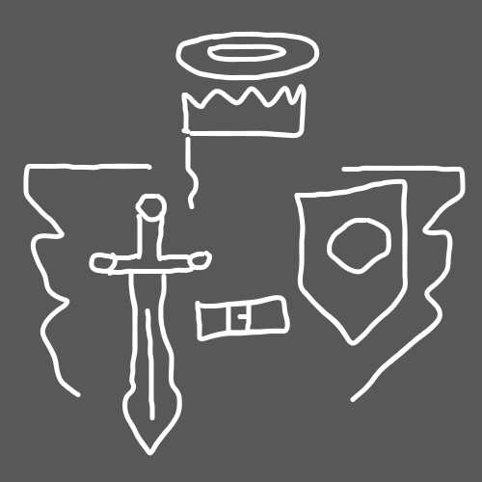(Symbol)

Principle 21.7 Sorcery

The halo is a circle, Gods symbol. Its Gods stamp upon our heads.

Principle 21.0; Sorcery

Body exercise, breathing exercise, and mediation exercise will increase a persons sixth sense, even if they already have a large amount of the sixth sense already.

ObjectName: Spell ObjectNumber: 0

Maker: Tome Of The Yellow Wizard

Model: 0

Name: Teaching Spell Room 10

Rank: 0

SerialNumber: 0

Level: 0

Score: 0

Birth:

Label: Action

Title: Teaching Spell Room 10

Details: Write your initials, together, somewhere in the book. Keep it small. This Spell creates a huge Connection, between you and this book. Its your initials, so it has a huge Connection to you. You wrote the initials, so has huge Connection to you. Is in this book, so has huge Connection to this book. If you haven’t already done, is time to keep Enchanting book. Make sure you have done a Symbol or Drawing on each Page, that you have done so far. Remember to add Complexity, and not just use the same Symbol or Drawing over and over. If you can Draw well, then you have a high Level on Runes Writing. The author of this book does not have a high Level of Runes Writing. If you wanted more Enchantment on this book, you could get a good Drawing person, to go through and draw nice drawing on a bunch of its Pages. In this book, Drawings and Symbols are equal. Symbols in this book, are as good as Drawings. This book is a Wizardry book, so Symbols are awesome to write throughout book. Complexity is added by me telling people to choose their own Symbols and Drawings.

Principle: Enchanting Levels Agenda: Enchanting Levels

Action: Enchanting Levels Information: Enchanting Levels