ObjectName: Room ObjectNumber: 13

Maker: Tome Of The Yellow Wizard

Model: 0

Name: Wizardry 1

Rank: 0

SerialNumber: 0

Level: 0

Score: 0

Birth: 6-9-2021

Label: Room 9

Title: Wizardry 1

Details: More Wizardry…

Principle: Wizardry Basics.

Agenda: Wizardry Basics.

Action: Wizardry Basics.

Information: Wizardry Basics.

Room 13: Wizardry 1

More Wizardry…

Principle 21.7 Wizardry

Until a better vocabulary has been decided upon, this is a level 4, wizardry book.

Principle 21.7 Wizardry

When you mix the knowledge with the ESP battery, you get a level 4 wizard. When you just have the knowledge, you are a 2 to 3 level. When you just have the ESP battery you are a 2 to 3 level. Exception is if you get the knowledge super high, or the ESP battery super high.

Principle 21.7 Wizardry

I call my wizard specialty the Cosmic knowledge. Some wizards do not have the Cosmic knowledge, but are still high level wizards. They specialize in something other than the Cosmic knowledge. The current vocabulary is that I am a Cosmic wizard, or a Cosmos Wizard. This book teach's cosmic wizardy, and ESP batterys. The only areas I am really an expert on. There are many sub categorys of wizardry.

Principle 21.7 Wizardry

ESP batterys are mostly always on. Everyone has one. Most people its small enough they dont really notice. Its there when you enjoy a view. Its there when you smell a beer. Its more or less a bunch of sensations, exactly like the other 5 senses.

Principle 21.7 Wizardry

Sometimes when you look at an object, you cant see all the sides. Sometimes you really dont know what the object looks like. This can happen with ESP, you get a part of the picture, but not the whole. This can result in what mediums refer to as a false reading. Your ESP power is not always right.

Principle 21.7 Wizardry

Nice smells can trigger an ESP experience. The ESP battery can be a pleasure, like smelling incense is a pleasure. Incence can trigger ESP experiences.

Principle 21.7 Wizardry

A visual view can trigger an ESP experience. As can hearing, and touch, and taste.

Principle 21.7 Aura

Aura is a major Word in wizardry. Everything has its own "Aura".

Principle 21.7 Wizardry

ESP batterys can sense aura's sometimes.

Principle 21.7 Wizardry

Some objects in life are no touch objects, where is not so good to touch them.

Principle 21.7 Wizardry

Sometimes its not for the best that you sense an aura, and the light might stop you from doing so.

Principle 21.7 Wizardry

Sometimes the darkness wins, and it keeps you from sensing the aura, even though it would be a good thing to sense it.

Principle 21.7 Wizardry

Pleasure's are the most common time people experience ESP sensations, without knowing it. Is really easy to get ESP experiences off of music.

Principle 21.7 Wizardry

ESP experiences are simply put, feelings. At least thats the main type for sure. There might be see the future ESP powers.

Principle 21.7 Wizardry

Because quicki marts are full of super awesome, beginning of time, first century objects, you can have a huge ESP experience from being in one. Last time I remember one was being in a quicki mart, and noticing all the nice things,(that helps to pay attention to how "its all nice things"), then I noticed the beer, and it reminded me of drinking beer, and being drunk on beer, and how, there was so much beer in the store, enough to get tons of people, super drunk. The final feeling is.... Wow! So nice all this stuff in the quiki mart(though I remember sensing the beer most), and it was like smelling nice incense. It reminded me of how beer is a "Fine" thing.

Principle 21.7 Fine Things

All this stuff is known as "Fine Things". Cars are a fine thing. Paintings, music, computer programming, brewing alcohol, nuclear power plants, being a teacher. Gambling is a fine thing, so is carpentry. All the sports are fine things. All the hard work is a fine thing. This list goes on and on.

Principle 21.7 Wizardry

Just thinking about the details of something, starts up an ESP attempt. Think about its color, its size, its weight. Where is the object, whats the material its made out of. When was it made. The more details the better. If its an object that is ok to touch, touching something can be a huge enhancement to getting an ESP sense on it. Never touch an object, your not supposed to touch. People break things that way.

Principle 21.7 Wizardry

Seeing an object can help sense the aura of the object. As can hearing it, by tapping it some. The truth is that your always hearing the objects around you. Sound is bouncing off those objects and hitting your ear. Smelling an object can work, but its never a good thing to do, if the smell is negative. Tasteing an object is also not right if its not going to be a good taste. Using your 5 sences you can trigger your 6th sense experiences.

Principle 21.7 Wizardry

A person can be hypnotized by the many fine things. Its not a "fine thing" if its not a good thing. This event is a great thing. It can leave you in a trance. This is a good thing. You can see infants get hypnotized by the simplest of things.

Principle 21.7 Wizardry

Meditation words....."Peace and Stillness".....Football, math, art, music

It seems extremely likely that the first meditation word is either "Meditate", or "Meditation", this will grow meditation levels faster, which is what you want to do first. Then after you have done a ton of that, you need to switch to other words. If your a football player, you should mix in football every once and awhile. Maybe, more than once and awhile. If you your a golfer, its "golf", and "golfing". If your a chef, you might like the word food, or cooking, or something.

Principle 21.7 Wizardry

Other than those words. I like the idea of thinking "Peace and Stillness", as meditation words. If you chose this one, you would think "Peace and stillness", over and over. You really can choose your own. This is not even close to the only options. I'd be suprized if theres not better than "Peace and stillness". Very suprized.

Principle 21.7 Wizardry

One awesome ritual is to get a random, positive, word from a dictionary, then read the word, then read the definition. Is a be positive ritual. Also might be better called an exercise. Ritual, more of a mystical vocabulary. Exercise a standard science word.

Principle 21.7 Wizardry

There is a mystical side of the universe.

Principle 21.7 Wizardry

There is the spiritual side of the universe. A spirit of the universe.

Principle 21.7 Wizardry

There is the mind's side of the universe. A mind of the universe.

Principle 21.7 Wizardry

There is the body's side of the universe. The body of the universe.

Principle 21.7 Myths

There's often something to the myth's and legends. Often, part truth, part not truth.

Principle 21.7 Wizardry

Things like people, talking "Mind, Body, Spirit"..... that turned out big time true. People talking about "cycles"....thats a huge one. Numerology, and colorology. I'd be surpized if theres nothing to astrology.

Principle 21.7 Wizardry

We all have a spirit animal. I doubt its are astrological sign. More the astrology is one of our lesser spirit animals. Not our main spirit animal.

Principle 21.7 Wizardry

My money is on the Dog for God's spirit animal.......God spelled backwards is doG. And dog is known as "man's best friend". Plus more reasons, why I would bet on the dog.

Principle 21.7 Wizardry

Is probably a fact, that God is man's best friend.

Principle 21.7 Wizardry

If your a nice person....you have a nice impact on the world. If your a nice person, you have a nice amount of meaning in your life.

Principle 21.7 Wizardry

A person pumps out a positive aura....from their positive spirit as they exsist. You never know what your positive aura is going to pump into. Could be your socks....could be your home. Could be unto the neighbors home. Most of the time it lives in our work though. The problem is that this is zooming in. The more you zoom in the less predictable things get. When you zoom in on an individual life, things get very unpredictable. A single life is a big time zoom in.

Principle 21.7 Aura

Most of the time it lives in our work, when you zoom out to 10 years at a time.

Principle 21.7 Cycles

Cycles is everything. The theory goes that height, width, depth, and time are all circle, 1 dimensional, loops. Reality happens in cycles.

Principle 21.7 Wizardry

The theory goes that the 4 spacial dimensions, are "particles", each with a surface, like other "particles". Like a proton has its surface, so do the 4 spatial dimensions.

Principle 21.7 Wizardry

In some ways, we are 4 dimensional beings. Since we live at a place, and a time. Inside a 3D body, inside time.

Principle 21.7 Wizardry

At the end of the Earth story, the credits roll, and we all end up in the credits.

Principle 21.7 High Scores

Top High Scores will be.....1st- God, 2nd-Jesus, 3rd.......

Principle 21.7 Wizardry

In some ways God is the first awareness, but his name in numbers is still 0. No one has a connection to the 0, like God does.

Principle 21.7 Domain

In science, we all have a Domain. God's domain is 0 to 0.999(repeating 9's). His holiness, the Messiah's, domain is 1 to 1.999(repeating 9's). We all have a name in numbers, and a domain, that ends in repeating 9's.

Principle 21.7 Buddha

The theory goes, that the Buddha, is more storys of the Messiah. Apparently, Buddha translates as "Enlightened One". Theres only 1, true, enlightened "one". Notice Christianity is a branch off the Jewish faith, and Buddhaism is a branch off the Hindu faith. Christ...Christian.....Buddha, Buddhist.

Principle 21.7 Re-incarnation

Every 1000 years a person very similar to us is born. A sort of re-incarnation.

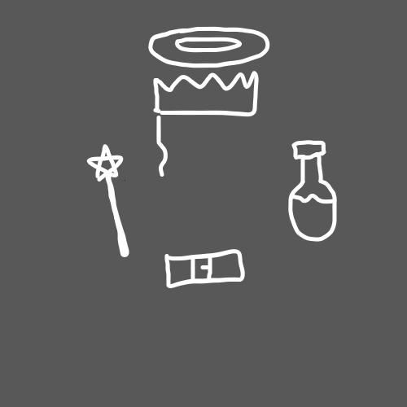

(Wand and Potion)

Principle 21.7 Alchemy

All the illegally made drugs, have big time negative enchantments. The drugs made by pharmaceutical companies, start out healthy. With positive enchantments.

Principle 21.7 Wizardry

Is possible this universe soaks up energy being emitted by God(like energy emits off stars). This soaking up, could be part, or all of the universe expansion we see.

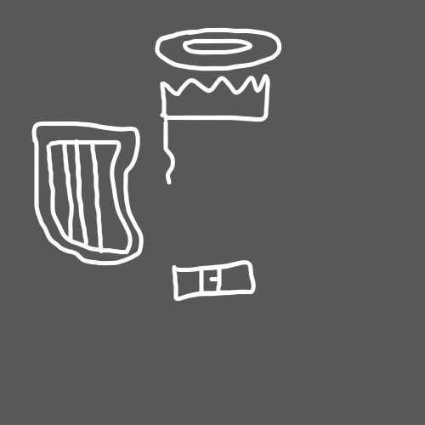

(Harp)

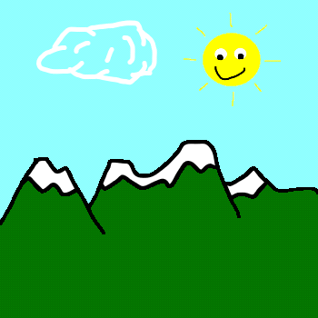(Star In The Sky)

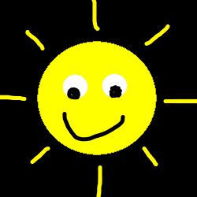(Star Person)

Principle 21.7 Wizardry

All objects have a mystical side. All actions. All things.

Principle 21.7 Spells

All actions are spells.

Principle 21.7 Wizardry

All rituals are spells.

Principle 21.7 Wizardry

All forms of energy have a name in numbers.

Principle 21.7 Wizardry

All numbers have a corrosponding form of energy.

Principle 21.7 Number Category

All forms of energy have a general number category. 0 - 9. Or when using the next scale up 0 -99.

Principle 21.7 Specific Number

All forms of energy have a specific number.

Principle 21.7 Wizardry

Seems likely what defines the category is either the 2nd number in the sequence, or the last number in the sequence. If 2nd number....then 10 is a zero category, 11 a 1, 12 a 2, and so on. 100 is a zero, 101 is a zero, 102 is a zero. If is last number, then things are a diffrent story. 100 is zero category, 101 is a 1 category, 102 is a 2 category.

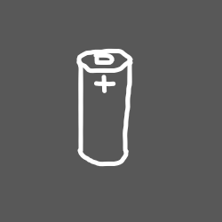(Battery)

Principle 21.7 Wizardry

A 10 times better Tome Of The Yellow Wizard, could be developed by a team of people who are Education Wizards.

Principle 21.7 Wizardry

Batterys are everything, and are a keyword in Wizardry.

Principle 21.7 Wizardry

Everything functions exactly like an electric battery.

Principle 21.7 Wizardry

All things are a battery. All things have an aura, that flows out from it.

Principle 21.7 Wizardry

The sixth sense is a battery. All people have one.

Principle 21.7 Wizardry

Batterys have a max energy they can store, at any given point.

Principle 21.7 Wizardry

When you use a battery, often it drains on the battery.

Principle 21.7 Wizardry

Draining a battery is exactly like exercising a muscle. When you drain the battery you exercise it and cause battery growth(muscle growth). This is how batterys are mainly grown.

Principle 21.7 Wizardry

Our food reality is a battery. Everyone has a Food Battery. To recharge it you have to eat, or have some medical doctor do something weird. When this battery is drained, it impacts your other batterys. Our Food Batterys are one of our primary sources of fuel, and are one of our most important batterys. The impact of a "low food battery level" is usually negative.

Principle 21.7 Wizardry

We all have a sleep battery. To recharge it, you must sleep, or have a medical doctor do something weird. It is one of our most important batterys. When it is drained it has an influence on your other batterys. The influence of a "low sleep battery level" is usually negative.

Principle 21.7 Wizardry

Batterys have parts. Those parts are also batterys.

Principle 21.7 Wizardry

There is the recharge part of a battery. How often you get a recharge tick. And there is how much you get when the tick happens.

Principle 21.7 Wizardry

When a battery hits zero, it can get extreme. Unless training, this is usually negative. It shuts down a persons ability to do the action.

Principle 21.7 Wizardry

Extreme caution should always be used when draining a battery down to 0. Sometimes its great. Sometimes its negative.

Principle 21.7 Wizardry

Please use extreme caution, when doing exercises from this book.

Principle 21.7 Wizardry

Every ability is a battery. It has parts. One part is how much is drained when you use that ability. A person can exercise, that when they use an ability, it does not drain as much from them. This happens natuarally as you do exercises. As you train abilitys, those abilitys drain from you less, when done.

Principle 21.7 Wizardry

It is possible all abilitys have a battery they belong to. That battery has your collection of abilitys, and this "collection battery", which you use, when doing the ability.

Principle 21.7 Wizardry

The force battery(Star Wars Games) can be a great example of how things work.

Principle 21.7 Wizardry

Abilitys drain on your force battery. As you train up an ability, it drains less when you use that ability.

Principle 21.7 Wizardry

In a star wars game example, force push takes less, and less energy to do. As you train up force push.

ObjectName: Spell Part ObjectNumber: 0

Maker: Tome Of The Yellow Wizard

Model: Spell Part

Name: Spell Part Chant Great, Gather, Get, Gain

Rank: 0

SerialNumber: 0

Level: 0

Score: 0

Birth: 6-10-2021

Label: Action

Title: Spell Part Chant Great, Gather, Get, Gain

Details: Level Gaining is a level we all have. Level Gaining is a Level, just like General Wizardry is a level. A person can have Level Gaining 40. Just like could have General Wizardry 40. Since Level Gaining is a Vocabulary term in this book, there are certain Enchantments to the term. As an ultimate Spell, to gain Level Gaining skill, you use the Word Gain. Because of the Gaining Part, you use the Word Gain. The ultimate Chant is, “Great, Gather, Get, Gain.”. Gain is the most important Word. Gain is the Foundation Word of the Spell. Notice all Words follow the Foundation Word and start with a “G”. For a time, persons doing this book, should train Level Gaining. After a person has trained the Word “Meditate”, while Meditating, to train up Meditation Levels, then a person should use their trained Meditation Levels to train up Level Gaining. An ultimate Chant on Level Gaining is… “Great, Gather, Get, Gain”. This Chant should be mixed into Meditation Rituals until you have trained up Level Gaining. Words are maybe the biggest part of Spells. If I were to design a new Level Gaining Meditation Spell, I would think Words, not Speak Words. Better “G” Words to mix with “Gain”, probably exist. Word “Gain” is important. I have decided to create new Vocabulary , with the Words, “Spell Part”.

Principle: Spell Part Agenda: Spell Part

Action: Spell Part Information: Spell Part