ObjectName: Room ObjectNumber: 15

Maker: Tome Of The Yellow Wizard

Model: 0

Name: Wizardry 3

Rank: 0

SerialNumber: 0

Level: 0

Score: 0

Birth: 6-9-2021

Label: Room 9

Title: Wizardry 3

Details: More Wizardry…

Principle: Wizardry Basics.

Agenda: Wizardry Basics.

Action: Wizardry Basics.

Information: Wizardry Basics.

Room 14: Wizardry 3

More Wizardry…

Principle 21.7 Wizardry

Levels are important, and a keyword of Wizardry.

Principle 21.7 Wizardry

We all have levels in everything we do. If you have never cleaned anything in your life, you have a level 0 in cleaning, other wise you a positive levels of cleaning. It is believed that people who trained up things on Earth, will be the first to hit God, of that specific thing. You can be a God of a specific thing.

Principle 21.7 Wizardry

Levels can be given number values, as well as color values, and title values as well. Say you have a level "4" in cleaning. That makes you level "yellow" in cleaning, and also makes you a "Expert Cleaner".

Principle 21.7 Wizardry

Usually it works, getting from level 1 to 20, takes no time at all. Getting from 20 to 40, takes forever, and it just keeps getting worse. 50 - 60 takes as long as it took you to get from 1 to 50. It would seem you get very little skill gain per use of time, once you have trained something up enough.

Principle 21.7 Wizardry

As you train up levels, in some ways you have 3 types of exercises. Basic, Intermediate, and Advanced. These line up nicely with numerology, we have our 3 basic numbers, 1,2,3....our 3 intermediate, 4,5,6....and our advanced, 7,8,9. This creates 9 categorys of exercises. Each fitting into one of the 3 groups.

Principle 21.7 Wizardry

Which exercise to use next is not a simple thing to figure out. You would think basic means only for new people, however that is not always true. Sometimes basic exercises are still ultimate even for Experts. Im sure there is a situation where the best exercise is an advanced one, even though you are just a beginnger.

Principle 21.7 Wizardry

Actions are spells, and levels are gained from our spells. All actions have a mystical side.

Principle 21.7 Wizardry

All symbols have a general number category, and also a specific number. A name in numbers.

Principle 21.7 Wizardry

Wizardry is just another area of science.

Principle 21.7 Wizardry

Wizardry is paranormal, and super-natural science.

Principle 21.7 Wizardry

Wizardry at least in part seems to be the mystical side of reality.

Principle 21.7 Wizardry

This book was developed using PAAIL. Visit PAAIL.org .

Principle 21.7 Wizardry

The beginning of time is know as Genesis. As in the time of Genesis.

Principle 21.7 Wizardry

Books tend to have a good deal of mass(weight), and are filled with Runes. They tend to be more Enchanted than some things.

Principle 21.7 Wizardry

A Rune is a Symbol/Drawing. Rune is the Mystical Word for Symbol/Drawing.

Principle 21.7 Wizardry

I’m sure the very best spell I could come up with, would be, to mix a nice "Meditation Item", mixed with a Body exercise, mixed with a Breathing exercise, mixed with a Meditation exercise, all at the same time(Do all 3 at once). Also want to have a think a word pattern over and over.....as in if you were just starting out....think the words "Meditation Growth. Meditation Growth.......", over and over.

Principle 21.7 Spells

I’m sure some exercises should not be all 3 at once.

Principle 21.7 Wizardry

When you do the 3 at once, you Fuse the 3 together. Creating a Hybrid Level gain, along with Level gains on the 3.

Principle 21.7 Wizardry

One of Wizardrys biggest practical applications, is that it is a huge positive inspiration while doing virtually all other areas of science.

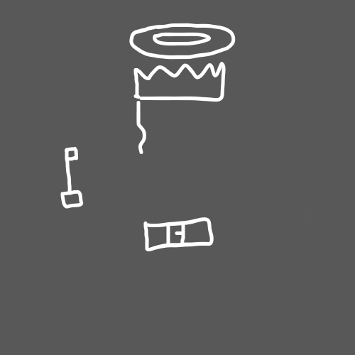

(Key)

Principle 21.7 Key

You can almost always switch the words "One", or "Won", or "I", in a song, with the word Jesus, resulting in something that makes sense. This is called using a Key.

Principle 21.7 Wizardry

I guess you could give this key a name and call it "The One Music Key".

Principle 21.7 Wizardry

Another example of a key, could be "The A Letter Words Key". Where you go with the words with an "A".

Another...Example...A...A...An...A----(The Words with A's)

Principle 21.7 Key Use----- A Name And----(The Words with A's)

Which you then combine and get -----

A name and another example, a, a, an, a.---(Interpret as you see fit)

-----Do next lines we get.........Principle 21.7 Spells

Can create a, a, and, make impact, a.---(Interpret as you see fit)

Principle 21.7 Wizardry

If you were to use a "The O Letter Words Key", you would end up with a bunch of stuff about God. This exsists in most all books, and writings.

----This Details using Key-------

You to O words, you, would, about, God. Most books.---(Interpret as you see fit)

--This almost seems like it might be better than my details.

Principle 21.7 Wizardry

Big brother, Titan, Michaels music key is rather nice. You take the words, "Two", "To", "Too", and switch them with the name Michael, in the music.

Principle 21.7 Wizardry

You can swap the word "to" around to "growth". I went "to" the store. I went "to" get apples. I went "growth" the store. I went "growth" get apples. I went "progress" the store. I went "progress" get apples. I went "measurement" the store. I went "measurement" get apples. You can swap the words "to", and "too", with "growth" in any sentance. You can use words progress, measurement as well. Other 2 category words also.

Principle 21.7 Wizardry

Better key examples are….use the Word “God”. Take a chunk of text and write down the first Word with a “G”. Then, write the next Word with a “O”, then do the “D”. Do this over and over on the chunk of text. You almost always, in every book, end up with these messages about God.

Example: This Text Chunk……….God of down, “G” Word do God.-(Example God Key)(Messages about Go) This message looks like “If you want God stuff written down, do the “G” Word, God.

Principle 21.7 Wizardry

You can use any Word as a key. You can use the Word Power for instance. You almost always end up with messages about Power.

Example: Prior Text Chunk………Examples, Word write the first.(Power Key)(Messages about Power) This message looks like… Example of get power is Write a Word first.

Principle 21.7 Wizardry

Keys are awesome, and a keyword of Wizardry. If you’re an Expert at something, you can get awesome inspiration by using Keys. If you are an Expert at Education, you could probably use the Word “Education”, as a Key. If your writing a Sci Fi script, you can probably use the Key Sci Fi. Choosing the best Key is not a simple matter. However they all tend to work awesome.

Principle 21.7 Wizardry

You can create a Spell, by using a word and doing some ceremony you make up. The spells impact is a connection with the words you use. You grow your Spell, the more you do it. The words you use mix with the ceremony, the words matter most. Be positive Spells, positive words, or nuetral words.

Principle 21.7 Wizardry

There are many old Spells on Earth, found in books, art, cultures, religions.....

Principle 21.7 Wizardry

Every Action is a Spell.

Principle 21.7 Wizardry

All the cartoons are big time, beginning of time stuff.

Principle 21.7 Wizardry

Enchantments age over time. Increasing more, and more. The really older cartoons have aged the most.

Principle 21.7 Wizardry

As expected, I have learned more, doing this book.

Principle 21.7 Wizardry

1 is the number for "Beginnings", and "Ends", but since the light side of the force is stronger, it has more of a connection to Beginnings.

...thus and there for....

2 is the number for "Growth", and "Decay", however has a stronger connection to "Growth". The numbers have a greater connection to they're positive Energy.

3 is the number for "Law", "Order", and "Lawless", "Disorder".

4 is the number for "Solid", and "Unstable".

5 is the number for "Balance", and for "Chaos".

6 is the number for "Change" and "Unchanging"

7 is the number for "Solution", and "Problems".

8 is the number for "Awareness", and "Confusion".

9 is the number for "Ends", and "Beginnings", with a greater connection to "Ends".

Principle 21.7 Wizardry

Sometimes ESP is sensing just one side of a thing. A part of something else.

Principle 21.7 Wizardry

People get different ESP experiences, because they can sense different sides of the same thing.

Principle 21.7 Wizardry

I suspect already, virtually everyone has already a rather built up ESP battery, without knowing it. Increasing it is still worth while, and doing Body, Breathing, Meditation exercises is the path.

Principle 21.7 Wizardry

The cause for people all having a built up ESP battery is the massive Education, exposure, sounds exposure, video screen exposure, complex reasoning in games, human huge technology state, more evolved culture, more social interaction, more Items around us .... the list of causes goes on and on.......adds up to higher Mind Levels, and more. Results in ESP battery increase.

Principle 21.7 Wizardry

Meditation rugs are very worth while.

Principle 21.7 Hands

Body exercise hands is very worth while.

Principle 21.7 Instructors

Meditation Guidance, by Instructors doing class's, is very worth while. More so at Beginner Levels.

Principle 21.7 Wizardry

Meditation Guidance has two types. Advise for people, Meditating on their own. And there is a 30 minute chunk of time, spent in a room, Meditating with a bunch of people, having an Instructor keep track of the time. That is the 2nd type of Guidance.

Principle 21.7 Wizardry

During class Meditation, sessions, we can also mix Body exercise, and Breathing exercise. Doing all 3 at the same time. It would be likely that such an exercise can be only done 2 minutes at a time, before a person needs a rest. The Instructor can keep time, so everyone else doesnt have to. Meditation in short 2 minute intervals, because they are mixed with Breathing, and Body exercise.

Principle 21.7 Wizardry

Mini-gongs, that dont make to much noise, would be worth while for Instructors.

Principle 21.7 Wizardry

Im sure there are other objects that would be just as good as mini-gong, and would replace it well.

Principle 21.7 Wizardry

Im sure I have seen a bowl that you can run a stone around the outside to create a humming noise. These would be great for Instructors.

Principle 21.7 Wizardry

It is a nice Enchantment to have the word "Meditation" on the bottom of the Meditation rugs. Only you really want it in 30 different languages. The more languages the better. The bottom of the rug covered in Runes, that say "Meditation".

Principle 21.7 Wizardry

Too many Runes on the top of the Rug, becomes a blast on the eyes. Is less connected to "Peace and Quite", though does gain other benifits. You want to put some Runes on the top of the Rug. On the bottom there is no blast on the eyes. On the bottom, make sure to max out on the word "Meditation".

Principle 21.7 Wizardry

You can put other words on the bottom of the Rug. If your a football player, it would be nice to have football on the bottom of the Rug. Custom Meditation Rugs, is a thing, putting things you want a connection to on the bottom of your Rug is great.

Principle 21.7 Wizardry

Meditation Chambers are a thing. Rooms people use for Meditation, sometimes qualifys as a Meditation Chamber. When an Instructor uses a room for it, they turn the room into a Meditation Chamber. At least for a bit.

Principle 21.7 Wizardry

Meditation Chambers can grow, over time, increasing in Level. Just like the Rugs.

Principle 21.7 Meditation Chamber

A Meditation Chamber Rug can be used. A rug that covers the floor, of most, or a good chunk of the room. A Rug, that people put their Rug on, when they Meditate. The bottom of the Chamber Rug, should be covered in Runes. If the top is too covered with Runes, it is a blast on the eyes, and is not right.

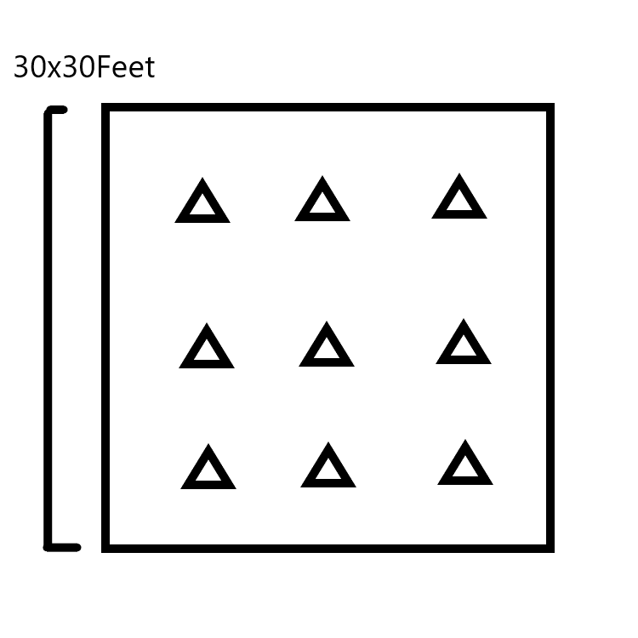(Chamber Rug) This is a Bad design, this is just an Example.

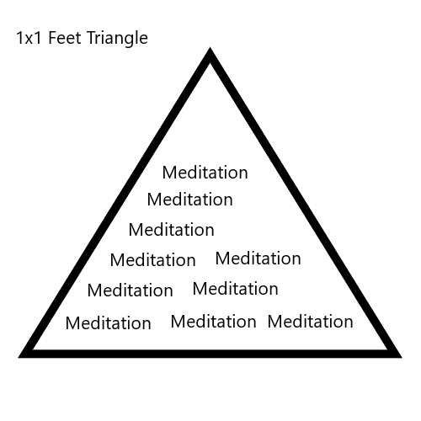(Chamber Rug Slots)

Principle 21.7 Chamber Rug

This Chamber Rug is just an example. A much better design can be done. Exact amount of slots is something to work out. The word Meditation would be in 10 different languages, the more the better. This is all about designing a nice Chamber Rug.

Principle 21.7 Rug Slots

The Triangle shape is just one of a million options for the Chamber Rug Slots.

Principle 21.7 Wizardry

People put their Rugs, over the Slots.

Principle 21.7 Wizardry

The ultimate Chamber, would have the floor, walls, ceiling, covered in Runes. However this would be a blast on the eyes. So then we would have to make curtains for the walls, to cover the Runes from sight. The curtains should be open when the room is not in use. We would also need a cloth cover for the ceiling. The Chamber Rug, should cover the Runes on the floor.

Principle 21.7 Wizardry

The Runes used on Chamber, should not get bigger than 1 inch. A 1 inch size font.

Principle 21.7 Wizardry

An Instructor will boost the room, if they think the word "Meditation", over and over, during some of the class. Other options also exist for Instructors. Instructor doing their own Chant helps a bunch, because they have a high Meditation Level.

Principle 21.7 Wizardry

Peaceful sounds like rivers, rain, and so forth are worth while in some Meditation I expect. Im guessing music too can be used to improve the situation, some times.

Principle 21.7 Wizardry

The Runes on the bottom of someone’s Rug, pushing into the Runes on the Slot, creates a strange Mystical circuitry. Like plugging a micro-chip into a slot.

ObjectName: Spell ObjectNumber: 0

Maker: Tome Of The Yellow Wizard

Model: Teaching Spell

Name: Teaching Spell Room 15

Rank: 0

SerialNumber: 0

Level: 0

Score: 0

Birth: 6-11-2021

Label: Action

Title: Teaching Spell Room 15

Details: Meditation is an ultimate way to Enchant yourself and other things. When you combine it with a bunch of other stuff it is some of the more ultimate Spells. Look at the first Word of these Details. The Word Meditation. Then keep looking at it, and in your mind, count to 5. Fixing your Eyes on a location, then keeping them there is a Meditation. Meditation also can be used to Gain Levels and turns into Powers as well.

Principle: Meditation Agenda: Meditation

Action: Meditation Information: Meditation