ObjectName: Room

ObjectNumber: 2

Maker: Tome Of The Yellow Wizard

Model: 0

Name: Twilight

Rank: 0

SerialNumber: 0

Level: 0

Score: 0

Birth: Unknown

Label: Room 2

Title: Twilight

Details: Light, Twilight, and Darkness.

Principle: Energy Basics.

Agenda: Energy Basics.

Action: Energy Basics.

Information: Energy Basics.

Room 2: Twilight

Light, Twilight, and Darkness.

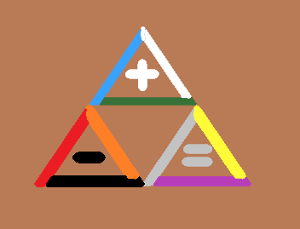(The Tri-Force)

Principle 0.0: Twilight

Before there was Light, or Darkness, there was Twilight.

Principle 0.1: Twilight

The Universe is made of Twilight. Neutral.

Principle 0.2: Light

The Universe is made of Light. Positive.

Principle 0.3: Darkness

The Universe is made of Darkness. Negative.

Principle 0.4: Energy

All Energy is either Positive, Neutral, or Negative, Energy.

Principle 0.5: Twilight

All Energy is either Light Energy, Twilight Energy, or Darkness Energy.

Principle 0.6: Twilight

All Numbers are either Positive, Neutral, or Negative.

Principle 0.7: Twilight

All Numbers have a corresponding form of Energy. All Energy’s have a corresponding Number.

Principle 0.8: Twilight

All Numbers have a Symbol. All Symbols have a Number.

Principle 0.9: Twilight

All Words have a corresponding Number.

Principle 1.0: +A

A = 1 - 0.999 Repeating 9's

Principle 1.1: -A

-A = A \* -1

Principle 1.2: Twilight

A is the Number for the Word Positive. Light.

Principle 1.3: Twilight

-A is the Number for the Word Negative. Darkness.

Principle 1.4: Twilight

0 is the Number for the Word Neutral. Twilight.

Principle 1.5: Twilight

The closest Numbers to 0 are A and -A.

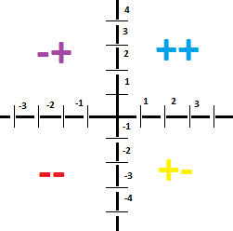(4 Quadrants)

Principle 1.51: Twilight

The first Numbers of Reality are 0, A, and -A.

Principle 1.6: Bits

The Universe is made of Energy Bits.

Principle 1.7: Twilight

At max zoom in, we find the Energy Bits.

Principle 1.8: Twilight

All Energy Bits are either Positive, or Negative.

Principle 1.9: Twilight

At the Origin there were Neutral Energy Bits. They exist no more.

Principle 2.0: Twilight

Neutral energy Bits, Positive Energy Bits, and Negative Energy bits are very similar.

Principle 2.1: Twilight

All Energy Bits are either an "A" or a "-A".

Principle 2.2: Twilight

All Energy Bits are Infinitely small.

Principle 2.3: Twilight

The max zoom in is exactly like a computer. 1's and 0's. Only it might be better said +'s and -'s.

Principle 2.4: Byte

The next zoom out is the Byte View. Two Bits make a Byte. The 2x View probably is what you call it.

Principle 2.5: Twilight

There are four types of Bytes. The ++, --, +-, -+.

Principle 2.6: Twilight

The next zoom out is the 4 Bit view. Four Bits at a time.

Principle 2.7: Twilight

After 4 Bits, comes 8 Bits.

Principle 2.8: Twilight

After 8 Bit Views, comes 16 Bit Views.

Principle 2.9: Twilight

After 16 Bit Views, comes 32 Bit Views.

Principle 3.0: Twilight

After 32 comes 64. After 64 comes 128. Then there is 256, 512, 1024, and 2048.

Principle 3.1: Twilight

This process continues forever and ever. You just double the number again.

Principle 3.2: Twilight

There are an Infinite number of zoom Levels.

Principle 3.3: Twilight

At these views it all becomes a bunch of code. As in Computer Science programming.

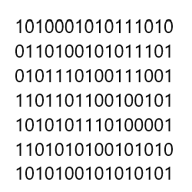(1's and 0's)

Principle 3.4: Twilight

Objects are made out of this +'s and -'s code. Like a chair or a table object.

Principle 3.5: Twilight

All tables and chairs have an Infinite amount of code to them.

Principle 3.6: Twilight

All tables and chairs have an Infinite amount of Properties to them.

Principle 3.3: Twilight

All tables and chairs have an Infinite amount of Bits to them.

Principle 3.4: Four Forces

The "Four Forces". (Strong nuclear, weak nuclear, electromagnetism, and Gravity). One is the ++ force. One is the -- force. One is the -+ force. One is the +- force.

Principle 3.5: Twilight

The four forces. One is the Addition force. One is the Subtraction force. One is the Multiplication force. One is the Division force.

Principle 3.6: Process’s

There are the four Process's. Addition, Subtraction, Multiplication, Division.

Principle 3.7: Twilight

The four forces. Again one is up, one is down, one is left, one is right.

Principle 3.8: Twilight

The four forces. One is the big picture. One is the small picture. Two are between big and small.

Principle 3.9: Twilight

All persons should look for Positive, Neutral, and Negative in everything.

ObjectName: Spell ObjectNumber: 0

Maker: Tome Of The Yellow Wizard

Model: 0

Name: Book Connection Spell 1

Rank: 0

SerialNumber: 0

Level: 0

Score: 0

Birth: 6-5-2021

Label: Action 1 Spell

Title: Book Connection Spell 1

Details: Draw 2 small plus Symbols in the book, next to each other. At the same time, tap one with Item, and think the word “Twilight”. Then do the same thing with the other plus Symbol. While tapping you should think the words “Twilight, Twilight”. Just repeating words “Twilight, Twilight” in your head is a great Connection Spell. This Spell creates a greater Connection between you and this book. That then creates a greater Connection between you and Wizardry. This Spell trains General Wizardry, Spell Casting, Enchanting, Runes Writing, Item Use, and more. The main focus of this Spell is to teach Spell Basics. You go up Levels as you do the Spells of this book. The first Spells of this book, are to create an ultimate Connection between you and the book. The first Spells are also to teach Spell basics.

Principle: Learn About Spells

Action: Learn About Spells

Agenda: Learn About Spells

Information: Learn About Spells