ObjectName: Room ObjectNumber: 3

Maker: Tome Of The Yellow Wizard

Model: 0

Name: Genesis

Rank: 0

SerialNumber: 0

Level: 0

Score: 0

Birth: 6-6-2021

Label: Room 3

Title: Genesis

Details: The beginnings…

Principle: History.

Agenda: History.

Action: History.

Information: History.

Room 3: Genesis

The beginnings…

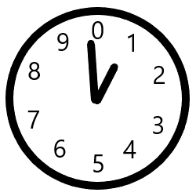(Cosmic Clock)

Principle 0.0: Genesis

The Word Genesis means beginning.

Principle 0.1: Earth

It goes some huge amount like........ 1 trillion Earth years is one year to God. God experiences time, that the 1 trillion Earth years is only a short 1 year for him.

Principle 0.2: Cosmic

Gods time scale is the true time scale. The Cosmic time scale.

Principle 0.3: Genesis

The Cosmic year is 99.

Principle 0.4: Genesis

God is 99.

Principle 0.5: Genesis

It is the beginning of time.

Principle 0.6: Genesis

It is the first century.

Principle 0.7: Genesis

We are all beginning of time people. First century even.

Principle 0.8: Genesis

The beginning of time is known as Genesis.

Principle 0.9: Genesis

When God turns 1000, we will all be 900. On the Cosmic scale.

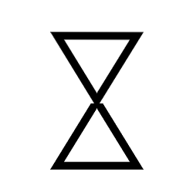(Hour Glass)

Principle 1.0: Genesis

We will always be known as the most ancient.

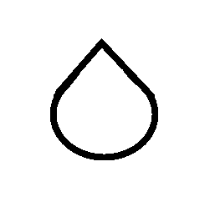(Seed)

Principle 8.41; Heaven

Exactly like a Particle accelerator, God takes two drops of blood, flings them around himself, and has them collide. While speaking "Let there be light", God creates Heaven.

Principle 8.5; Genesis

The birth of Heaven is a birth of another Universe. Another Fussion event. Another Big Bang. God lives in one Universe. This Universe lives in God's Universe. Heaven is the name of this Universe.

Principle 8.6; Genesis

Heaven lives in God's Universe, going round and round him.

Principle 8.7; Genesis

Physically and metaphoricaly, this Universe revolves around God.

Principle 8.9; Genesis

The camparison is that God is the size of our star, and this Universe is the size of a planet.

Principle 9.0; Genesis

The amount of Energy in God's Body is greater than all the Energy in this Universe, and God's Body is larger than this whole Universe.

Principle 9.1; Genesis

For God, this Universe is like a giant marble.

Principle 9.2; Genesis

This Universe is round.

Principle 9.3; Messiah

The birth of Heaven, is also the birth of his holiness, the Messiah.

Principle 9.4; Genesis

His name in numbers is One. His symbol is the 1 pointed seed.

Principle 9.5; Genesis

Messiah mean "Annointed One"(Notice the number 1).

Principle 9.6; Genesis

Christ also means "Annointed One". Thus also is his holiness known by this title.

Principle 9.7; Genesis

Reality sort of has at least two Big Bangs.

Principle 9.8; Genesis

Now we have God, and his Holiness, Jesus. Time for Holiness to have children. 2-9 are born. 2,3,4,5,6,7,8,9. These are all our 1-digit people, God, Jesus, and the 8 grandchildren.

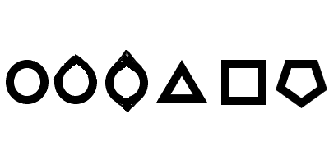(0 To 5)

Principle 9.9; Genesis

God, Jesus, and God's eldest grandchildren. Time passes. They age. Then Jesus has more children.

Principle 10; Genesis

God's Body is a giant Energy ball. The Angels Bodys are giant Energy balls.

Principle 10.1; Genesis

The Stars are the Angels. Everyones a Star in Heaven!

Principle 10.2; Genesis

Heaven is one big family. Everyone has time to interact with everyone. Is the human equivelant of a family of 10.

Principle 10.3; Genesis

In Heaven its more like being a God. With ultra power Star Bodys.

Principle 10.4; Genesis

Then it was time to create Earth. So once again we fuse two things. This time two planets. The birth of Earth.

Principle 10.5; Genesis

The Earth drained the Darkness from Heaven.

Principle 10.6; Human

Then God created Adam. The birth of Human time. A primitive, and Primordial realm.

Principle 10.7; Genesis

The Human realm is the Quantum realm.

Principle 10.8; Bible

The Bible states that Humans are made in God's image.

Principle 10.9; Genesis

Humans have some similarities to God.

ObjectName: Spell ObjectNumber: 0

Maker: Tome Of The Yellow Wizard

Model: 0

Name: Book Connection Genesis 0

Rank: 0

SerialNumber: 0

Level: 0

Score: 0

Birth:

Label: Action 0

Title: Book Connection Genesis 0

Details: Think in your head, “Genesis, Genesis, Genesis.” Doing this is a Spell. You recently saw the word Genesis, over and over in this book. Because of that, and more, this Spell creates a huge Connection to this book. This Spell Enchants you with more of a Connection to this book. Therefor it is Enchanting Level gain. It is casting a Spell, so it is Spell Casting Level gain. The Word Genesis is a Potent Word. This Spell builds on a Connection to the Word Genesis. It is also General Wizardry Level Gain.

Principle: Connection Spell Agenda: Connection Spell

Action: Connection Spell Information: Connection Spell