ObjectName: Room ObjectNumber: 5

Maker: Tome Of The Yellow Wizard

Model: 0

Name: Colorology

Rank: 0

SerialNumber: 0

Level: 0

Score: 0

Birth: 6-6-2021

Label: Room 3

Title: Colorology

Details: Colors…

Principle: Colorology.

Agenda: Colorology.

Action: Colorology.

Information: Colorology

Room 5: Colorology

Colors…

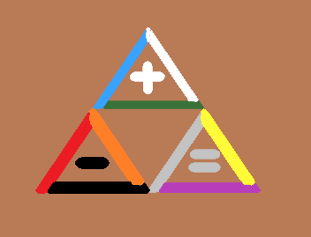(The Tri-Force)

(Purple Area)

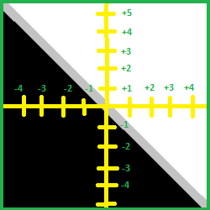(3 Areas)

Principle 8.0; Colorology

The 3 positive colors are white first, then blue, then green.

Principle 8.1; Colorology

The 3 neutral colors are, yellow first, then grey, then yellow.

Principle 8.2; Colorology

The 3 negative colors are, black first, then red, then orange.

Principle 8.3; Colorology

On the positive number/color scale. We have +1 is white. +2 is blue. +3 is green. +4 is yellow. +5 is grey. +6 is purple. +7 is orange. +8 is red, and +9 is black. So in some ways black is the color of the highest positive energies. 0 is transparent.

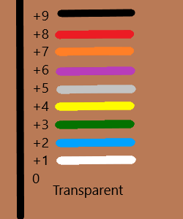(Colors)

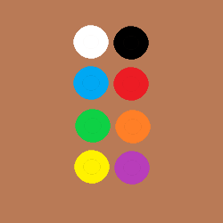(Colors Have Opposites)

Principle 8.4; Colorology

White is the opposite of black. Blue the opposite of red. Green the opposite of orange. Yellow the opposite of purple.

Principle 8.4; Colorology

Grey might be the opposite of transparent.

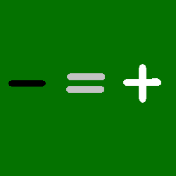(3 Energys)

ObjectName: Spell ObjectNumber: 0

Maker: Tome Of The Yellow Wizard

Model: 0

Name: Level Gaining Example Spell

Rank: 0

SerialNumber: 0

Level: 0

Score: 0

Birth:

Label: Action

Title: Level Gaining Example Spell

Details: Bow twice. On each bow think the Words, “Level Gaining.” That adds up to two times thinking “Level Gaining”. This Spell makes a person go up Level Gaining Levels. As in a person having Level Gaining 40. We all use Level Gaining. We use it when we train anything. We all have a Level Called “Level Gaining”. High Levels of Level Gaining helps train all other Levels. Building a high Level of Level Gaining is one of the first things to do. People most of the time already have this at high Levels. Even for these people though, it would be good to focus on it for a Bit of time. This Spells main purpose is to teach more about Spells. It is not intended for mass use. Because Level Gaining is printed all over this Page, this Spell also creates a Connection to this book. This Spell trains all kinds of different Wizardry Levels. Since this Spell comes from this book, this also creates more of a Connection to this book. At first reading a Page like this may be a drain. As people grow in Levels, reading Page’s like this don’t drain as much.

Principle: Level Gaining Agenda: Level Gaining

Action: Level Gaining Information: Level Gaining