ObjectName: Room ObjectNumber: 7

Maker: Tome Of The Yellow Wizard

Model: 0

Name: Spirit 0

Rank: 0

SerialNumber: 0

Level: 0

Score: 0

Birth: 6-6-2021

Label: Room 7

Title: Spirit 0

Details: The Spirit Side of Reality…

Principle: Spirit.

Agenda: Spirit.

Action: Spirit.

Information: Spirit.

Room 7: Spirit 0

The Spirit Side of Reality…

Principle 16.0; Spirit

A Humans Spirit Score is generated by their Spirit Level.

Principle 16.1; Spirit

In some ways the human, numerology, spirit level, scale, is -9 to +9. 19 groups. -9-8-7-6-5-4-3-2-1+0+1+2+3+4+5+6+7+8+9.

Principle 16.2; Spirit

The highest spiritual level obtained by humans is that of people like Noah, Abraham, Moses. Spiritual Level +9.

Principle 16.3; Spirit

+8 is the Prophet. +7 Holy Man. +6 A Sage.

Principle 16.4; Spirit

No one gets to +7 Holy man before 50 years of age. Most that do hit +7, do so after 70 years of age.

Principle 16.5; Spirit

+5 always reminds me of a Knight. +4 a Squire.

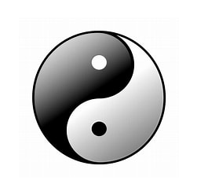(Yin Yang)

(Christian Cross)

(Star of David)

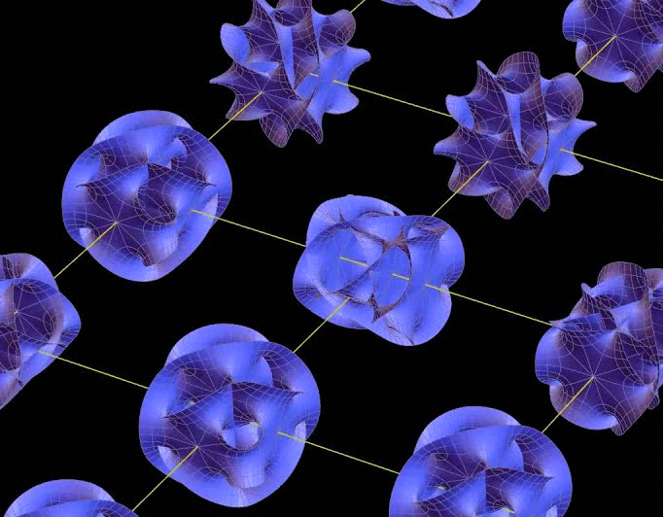

(Calabi Yau)

Principle 16.9; Spirit

A table does not have a soul. God, and all the other life forms have souls. Angels, humans, animals, bugs.... each and every cell in the human body.

Principle 17.0; Calabi Yau

I suspect that scientists have finally discovered souls. In science, they are called a "Calabi Yau". They create consciousness.

Principle 17.1; Spirit

All souls evolve into God's eventually. God is a spiritual level. Eventually we evolve beyond the God level. Titles like High God, Supreme God, Grand Supreme God. Another one you can do is God 1, then God 2, God 3, on and on.

Principle 17.2; Spirit

Our spiritual levels will increase forever.

Principle 17.3; Spirit

There is Spiritual Accension, and there is Spiritual Decension. There is also the Twilight, no change.

Principle 17.4; Growth

Positive Spiritual Growth, Neutral Spiritual Growth, and negative spiritual growth are the only options.

Principle 17.5; Work

It is not by work that we have positive spiritual success. It is by being a nice person for 10 years at a time. When you are a nice person for 10 years straight, you are guaranteed spiritual success, over that 10 years. The final average will be that you Scored more Points. That you increased your Spirit Score.

Principle 17.6; Spirit

Spiritual success is a long term, be a nice person thing.

Principle 17.7; Zoom

When you zoom in on just one year of that 10 years, you can find a total fail year.

Principle 17.8; Physics

When you zoom in on things, reality gets less predictable, and the physics of things change.

Principle 17.9; Spirit

Being a nice person will not guarantee a year is successful. It will with 10 years.

Principle 18.0; Spirit

A positive spiritual Chi will pump positive energy into the universe, even if you are not working. Its always on. Work days, and days off.

Principle 18.0; Spirit

Most of the time peoples Positive Energy does flow through their Work. While at Work, people have higher probability of doing Positive Spirit Enchants on the things around them. Increasing the Spirit Level on the Items around them.

ObjectName: Spell ObjectNumber: 0

Maker: Tome Of The Yellow Wizard

Model: 0

Name: Tome Custom Enchant 0

Rank: 0

SerialNumber: 0

Level: 0

Score: 0

Birth: 6-8-2021

Label: Action 0

Title: Tome Custom Enchant 0

Details: Time to Enchant the book for real. Draw a quick Symbol on every Page you have done so far. Skip the Pages that already you have done something on. Use at least 4 different Symbols. In the future, draw a Symbol or Image on every Page. Keep the drawings small. Do this after you have done each room. No Negative Runes. The minus Symbol is not a Rune you would call “too Negative….”. After doing this. Wash hands. This will take away a Blocker on Connecting to the book. Then, rub your hand on the outside of the book for 10 minutes. 5 minutes the front of book. 5 minutes the back of book. Do not wear Gloves.

Principle: Quick Book Enchantment Agenda: Quick Book Enchantment

Action: Quick Book Enchantment Information: Quick Book Enchantment