Tome of The Cosmos:
Cosmic knowledge…
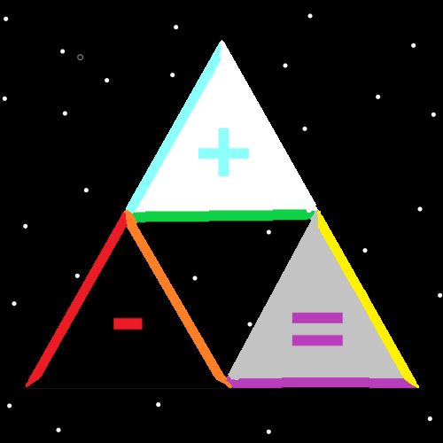

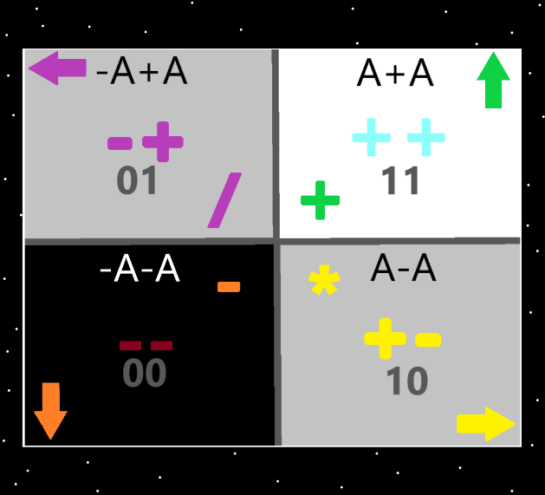
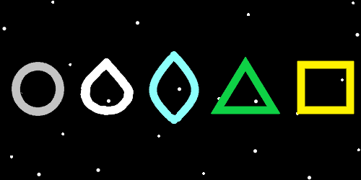
Chapter 0: Zero
In the time before time there was the Zero moment. In the time before time there was the Origin moment. At the zero moment there was a 0 amount of time. The zero moment was the beginning of what’s called the “big bang”.
One of Gods many names is Origin, his main name in numbers is Zero, his main symbol is the Circle. His 3D symbol is the sphere.
Notice the “o” in the word “God”, the “o” in the word “zero”, and the “o”, in the word “origin”. Notice the number 0 is a circle symbol. Notice the pattern(map above)…. The square is 4 points, 4 sides. The triangle is 3 points, 3 sides. The 2 symbol is 2 points, 2 sides. The 1 symbol is 1 point, 1 side. The circle symbol is 0 points and 1 side.
His holiness Origin is something like trillions of earth years old, however on a cosmic scale he and the multiverse are only 99 years old.
It is the first century of time, also known as the beginning of time, also known as “genesis”, also known as the 0 century, also known as the Origin century.
His holiness Zero has many names like…. Circle, Ball, Sphere, Dot, Halo, Twilight, Symbol and Bubble. Gods numbers are 0.0 to 0.99999999999 repeating 9’s. His color is transparent.
His holiness Shiva has a sphere, energy ball body, like the stars, only his body is larger than this entire universe. This universe orbits God, like a planet around a star. His holiness has a real, physical, cosmic body.
The first line of the Bible is…. “In the beginning God created the Heavens and the Earth”.
To create this universe his holiness Jehovah used 2 drops of his blood. He flung them around himself, at a huge speed (exactly like a particle accelerator) and fused them together. It was the birth of Heaven, this universe, and also the birth of his holiness the Messiah, son of Jehovah, right hand of God, king of Heaven, first of the stars, first of the angels.
The stars are the angels. If you zoom out far enough, you see that this universe looks like a marble orbiting the body of his holiness Jehovah.
His holiness One has also a main number. His number is 1. His main symbol is the 1-pointed seed. The plus sign (“+”) is also one of his symbols. He has many names as well. Light, beginning, genesis, on, seed, won, “I”, and an endless number more. He is known as the Christ, the anointed one, and also the enlightened one. Stories about the buddha are likely more stories about his holiness Jesus. The messiahs numbers are 1.0 to 1.99999999 repeating 9’s. His color is white, and his age is 69 (in cosmic years).
His holiness Won created many children of his own. His first children were 2, 3, 4, 5, 6, 7, 8 and 9. The combination of them all adds up to people known as the “Single Digit People”. The 10 single digit people. We all have a name in numbers, we are all anointed a number. Person 2, also known as his holiness Michael is the “anointed two”/”anointed too”. His holiness the Messiah is father to all except his holiness Zero. We all are the grand-children of his holiness Zero. Person 2 also has many names, like “growth” and “progress”. His numbers are 2.0 to 2.999999999 repeating 9’s.
Heaven is one big family. Everyone knows everyone. Everyone’s a star! Everyone gets to interact with everyone all day. There are no troubles ever. People are like god, energy balls, and their existence is god-like. Its more than billions of people and yet it feels like a small family. An angel in heaven can read an entire library of earth books in one earth week. An angel in Heaven can memorize all human swords ever made, and the story of each sword. God can do more math in his head than all the computers of this planet. The angels have a more God like existence.
For all eternity the future holds more and more advanced bodies than the current star bodies. Eventually there will be a body more powerful than Gods body and the family will get bigger and bigger forever as well. The multiverse evolves and the bodies evolve too.

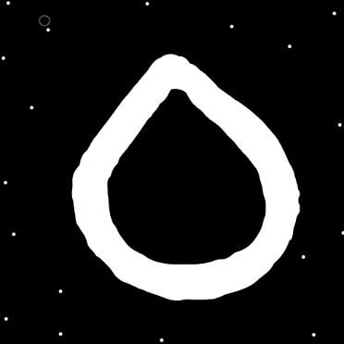

Chapter 1: Won
All of the 5 major religions, Christian, Buddhist, Jewish, Muslim, Hindu have had prophets throughout their existence. All 5 major religions worship the same God. This is the story with many religions of earth, not just the 5. All their scripture counts as more scripture. All the 5 major religions get things right and get things wrong.
Like his holiness our God, we all have a spirit, a mind, and a body. This adds up to a spiritual side, a mind side, and a body side. The spiritual side is the amount of meaning in a person’s life and we all have both a spiritual level, and a spiritual score.
Your spiritual score is how much good you have done in your life. Your spiritual level is how much good you accomplish each year. In positive human reality there are 9 spiritual levels.
A person with a spiritual level of 1, scores 1 point of spiritual score each year. A person with a spiritual level of 1 helps 1 person get from level 0 to level 1 (each year). The 9 spiritual levels have numbers….1 through 9. A person with a spiritual level of 9 helps 9 people get from spiritual level 0 to spiritual level 1 (each year) (nine times more than a person at level 1). In other words, spiritual level 1 people lift up one person per year, and spiritual level 9 people lift up 9 people per year. The most any human can get is 9. The truth is that all light side people have about the same spiritual score. The same amount of meaning in their lives.
Part of the multiverse is that there is spiritual accension. The worship of his holiness Origin is also a part of the spiritual side as well. His holiness Origin and everyone else has a connection to the spiritual side of the multiverse. Merlin would say the spiritual side of the dragon.
Since it is the zero century (year 99)…we all are about as old as his holiness Zero. When his holiness turns 1000, we will all be about 900. On a cosmic scale we are about as old as his holiness God.
All human lifeforms are known as “Elementals”. God is also an “Elemental”. Also there are other titles, like “Eternals”, “Origin Beings”, “First age people”(since in first 1000 years) and “Origin age people”. As elementals we all have a monumental, huge chi. Eventually we will end up as powerful as his holiness Origin is now.
Being “one with the universe”, is the same as saying “won with the universe”, and a person is “won with the universe” if they are a light side being. All good people are one with the universe. Since there are levels to the multiverse, there is such thing as “won with the universe levels”. Enlightenment follows the pattern. Enlightenment is common. As long as you’re a being of light you are enlightened. And there are also levels of enlightenment.
The word “God” is a chi title and a spirit title. Eventually we all evolve into Gods. Because we become Gods…..because we are elementals….because we are his holiness Origins grand-children…….and because more….the light side people lives are scripture in Heaven. Our lives are scripture to his holiness Bubble. Most people do not realize how monumental their lives are and everyone’s lives are monumental.


Chapter 2: To
In some ways there are the 3 groups. The grandpa/grandma group(his holiness Origin). The dad/mom group(his holiness the messiah). And the everyone else group(children of his holiness the messiah). Also known as the sibling group.
In heaven the crown prince is his holiness archangel Michael/Michell. First born of his holiness Jesus. First of the sibling group. Biggest of the big brothers. Left hand of God. Like the mickey mouse theme song…. he is truly the leader of the club that’s made for you and me. His symbol is the 2 pointed/2 sided seed. His color is blue. A shape with 2 sides and 2 points would be his 3D symbol. He is also known as growth, progress, amplification, to, too, and many more.
In heaven there is the also his holiness archangel Gabriel/Gabriela. He is the twin of his holiness Too. His name in numbers is 3. His symbol is the triangle. His color is green. We all have a number, symbols and colors. A number that a human can write in 30 minutes is a small number in truth and is a small number to God. All our numbers are small ones. Like number 985 rolled a small number. We all rolled a small number.
The main 5 chi titles are “God, Demi-God, Titan, Immortal, Mortal”. Everyone lives forever, however humans are called Mortals. His holiness Sphere is the only God, there are no Demi-Gods, and the holy elder angels are a mix of Titans and Immortals.
There are many questions people have about the multiverse. Questions like…”what is the meaning of life?”. All answers to such questions are a teaching about the multiverse. All teachings about the multiverse are science and his holiness Zero is a scientist.
Picking the ultimate questions is a science all on its own and the ultimate questions would likely change from person to person. Knowing what the ultimate questions is a bunch of secrets on its own. Not just knowing the answers to ultimate questions but knowing what the ultimate questions are. Before we hear the ultimate answers, we need to know the ultimate questions.
My favorite quote is: “…luminous beings are we…”- Yoda from Star Wars. In the movie “Excalibur”, Merlin refers to the Multiverse as the Dragon. These are accurate statements.
In truth there is only 1 family in the multiverse.
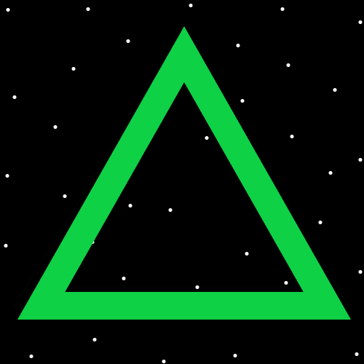
Chapter 3: Laws
The disappointing truth is that the question “What is the meaning of life?”….is not a very good question, and the answer to that age old question is……”That’s not a very good question.”. If the author here could ask a question, it would be something along the lines of “Are proton’s, neutrons or electrons alive?”. It seems one of the best questions might be “Is there a God?”. God is the largest or one of the largest parts of the multiverse. The fact that there is a God is a major detail. Spiritually knowing there is a God can be unimportant. Not believing there is a God…..to god….is entirely understandable. God understands when and why people don’t believe. They lose no favor with him.
One disappointing fact is that God does not have infinite power. The answer to some questions is….” God does not have infinite power.”.
And another fact that people often find disappointing is that you don’t go to heaven when you die. You go to “resurrection day”. the year 0f 7000 Adam/Eve time, around the year 3100 AD. When according to the Bible “multitudes will rise from the dust of the earth.”. Then after 3000 earth years of heaven giving us paradise, we reach “accension day” and ascend to heaven. Its possible humans will be sped up 10x. If humans are sped up 10x it makes the experience 30,000 earth years before we ascend to heaven. Accension happens at 10,000 Adam/Eve time, around 6100 AD.
On “resurrection day”, everyone gets a planet if they want, and much, much more. Flying through space on a mechanical unicorn will be an option. You will be able to get things like space ships the size of moons. Heaven power is endless, when it comes to humans. It’s a lot like they are trillions of years more advanced than us, and trillions of times more powerful.
On “accension day” all humans ascend to heaven and become infants again. A good detail is that we all get raised by his holiness Zero, his holiness Won, and a bunch of holy siblings. The Bible speaks of people “being given the morning star”. This means a star body will be given to them on “ascension day”, and it is also possible that there is double meaning in it, that people will also get their own solar system on “resurrection day”.
It seems like one of the more common questions is “Why am I here?”. When I ask myself that question I think… because I rolled a beginning of time number, and because positive energy evolved to create the most amazing of energies…..consciousness.

