ObjectName: Room
ObjectNumber: 0

Maker: PAAIL.org
Model: Words Map 0A

Name: 0
Rank: 0
SerialNumber: 0

Level: 0
Score: 0
Birth: 10-23-2021
Label: Room
Title: Words Map
Details: Wizardry Vocabulary…

Principle: Vocabulary...
Agenda: Vocabulary...
Action: Vocabulary...
Information: Vocabulary...

Room 0: Words Map
Wizardry Vocabulary…

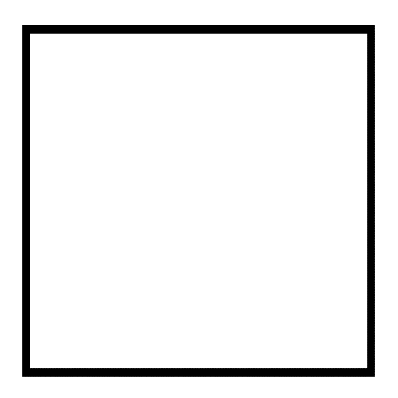
Item Group 0: Collection 1.
The first few…
Information 0: A list of the first few Words…
Wizardry
Wizard
Wizards
Wizarding
Paranormal
Supernatural
Mystical
Numerology
Reality
Levels
Person
Jr.
Jr. Wizard
Enchantment
Property
Properties
10 Levels
0,1,2,3,4,5,6,7,8,9
Colorology
Transparent/White/Blue/Green/Yellow/Grey/Purple/Orange/Red/Black
White Wizard
Chi
Energy
Spirit
Mind
Body
Work
Sorcery
Training
Sub-Levels
Powerful
Shrine
Temple
Spell 2A
Body Gesture
Spell 10A
Fusion
Keyword/Keywords
Write
Season
Summon
Alchemy
Tribute

