ObjectName: Room
ObjectNumber: 2

Maker: PAAIL.org
Model: Wizardry Start 0A

Name: 0
Rank: 0
SerialNumber: 0

Level: 0
Score: 0
Birth: 10-24-2021
Label: Room
Title: Wizardry Start
Details: Wizardry Start…

Principle: Wizardry Start...
Agenda: Wizardry Start...
Action: Wizardry Start...
Information: Wizardry Start...

Room 1: Wizardry Start
Starting Wizardry…

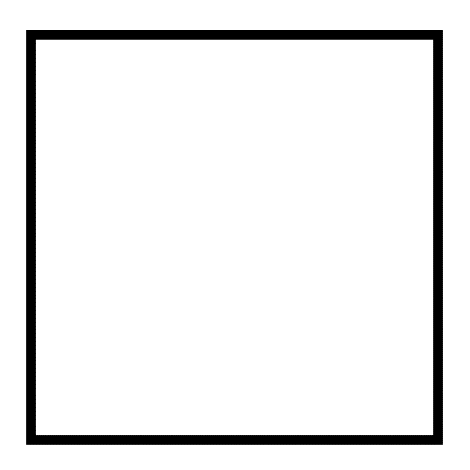

Item Group 0: Wizardry Start…
First stuff…
Principle 0: One ultimate path is to get going on Training some Powerful Spells.
Principle 0: It is also good to Make a Shrine, and a Temple.
Agenda 0: Train up Wizardry Spells.
Agenda 0: Make a bunch of Wizardry Shrines.
Agenda 0: Make a Wizardry Temple.
Principle 0: All People have a Level on Each and every Spell.
Principle 0: A Person has to Train up their Level on each Spell.
Principle 0: The first Spell to Learn is “Spell 0A”.
Principle 0: Spell 0A is Think a Keyword or Keywords 1 time.
Example 1: “Wizardry Spell 0A” is Think the Keyword “Wizardry” 1 time in your Mind.
Example 2: “Bow Spell 0A” is Think the Keyword “Bow” 1 time.
Example 3: “Wizard Bow Spell 0A” is to Think the Keywords “Wizard Bow” 1 time.
Example 4: “Chess Spell 0A” would be to Think the Keyword “Chess” 1 time.
Principle 0: All Spells are both Spells and Spell Parts.
Action 0: Do 1 round of” Wizard Spell 0A”. Think the Keyword Wizard in your Mind… 1 time.
Principle 0: The second Spell/Spell Part is “Spell 1A”.
Principle 0: Spell 1A is Write a Keyword or Keywords 1 time.
Example 1: “Wizard Spell 1A” is Write the Keyword “Wizard” 1 time.
Example 2: “Bow Spell 1A” is Write the Keyword “Bow” 1 time.
Example 3: “Wizard Bow Spell 1A” is Write the Keywords “Wizard Bow” 1 time.
Example 4: “Chess Spell 1A” is Write the Keyword “Chess” 1 time.
Principle 0: Chess Spell 1A is a Chess Spell. Wizard Spell 1A is a Wizard Spell.
Principle 0: Chess Spell 1A would be used for Chess.
Action 0: Do 1 round of Wizardry Spell 1A. Write the Keyword “Wizardry” 1 time.
Principle 0: Spell 0A and Spell 1A Summon Energy. Based on the Keyword/Keywords.
Item Group 0: Advanced Wizardry 1.
Advanced Wizardry 1…
Principle 0: “Spell 2A”(also known as “Bow Spell 2A”) is Bow 1 time. This is a Body Gesture… like waving a Wand around. Or waving you Hand around.
Principle 0: The first that you use is “Spell 10A”.
Principle 0: Spell 10A is High Powered right away, and you don’t Train it. You use it.
Principle 0: You do gain Spell 10A Levels while using Spell 10A.
Principle 0: Spell 10A is a Fusion of other Spells/Spell Parts.
Principle 0: “Spell 10A” is Write a Keyword or Keywords 10 times.
Example 1: Wizardry Spell 10A is Write the Word “Wizardry” 10 times.
Example 2: Wizard Bow Spell 10A is Write the Word “Wizard Bow” 10 times.
Example 3: Chess Spell 10A would be Write the Keyword “Chess” 10 times.
Principle 0: If you play Chess. Chess 10A is a Spell you should do.
Principle 0: If you play Chess, you should use Chess Spell 10A once each Season.
Action 0: Do 1 round of Wizardry Spell 10A. Write the Keyword “Wizardry” 10 times.
Principle 0: Doing Wizardry Spell 10A more than once a Season has no real effect.
Principle 0: You have to let the Season change for the Spell to Work once more.
Principle 0: Most Spell 10A’s you do only once. Ever. Your whole life. 1 time.
Action 0: Do 1 round of Origin Spell 10A.
Action 0: Do 1 round of God Spell 10A.
Action 0: Do 1 round of Power Spell 10A.
Principle 0: Later in this book will be a Room dedicated to the many worthwhile Spell 10A’s.
Principle 0: Once you have done all the Spell 10A’s. You never do them again. They are a one time thing.
Principle 0: Spell 10A’s are one of the primary weapons of this book.
Principle 0: Spell 10A’s are a huge enhancement to the Mind.
Principle 0: Spell 10A’s Summon Energy.
Principle 0: Spells are Sorcery.
Principle 0: Even Low Level Sorcery is Powerful. After all… its Sorcery.
Principle 0: Right away a Person will get Level 1 on Spell 10A.
Principle 0: Right away a Person will get Level 2 on Spell 10A.
Item Group 0: Advanced Wizardry 2.
Advanced Wizardry 2…
Principle 0: There are 4 major things of this book. Thinking Keywords, Writing Keywords, Making Shrines, Making Temples.
Principle 0: There is a way of Making Paper Shrines, that only take a few minutes to make 1 Shrine.
Principle 0: When you put a bunch of Paper Shrines together you unlock the Temple Level 1 Enchantment. You Make a Temple.
Principle 0: Shrines and Temples can be Devoted/Dedicated to anything.
Principle 0: Shrines and Temples can be Devoted/Dedicated to more than one thing.
Principle 0: Making Shrines and Temples is Alchemy.
Principle 0: “Spell 11A” is a Spell you have to Train up.
Principle 0: Spell 11A is one of the primary weapons of this book.
Principle 0: Right away a Person will get Level 1 on Spell 11A.
Principle 0: Right away a Person will get Level 2 on Spell 11A.
Principle 0: It takes very little effort and time to get to Level 3 on Spell 11A.
Principle 0: At Level 3, Spell 11A is super useful.
Principle 0: Spell 11A is Bow 3 times. Each time you Bow you Think the Keyword or Keywords. At the end of the 3 Bows you Pause. During Pause you do Controlled Breathing. Where you think about your Breathing and Control it. You Repeat the process over and over.
Example 1: Wizard Spell 11A is Bow 3 times. Each time you Bow, Think the Keyword “Wizard”. At the end of the 3 Bows you Pause. During Pause you do Controlled Breathing. Think about your Breathing and Control it.
Example 2: Wizard Skill Spell 11A is Bow 3 times. Each time you Bow, Think the Keyword “Wizard Skill”. At the end of the 3 Bows you Pause. During Pause you do Controlled Breathing. Think about your Breathing and Control it.
Example 3: Chess Spell 11A is Bow 3 times. Each time you Bow, Think the Keyword “Chess”. At the end of the 3 Bows you Pause. During Pause you do Controlled Breathing. Think about your Breathing and Control it.
Principle 0: The best Spell 11A’s at first are…Bow Spell 11A, and Breathe Spell 11A.
Principle 0: With Bow Spell 11A… for one… your Bow Level goes up. You gain 1 point gain from each Bow. You gain 1 point for each time Think “Bow”, and you get 3 points for the Fusion of the 2. Resulting in 9 points of gain per Bow Spell 11A.
Principle 0: Bow Spell 11A is quick Grow Bow Levels and Spell 11A Levels.
Principle 0: Spell 11A is very Powerful.
Principle 0: Spell 11A will do the opposite of what is desired until you Train it up to Level 1, and Level 1 will not do anything. You must get to Level 2.
Principle 0: Level 4 on Spell 11A is Advanced Sorcery, and can easily be achieved in a short amount of time.
Principle 0: Breathe Spell 11A does many things. One thing is that it Enchants your Breathing.
Principle 0: Breathe Spell 11A Trains up Spell 11A.
Principle 0: Breathe Spell 11A reminds a Person to Breathe.
Principle 0: From Breathe Spell 11A comes a Connection between your Bow’s and your Breathing.
Principle 0: Breathe Spell 11A Summons Breathing Energy.
Principle 0: Breathe Spell 11A Makes a Connection between your Breathing and Spell 11A’s.
Action 0: Do 1 round of Bow Spell 11A, then do 1 round of Breathe Spell 11A. Then do them again 1 more time. First Bow, then Breathe.
Principle 0: At 2 hours of Spell 11A a Person will be Level 1 or Level 2 on Spell 11A.
Principle 0: At 10 hours of Spell 11A a Person will be Level 3 or Higher, on Spell 11A.
Principle 0: Even at Level 1 there is great value to Spell 11A. It Grows other Levels than just Spell 11A Levels.
Principle 0: For many reasons Spell 11A is a ultimate Power of this Wizard Order. Something you use for the rest of your life.
Principle 0: Once a Person has Trained up Bow Spell 11A and Breathe Spell 11A, they should move onto another Word. Like Chi. Chi Spell 11A.
Principle 0: It takes 2 hours to Train a Spell 11A. 2 hours to Train Chi Spell 11A.
Action 0: Do 2 hours of Bow Spell 11A.
Action 0: Do 2 hours of Breathe Spell 11A.
Action 0: Do 2 hours of Chi Spell 11A.
Principle 0: After doing the last 3 Actions, your Spell 11A is now Level 1.
Principle 0: After doing the last 3 Actions, your Bow Spell 11A is now Level 2.
Principle 0: After doing the last 3 Actions, your Breathe Spell 11A is now Level 2.
Principle 0: After doing the last 3 Actions, your Chi Spell 11A is now Level 2.
Principle 0: After doing the last 3 Actions, your Bow is now Level 1.
Principle 0: After doing the last 3 Actions, your Enchanted Breathing is now Level 1.
Principle 0: After doing the last 3 Actions, your Sorcery Level is now Level 1.
Principle 0: After doing the last 3 Actions, your Wizard Level is 1.
Principle 0: White Wizard and White Sorcerer.
Principle 0: The combination of all these Levels is extremely useful.
Item Group 0: Advanced Alchemy.
Alchemy…
Principle 0: It has been decided to declare all Physical Items Charms. Rather than Write Physical Item all the time.
Principle 0: The definition of Charm is “a Physical Item”.
Principle 0: Some of the biggest Charms are Galaxy’s, Stars, Planets, Moons, Oceans, Mountains….
Principle 0: Some of the most Powerful are Temples and Shrines.
Principle 0: Making Charms is Alchemy.
Principle 0: Enchanting Charms is Alchemy.
Principle 0: Temples and Shrines can be Dedicated/Devoted to anything.
Principle 0: Temples and Shrines can be Dedicated/Devoted to multiple things.
Principle 0: All Charms have things they are Dedicated/Devoted to.
Principle 0: All Charms have Enchantments.
Principle 0: All Charms a Person owns should be thought of as Equipped Charms.
Principle 0: When you own a Shrine or Temple you have it Equipped.
Principle 0: Having a equipped Shrine and Temple is worth while.
Principle 0: It is easy to Make Paper Shrines, and then use them in the Making of a Temple.
Principle 0: With Paper Shrines a Person can Make a very mobile Temple, or just turn any ordinary place into a Temple.
Principle 0: When you Make a Temple, it means you have unlocked the Level 1 Temple Enchantment on a place. You Make a Level 1 Temple.
Principle 0: Even a Low Level 1 Temple is a super awesome thing to have Equipped.
Principle 0: People can share Temples and have the same impact of owning a Personal one.
Principle 0: Along with having a Temple Equipped, you have all the Shrines too. They are super awesome.
Principle 0: The next steps are about Making Wizardry Shrines and Wizardry Temples.
Principle 0: The first step to Making a Wizardry Shrine is to Make Wizardry Items(Wizardry Charms).
Principle 0: A Wizardry Charm is an Item with at least a Level 1 Wizardry Enchantment.
Principle 0: Wizardry Charms are needed to make a Wizardry Shrine.
Principle 0: Wizardry Shrines are needed to make a Wizardry Temple.
Action 0: This is a Spell. Draw the drawing on a blank piece of Paper. Close enough, is good enough.
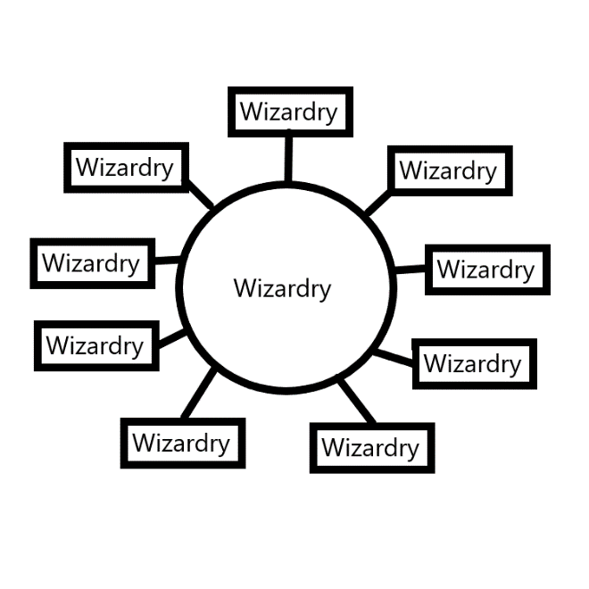
Action 0: Roll the Paper up into a Scroll. Then bend at the center so that it stays closed.
Principle 0: You have now Made a Level 1 Wizardry Scroll. It is best to Keep it in a rolled up form.
Principle 0: This Scroll’s Level will Grow on its own, over time.
Principle 0: Scrolls have more uses than just Making Shrines.
Principle 0: There will be uses for the Scroll you Made, later down the road.
Principle 0: Notice Spell 10A is a Spell Part of the Make Scroll Spell. You Write the Keyword Wizardry 10 times.
Principle 0: The next piece of Paper will not be a Scroll at the end. We will call this a Shrine Paper.
Action 0: This is a Spell. Draw the drawing on a blank piece of Paper. Close enough is good enough.
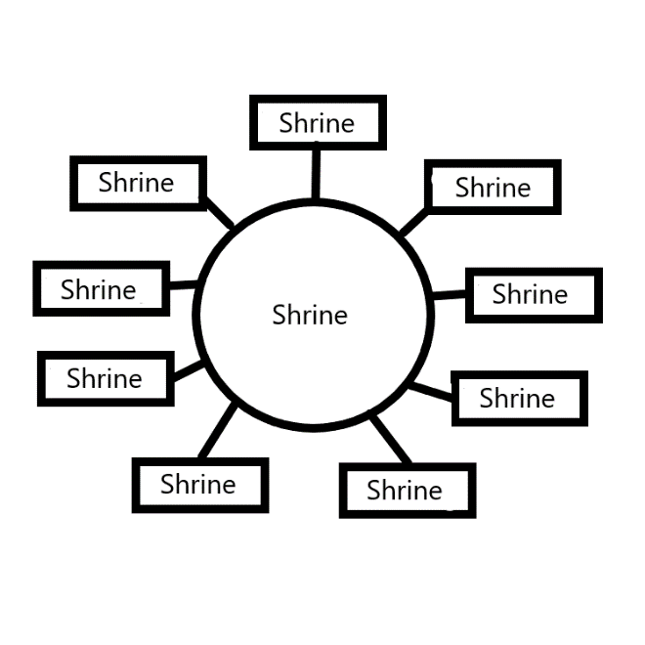
Action 0: Roll the Wizardry Scroll up in the Shrine Paper. Then fold the Shrine Paper at both ends… so it all stays together.
Principle 0: You have now Made your first Wizardry Paper Shrine, and now have at least 1 Shrine Equipped.
Action 0: Make 4 more Wizardry Shrines and put all 5 in one place. After a few days the place will turn into a Temple.
Principle 0: You now have a Level 1 Wizardry Temple.
Principle 0: Put all the Shrines in a bag and you have a mobile Temple.
Principle 0: You don’t need to transport Shrines and Temples around to gain from them.
Principle 0: It is best to have at least one Personal Charm you transport around with you.
Information 0: As a Personal Charm the author of this book right now has 1 Wizardry Paper Shrine in a pocket.
Principle 0: Shrines and Temples are very useful, even at Low Levels.
Principle 0: Shrines and Temples can be used for Ceremony’s, Rituals, Spells and more. They are not just for being equipped.
Principle 0: The Levels of Shrines and Temples Grow over time.
Principle 0: A Person can do things that will help Shrines and Temples Grow.
Principle 0: One of the biggest ways to help Shrines and Temples Grow is to Clean them.
Principle 0: So far the only way I can think of to Clean a Paper Shrine is to wipe it, with a dry cloth. There is probably better Cleaning that can be done.
Principle 0: Some Charms only Expert Cleaning People are supposed to Clean. Experts at Restoring and what not.
Principle 0: Some Charms are “no touch” Charms. Meaning, you are not supposed to Touch them. Often Antiques are this way.
Principle 0: Some Charms you never Touch.
Principle 0: Touching things is a major Spell/Spell Part.
Item Group 0: Wizard Education
Education…
Principle 0: Its probably 100 hours of Work reading “Tome Of the Yellow Wizard”, reading this book and so forth… 100 hours from Level 0 Wizard to Level 3 Wizard.
Principle 0: Its probably a tiny 200 hours to get from Level 0 Wizard to Level 4 Wizard. At 40 hours a week, you would be Level 4 Expert Wizard in 5 weeks.
Principle 0: Once you do your 200 hours. You still need 3 to 6 months of letting your Enchantments Grow on their own, for full effect.
Principle 0: Its probably easy to get from Level 0 to Level 5 Wizard in 400 hours. At 40 hours a week it would take you 10 weeks.
Principle 0: Its recommended to do at least 2 hours a week. Then in one year you will be at Level 3 Wizard.
Principle 0: At 2 hours a week, a person can get from Level 0 to Expert Wizard, Yellow Wizard, in 2 years.
Item Group 0: Enchantments
Enchantments…
Principle 0: Enchantments are Properties.
Principle 0: All Charms have Enchantments.
Principle 0: All People have Enchantments.
Principle 0: A Person can Enchant Charms.
Principle 0: All Enchantments have a Level.
Principle: Enchantments mainly improve Skill Gain per Month for Students and give Performance Enhancements for Experts.
Principle 0: A Person can Enchant themselves.
Principle 0: Enchanting yourself is far more important than Enchanting Charms.
Principle 0: Having a Wizardry Shrine is a huge Enchantment for a Person.
Principle 0: Even a Level 1 Wizardry Shrine is a huge Enchantment for Wizards.
Principle 0: A Level 1 Chess Shrine is huge for a Chess Player.
Principle: A Level 1 Teaching Shrine is huge for a Teacher.
Principle: Having a Temple Equipped is another huge Enchantment. Even a Level 1 Temple.
Principle: If you play Chess, you should make a Chess Shrine and add it to your current Paper Temple.
Principle: 1 Chess Shrine and it will take a week for your Temple to gain the Chess Temple Enchantment.
Principle: If you’re a Teacher, you should make a Teaching Shrine and add it to your current Paper Temple.
Principle: Its not having High Level Charms. Its having Charms Equipped.
Principle: Most Enchantments start at Level 1.
Principle: A Person able to do a Powerful Enchantment, would still Make a Level 1 Enchantment.
Principle: A Person able to do a Powerful Enchantment, would Make an Enchantment that Grows fast.
Principle: An Expert at something can Bless things with a Powerful Enchantment.
Principle: Most Enchantments Grow on their own, once Made.
Principle: Since most Enchantments start out at Level 1… it takes time for Enchantments to Grow.
Principle: One thing in Sorcery is Ageing.
Principle: Ageing is the process of improving over time.
Principle: Enchantments are a thing you Age.
Principle: Charms are a thing you Age.
Principle: Things Age on their own.
Principle: A Person can improve the Ageing process by doing Spells and so forth.
Principle: A Person having Level 1 Sorcery is the Level 1 Sorcery Enchantment.
Principle: If you read “Tome of The Yellow Wizard”, you likely have at least a Level 1 Sorcery Enchantment. You are a Level 1 Sorcerer.
Principle: Tome of The Yellow Wizard is General Wizardry. This book is Sorcery.
Principle: Since practicing Wizardry is Actions… “Wizardry Practice” should be defined as Sorcery.
Principle: Learning General Wizardry is Enchantments gained, and thus there is Sorcery there as well.
Principle: What does Wizardry/Sorcery do. It enhances almost all Powers.
Principle: Wizardry can be used at Chess, Teaching, and most all other things.

Item Group 0: Training 1
Training…
Information: The author of this book is a Level 5 Wizard(Grey Wizard), currently Training Spell 11A, Bow Spell 11A, Breathe Spell 11A, Fists Spell 4A, Breath Spell 3A.
Information: The author has not trained Level 3 on any of these things yet. This is because this information is rather new to the author.
Principle: “Bow Breathe Combo 0A” is a Spell.
Principle: Bow Breathe Combo 0A is a Fusion of Bow Spell 11A, and Breath Spell 11A.
Principle: Bow Breath Combo 0A is do 1 Round of Bow Spell 11A, then do 1 Round of Breathe Spell 11A.
Information: The author of this book is using right now Bow Breathe Combo 0A to Train up Levels, and because it’s a Powerful Spell.
Principle: Bow Breathe Combo 0A does more than just Level gain as well. It is a Powerful Spell.
Action: Do 2 rounds of Bow Breathe Combo 0A.
Agenda: Do Bow Breathe Spell Combo 0A as a major part of your Training.
Information: The author of this book does Bow Breathe Combo 0A spread out, through the day. 30 seconds here…30 seconds there. Total just A few minutes a day.
Information: The author of this book is doing a very slow path at the moment. Not 40 hours a week.
Principle: Often People are busy People. They don’t have much free time.
Principle: I would think most People can find 1 hour a week for Wizardry. Which will have you Expert Wizard in 4 years.
Principle: It is recommended to find at least 2 hours a week for Wizardry. Which will have you Expert Wizard in 2 years.
Principle: Tome of The Yellow Wizard is good enough. This book is a lot more though.
Principle: Do Tome of The Yellow Wizard as your book and you end up a General Wizardry Expert Wizard.
Principle: Do this book and you get another Level of Wizardry and end up more of a Sorcery Wizard.
Principle: The Fusion of the 2 books is the easy get to Level 6 Wizard.
Action: Do 2 Rounds only of Bow Breathe Combo 0A.
Item Group 0: Training 2
Training 2…
Information: The author of this book is a Grey Wizard, currently Training Spell 11A, Bow Breathe Combo 0A, Fists Spell 4A, Breath Spell 3A.
Action: For 10 seconds or close to 10 seconds do Fists Spell 4A(Makes Fists or a Fist. Don’t Squeeze hard).
Agenda: Make Training Fists Spell 4A a major part of your Training.
Information: The author of the book uses Fists Spell 4A, spread throughout the day. About the same amount as Bow Breathe Combo 0A.
Action: For 10 seconds or close to 10 seconds do Fists Spell 4A.
Principle: It is an old lesson to sometimes take a Breath.
Principle: As a Master Wizard, you know that Breathing is important. A Person can even have a more Enchanted Breathing.
Principle: A Person can further improve their Breathing just by doing Breathe Spell 3A, throughout the day.
Action: Do 3-4 Rounds of Breathe Spell 3A(Breathe in 1 time, then Breathe out 1 time). Meaning you Breathe in an out 3 to 4 times.
Principle: A more passive manner is to not count how many times you do Breathe Spell 3A. Just do it a few times.
Principle: A more passive manner is to not count how long you do Fists Spell 4A. Just do it for a few moments.
Principle: Counting how long you have been doing a Spell is not a part of any of these Spells. Don’t do it.
Principle: Nowhere in these Spells is there “count to 10”, or count how many times you do a Spell.
Action: Do 2 Rounds of Bow Breathe Combo 0A.
Action: For 10 seconds or close to 10 seconds do Fists Spell 4A.
Action: For 10 seconds or close to 10 seconds do Breathe Spell 3A.
Principle: Eventually you can Fuse Fists Spell 4A with Bow Breathe Combo 0A. Not at first though. First you have to Train them up. Eventually I will end up Making that Spell.
Principle: Bow Breathe Combo 0A is the ultimate first Training Spell.
Principle: Getting to Level 2 at something is often very easy, and is good time management.
Principle: Level 2 most of the time is a very useful Level.
Principle: 4 hours of Bow Breathe Combo 0A is enough to get Level 2 on the Spell Bow Breathe Combo.
Principle: People have their own Personal Level on a Spell.
Principle: Every Spell has a Global Level.
Principle: The Global Level of a Spell is mainly how much the Spell has been done by People over the years.
Principle: A high Global Level on a Spell is not required however it does help the Spell.
Principle: Once a Person gets to Level 2 on Bow Breathe Combo 0A, they should no longer use Bow Breathe Combo 0A.
Principle: The whole purpose of Bow Breathe Combo 0A is to Train up Bow Levels, and do Enchanting on your Breathing.
Principle: In the future you use Bow so much, that you Train more Bow Levels while using the powerful Bow Body Gesture.
Principle: Bow Level 2 is 20 times better than Bow Level 0.
Principle: Bow Level 2 is a powerful Level on Bow.
Principle: A Level 2 at anything can be very powerful.

Item Group 0: Final Thoughts
Final thoughts…
Principle: Its not about having a high Level Temple equipped… Its about having at least 1 Temple equipped.
Principle: Its not about High Level Charms… Low Level Charms are very Powerful.
Principle: Low Level Charms are easy to Make, and Making them is good Time Management.
Principle: It takes to much time to Make Higher Level Charms, and is bad Time Management.
Principle: Charms Grow on their own over time.
Principle: All Charms end up at the same Location… Level 4.
Principle: Charms Grow on their own very fast.
Principle: Before Level 2(Level 1 and Level 0) a Spell can do the opposite of the desired thing. You must Train at least Level 2 on a Spell.
Item Group 0: Spell 11A
More Training…
Principle: A Person can further Enchant their Spell 11A’s, and Train Higher Levels of Spell 11A’s.
Agenda: Enchant and Train your Spell 11A.
Action: Do Recharge Spell 11A for 2 hours.
Principle: Doing Recharge Spell 11A will Enchant a Person’s Spell 11A’s with a Recharge Enchantment.
Principle: Doing Recharge Spell 11A will increase a Persons Level on Spell 11A’s.
Principe: Recharge Spell 11A is a Spell you can use for the rest of your life. It is not for just Training.
Action: Do Drain Spell 11A for 2 hours.
Principle: Doing Drain Spell 11A will Enchant a Person’s Spell 11A’s with a Drain Enchantment.
Principle: Doing Drain Spell 11A will increase a Persons Level on Spell 11A’s.
Principle: Drain Spell 11A is a Spell you can use throughout your life. However it is mainly a Training Spell.
Item Group 0: Choosing Paths
Different paths for different People…
Principle: Some People should Train 40 hours a week.
Principle: Some People should Train 1 hour a week.
Principle: Some People should use a Higher difficulty path.
Principle: Some People should use a Lower difficulty path.
Principle: 2 hours a week and you get to Expert Wizard after 2 years.
Principle: Body Exercise, Breathing Exercise, and Meditation Exercise are most important of all.
Principle: The older you are, the Higher Level your Body is already.
Principle: The older you are, the less important Body Exercise is.
Principle: Body Exercise increases the quality of the blood in your veins.
Principle: The Mind is fueled by your blood.
Principle: Body Exercise increases a Persons Mana Level, and Mana Battery.
Principle: Body Exercise is a huge Spell.
Principle: Some People get tons of Body Exercise by doing their job.
Principle: Spell 11A has a Breathing Exercise in it. This does a lot of the Breathing Exercise that a Person should do.
Principle: It is likely there are ultimate Breathing Exercises not known to the author of this book.
Principle: Meditation is a subject that a Person could write a whole book on.
Principle: The author of this book has a Low Meditation Knowledge Level.
Principle: The author of this book is not qualified to write a Meditation Book.
Principle: Meditation is casting a Spell.
Principle: Mediation is Spells.
Principle: The oldest Mediation type is the one where you sit and clear your mind or something.
Principle: The oldest one is the ultimate path to choose, and do a lot of.
Principle: The oldest type increases a Persons Mana Level, and Mana Battery, a lot.
Principle: That covers Body Exercise, Breathing Exercise, and Meditation Exercise:
Item Group 0: More Training
More Training…
Action: Do Peace Spell 11A for 2 hours.
Principle: Peace Spell 11A can Summon Peace.
Principle: Peace Spell 11A Enchants your Spell 11A’s with a peaceful Enchantment.
Action: Do Chi Spell 11A for 2 hours.
Action: Do Power Spell 11A for 2 hours.
Principle: At this point a Person has Trained up their Spell Casting and more.
Principle: At this point a Person has increased their Sorcery Levels.
Action: Do Origin Spell 11A for 2 hours.
Principle: At this point a Person can Train Chess Spell 11A.
Principle: Training Chess Spell 11A, Level 2, takes 2 hours of doing Chess Spell 11A.
Principle: Chess Spell 11A is an ultimate warm up Spell. You use it just before a match, to warm up. Do for 30 seconds of your warm up Spells.
Principle: Chess Spell 11A can be added to current warm up.
Principle: Chess Spell 11A will Recharge you when you need Recharge, and Drain you when you want to Drain your Batteries.
Principle: Chess Spell 11A can Recharge and Drain at the same time.
Principle: Just before the start of things there is often a “warm up” time.
Principle: Athletes often stretch as a “warm up”.
Principle: Spell 11A’s are often great to add to a “warm up”.
Principle: If you like Chess a lot… at least once a day… pay Tribute to Chess, and do Chess Spell 11A for 1 minute.
Action: Do Wizardry Spell 11A for 2 hours.
Principle: Since we are Training Wizardry, we did Wizardry Spell 11A for 2 hours.
Principle: A Person who is an Expert at something should do a Spell 11A for 2 hours.
Principle: If a Person is an Expert Teacher they should do Teaching Spell 11A for 2 hours.
Action: All major things you are Expert at do a Spell 11A 2 hours on.
Action: All major things you are Training at do a Spell 11A 2 hours on.
Principle: Now your Knowledge is more Connected to your Mana Level/Mana Battery.
Item Group 0: More Powerful 1
More Powerful…
Principle: Training the Fists Body Gesture is next.
Action: While Making a Fist or Fists(Don’t squeeze hard) do Fists Spell 11A for 2 hours.
Agenda: From now on, when you do a Spell 11A, add Making a Fist or Fists(Don’t squeeze hard).
Item Group 0: More Powerful 2
More Powerful to…

Information: The author does not know all moments when to use Spell 11, or Spell 10A.
Information: All information is authors best guess.
Principle: If you were writing a book on Chess, you would use Chess Spell 11A 5 times each day(30 seconds each time). Maybe…
Principle: Chess Spell 11A would be useful as a 30 seconds of your warm up before each match.
Principle: Body Exercise Spell 11A would be good for 30 seconds of warm up before a bunch of physical exercise.
Principle: Jog Spell 11A would be good as part of warm up before a jog. 30 seconds.
Principle: If you were writing a book on Chess, you would use Chess Spell 10A at least 1 time a day.
Principle: “Push Ups” have a huge Global Level, and have a huge Connection to the military side of the Universe.
Principle: A Person can Meditate a Low amount of time (Low Difficulty).
Principle: A Person can Meditate a Medium amount of time(Medium Difficulty).
Principle: A Person can Meditate a High amount of time (High Difficulty).
Principle: A Person has to choose the difficulty of the Path they go.

Principle: In Numerology there is Low, Medium, High. The Low Numbers 1,2,3. The Medium Numbers, 4,5,6. The High Numbers, 7,8,9.
Principle: In Wizardry there is Low, Medium, and High.
Principle: Often People choose Low difficulty at first, then Higher difficulty later.
Principle: Often People have little spare time and should choose Low difficulty.
Principle: Spell 11A is a Meditation. It would seem there are different Types of Meditation.
Principle: The more famous Meditation Type is the one where you sit and clear your mind or something.
Principle: There are items that are more Wizard like. One is the Mediation Rug. One is the Shrine. One is the Temple.
Principle: A Wizard understands we Enchant People, Places, and Things.
Principle: A Wizard understands all things have their Enchantments.
Principle: People go around Enchanting things without knowing it.

