ObjectName: Room
ObjectNumber: 5

Maker: Wizardry Practice 0A
Model: Charm Spells 0A

Name: 0
Rank: 0
SerialNumber: 0

Level: 0
Score: 0
Birth: 10-17-2021
Label: Room
Title: Charm Spells
Details: Powerful Spells…

Principle: Spells Powerful.
Agenda: Spells Powerful.
Action: Spells Powerful.
Information: Spells Powerful.

Room 5: Charm Spells
Powerful Spells…


Principle 0: Alchemy is not just potions and powders. Alchemy is Charms.
Principle 0: Alchemy is Making Charms, Enchanting Charms, and Increasing Levels on Charms.
Principle 0: These Spells are Charm related.
Principle 0: All Physical Items are Charms.

ObjectName: Spell Item
ObjectNumber: 0

Maker: Wizardry Practice 0A
Model: Wizardry Charm 0A

Name:0
Rank:0
SerialNumber: 0

Level:0
Score:0
Birth: 8-26-2021

Label: Action
Title: Wizardry Charm 0A
Details:
Draw the drawing on a piece of paper. Close enough, is good enough. Notice Wizardry Spell 10A is a part of this Spell. You must write the Word Wizardry 10 times. Do not draw on other side of paper. Make sure to use a blank piece of paper. Draw the drawing, not print the drawing. This is a Weak Wizardry Item. Turn it into a Scroll and you Make a Strong Wizardry Item.

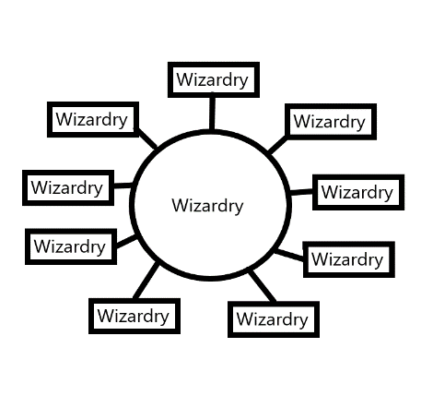
Principle: Weak Wizardry Item.
Agenda: Weak Wizardry Item.
Action: Weak Wizardry Item.
Information: Weak Wizardry Item.
ObjectName: Spell Item
ObjectNumber: 0

Maker: Wizardry Practice 0A
Model: Quick Paper Scroll 0A

Name:0
Rank:0
SerialNumber: 0

Level:0
Score:0
Birth: 8-26-2021

Label: Action
Title: Quick Paper Scroll 0A
Details:
You can roll up a piece of paper and it turns into a Scroll. If you have no rope/string or something else to keep it rolled up… you can bend it at the center to keep it closed. It is better Kept in a closed manner…
Note: Paper Scrolls are a great way to Make an Enchanted Charm…
Note: The main purpose of Paper Scrolls is to Make Enchanted Items that get used for quick Shrine Making…
Note: You have to Write Keywords or Symbols/Drawings on the Scroll for it to be an Enchanted Scroll…

Principle: Strong Wizardry Item for quick making Shrines…
Agenda: Strong Wizardry Item for quick making Shrines…
Action: Strong Wizardry Item for quick making Shrines…
Information: Strong Wizardry Item for quick making Shrines…

ObjectName: Spell Item
ObjectNumber: 0

Maker: Wizardry Practice 0A
Model: Quick Shrine 0A

Name:0
Rank:0
SerialNumber: 0

Level:0
Score:0
Birth: 10-17-2021

Label: Action
Title: Quick Shrine 0A
Details:
1-Draw the drawing on a piece of paper. Close enough, is good enough. Notice Wizardry Spell 10A is a part of this Spell. You must write the Word Shrine 10 times. Do not draw on other side of paper. Make sure to use a blank piece of paper. Draw the drawing, not print the drawing.
2-Roll up 1, 2, or 3 Scrolls inside the Shrine Paper. Then bend the ends up the Shrine Paper. So it all stays together on its own. You now have a Paper Shrine.
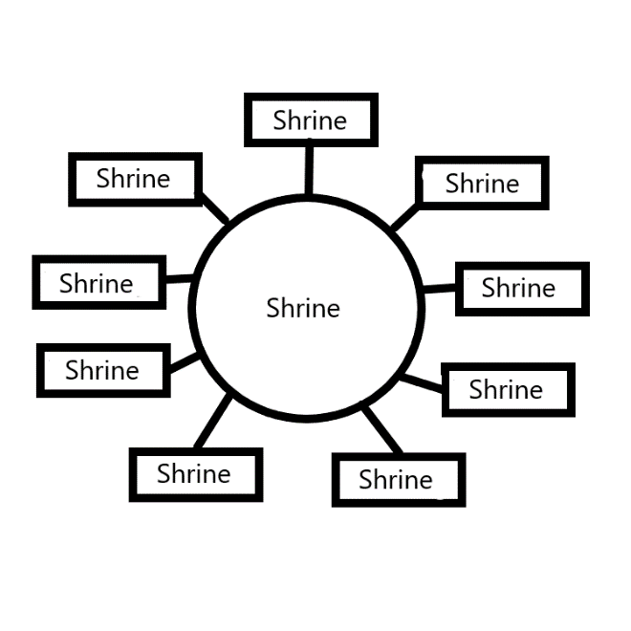
Note: Quick Shrines are great because they are Shrines. Shrines are Powerful Charms.
Note: Put 5 Shrines in one place and you Make a Temple, which is an even more Powerful Charm.
Note: Making Shrines and Temples is Alchemy.

Principle: Quick Shrines.
Agenda: Quick Shrines.
Action: Quick Shrines.
Information: Quick Shrines.
ObjectName: Spell Item
ObjectNumber: 0

Maker: Wizardry Practice 0A
Model: Shrine Grow 0A

Name:0
Rank:0
SerialNumber: 0

Level:0
Score:0
Birth: 10-2-2021

Label: Action
Title: Shrine Grow 0A
Details:
1-First you must decide which Shrine Enchantment you are trying to Increase. If it is the Wizardry Enchantment on the Shrine… then the Keyword of this Spell is Wizardry. If it is the Chess Enchantment on a Shrine… then the Keyword of this Spell is Chess.
2- With your Shrine before you. Bow 3 times. Each time you Bow think the Keyword then think the Word Shrine. After 3 Bows then Pause for a moment. During Pause do Controlled Breathing(Control your Breathing).

3-Example 0: If the Spell is Wizardry Shrine Grow 0A then the Keywords are “Wizardry Shrine”. With your Shrine before you. Bow 3 times. Each time you Bow think the Words “Wizardry Shrine”. After 3 Bows then Pause for a moment. During Pause do Controlled Breathing.
Note: A Shrine is like a plant. You only want to water it so much. Shrine Grow 0A is watering the Shrine. Never do more than 5 minutes a day. And on the long term its 5 minutes a week.
Note: Shrines Grow on their own. This Spell does speed up growth when it comes to Level 2 and Level 3.
Note: This Spell should only be used to Grow a Shrine to Level 2. At that point you stop using this Spell.
Note: This Spell is all about quick Grow Level 2 Shrines. Which is quick Grow Level 2 Temples.

Principle: Level 2 Temples…
Agenda: Level 2 Temples…
Action: Level 2 Temples…
Information: Level 2 Temples…
ObjectName: Spell Item
ObjectNumber: 0

Maker: Wizardry Practice 0B
Model: Charm Raise 0A

Name:0
Rank:0
SerialNumber: 0

Level:0
Score:0
Birth: 12-10-2021

Label: Action
Title: Charm Raise 0A
Details:
Raise a Charm above your head.

Principle: Charms Power…
Agenda: Charms Power …
Action: Charms Power …
Information: Charms Power …

