ObjectName: Room
ObjectNumber: 9

Maker: Wizardry Practice 0A
Model: Spell 10A 0A

Name: 0
Rank: 0
SerialNumber: 0

Level: 0
Score: 0
Birth: 12-23-2021
Label: Room
Title: Spell 10A
Details: All about Spell 10A…

Principle: Spell 10A Details.
Agenda: Spell 10A Details.
Action: Spell 10A Details.
Information: Spell 10A Details.

Room 8: Spell 10A
All about Spell 10A…

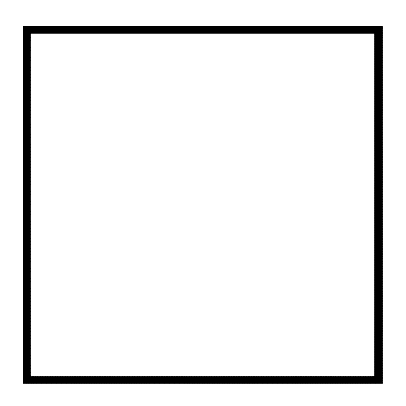
Item Group 0: Details
Spell 10A…
Principle: Spell 10A is Write a Keyword 10 times.
Example: Wizardry Spell 10A is Write the Word “Wizardry” 10 times.
Principle: A Person can use Spell 10A on many things.
Principle: All Experts at things should use Spell 10A at least once a year. A Expert at Chess would use Chess Spell 10A once a year. Education Experts would use Teaching Spell 10A once a year.
Principle: All Students of things should use the major Keywords of there subject in Spell 10A’s.
Example: Chess Students would use Chess Spell 10A once a week.
Principle: This book comes with a list of Spell 10A’s that everyone should do 1 time.
Principle: An Expert can Channel more Energy through things. An Expert at Chess can Channel more Energy through Chess Spell 10A.
Principle: There are many Words worth doing A Spell 10A on.
Principle: There are many Words a Person should do 1 time in their lives.
Principle: A Person gets a bunch of Hand Body Exercise doing Spell 10A’s.
Principle: For a Sorcerer the Hands are like Wands.
Principle: Exercise on the Hands is very good for a Person.
Principle: Spell 10A Enchants the Person doing the Spell.
Principle: Spell 10A Makes a greater Connection between a Person and something else.
Principle: Spell 10A is Low difficulty, High Power Sorcery.
Principle: A Person will get Level 1 Sorcery… very easy… doing a bunch of Spell 10A’s.
Principle: A Person can get 1 Sorcery Level out of doing Spell 10A’s.

