ObjectName: Room
ObjectNumber: 10

Maker: Wizardry Practice 0A
Model: Words Spells 0A

Name: 0
Rank: 0
SerialNumber: 0

Level: 0
Score: 0
Birth: 10-4-2021
Label: Room
Title: Words Spells
Details: Spell 10A’s worth doing 1 time…

Principle: Tap Into Power.
Agenda: Tap Into Power.
Action: Tap Into Power.
Information: Tap Into Power.

Room 10: Words Spells
Spell 10A’s worth doing 1 time…

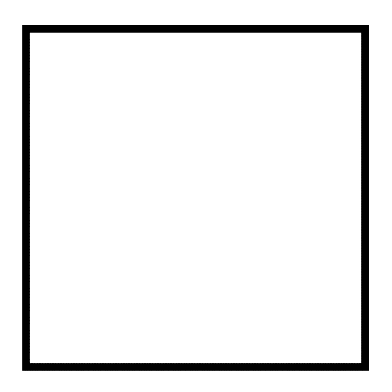
Item Group 0: Principles
Mainly Room Principles…
Principle 0: Most all these Words are only good to do 1 time. Most all these Spells are good only 1 time.
Principle 0: These Spells are super awesome, and very worthwhile.
Principle 0: These Spells are Words on the brain(Mind).
Principle 0: TV shows are Words on the brain(Mind).
Principle 0: Music is Words on the brain(Mind). If it has lyrics.
Principle 0: Reading is Words on the brain.
Principle 0: Movies are Words on the brain.
Principle 0: Thinking Words. Speaking Words. All Words on the brain.
Principle 0: In life there are many sources of Words on the brain.
Principle 0: Words on the brain Increases intelligence.
Principle 0: All the Spell 10A’s of this book shred the Mind.
Principle 0: Shredding the Mind is exactly like Shredding Body muscle… through physical Exercise. It results in massive muscle Growth. Massive Mind Growth.
Principle 0: These Spells Summon Energy. Principle 0: These Spells Tap Into Energy. Principle 0: These Spells Connect a Person to Energy.
Information 0: Some Spell 10A Actions should exist throughout the Rooms of this book.
Information 0: Some Spell 10A Actions should be moved to this Room in the book.
Action 0: Do Breathe Spell 3A 1 time. Then do Fist Spell 4A for 10 seconds or close to 10 seconds.
.
Item Group 0: Actions
Mainly Room Actions…
Principle 0: Skip all Actions you have already done before in your life.
Action 0: Do Giant Spell 10A.
Action 0: Do Hybrid Spell 10A.
Action 0: Do Cosmos Spell 10A.
Action 0: Do Immortal Spell 10A.
Action 0: Do Lord Spell 10A.

