ObjectName: Room ObjectNumber: 1

Maker:
Model: 0

Name: Words Map
Rank: 0
SerialNumber: 0

Level: 0
Score: 0
Birth: 8-25-2021

Label: Room
Title: Words Map
Details: A Words Map…

Principle: Words Map.
Agenda: Words Map.
Action: Words Map.
Information: Words Map.

Room 0: Words Map
A Words Map…
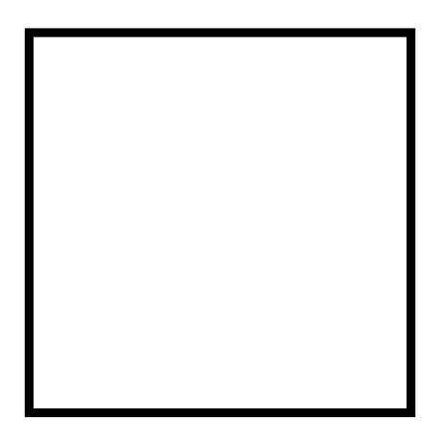

Information 0: Quick Words List

Wizardry
Wizardry Practice
Sorcery
Bow Gesture
Spell 0’s
Spell 1’s
General Bow Levels
Keywords
Paying Tribute
Training
Words
Thinking Words
Speaking Words
Sessions
Spells
Spell Parts
Controlled Breathing
Power Up
Bow Spell 1
Chi Spell 1
Disconnect Spell 1
Recharge Spell 1
Drain Spell 1
Wizardry Spell 1
Breath Spell 1
Batteries
Time Management
Runes
Negative Runes
Lots more of these…..
Shrine
Enchantment
Enchanting
Properties
This list goes on and on…
Spell 2
Spell 3
Fists Spell 2
Palms Spell 3
I could spend a long time on this room.
Lots to do in this room.
Make
Wizardry Charm 0
Shrine Charm 0
Mirroring
Ageing
Bond
Tame
Tribute
Summon/Summons/Summoning
Summoned
Paralleling

PAAIL
Principle/Principles
Agenda/Agendas
Action/Actions
Information
Universe
Galaxy
Star Group
Star
Planet
Land
Building
Room
Item Group
Item
Item Item
Item Item Item
View/Views/Viewer/Viewing/Viewed
Location
Map/Maps/Mapping/Mapper/Mapped

Principle 0.0: Wizardry Definition

