ObjectName: Room ObjectNumber: 3

Maker: Wizardry Practice 0A
Model: 0A

Name: Book Beginning
Rank: 0
SerialNumber: 0

Level: 0
Score: 0
Birth: 9-6-2021

Label: Room
Title: Book Beginning
Details: Being book ready and more…

Principle: Book start.
Agenda: Book ready and more.
Action: Book ready and more.
Information: Book start.

Room 0: Book Beginning
Being book ready and more…
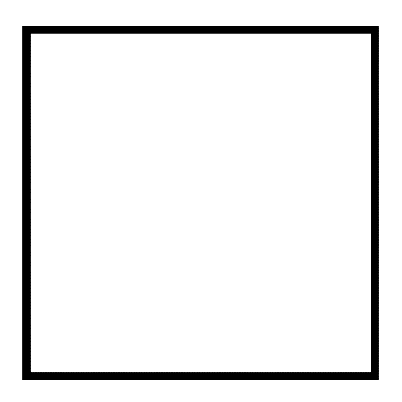
Information 0: Tome Maker
I am your Instructor. The Maker of this book. A Master Wizard, Jr. Teacher, and Jr. Programmer. My writing Level is very Low. A 10 times better book than this could be Made by Expert Teachers, and Expert Writers. However this book is good enough to get the job done.
Principle 0.0: Wizardry Definition
Wizardry is Paranormal, Supernatural, and Mystical Science.
Principle 0.0: Wizardry Practice
Wizardry Practice is using Paranormal, Supernatural, and Mystical Knowledge.
Principle 0.0: Wizardry Areas
Wizardry includes, Sorcery, Numerology, Colorology, Cosmic Knowledge, Astronomy, Chakra’s, Greek Gods, Dream Interpretation, Animal Spirits, Tarot Cards, Alchemy, ESP, Spells, Enchanting, and more. The author of this book does not know them all. There’s probably another 100 of them. Greek Gods never existed. There are Secrets behind the Greek God myths.
Principle 0.0: Sorcery
Tarot Cards is a Sorcery, so is Alchemy, so is Dream Interpretation. Many things are Sorcery. Using Astrology Knowledge is a Sorcery.
Principle 0.0: Sorcery
Sorcery is Spells. Spells are Actions. Sorcery is the Actions part of Wizardry. Sorcery is Paranormal, Supernatural, Mystical, Actions. All Sorcery is Actions.

Principle 0.0: Sorcery
Though all Actions have a Paranormal, Supernatural, Mystical Side. Some Actions are deemed not Paranormal, Supernatural, or Mystical, and therefor some Actions in life are not Sorcery.

Principle 0.0: Wizardry
Wizardry Knowledge is part of Wizardry, however Wizardry Practice is using the Knowledge and doing actual Sorcery.
Principle 0.0: Paper Book Version
If you have a paper copy of this book, then it may have come with mini black squares on every page, and a big black square every Room. These are used for book exercises and for Enchanting the paper book.
Principle 0.0: Paper Book Version
The mini black squares are for Enchanting the book. The big black squares are for doing Spells where you Write.
Principle 0.0: Paper Book Version
You do not need a paper copy of this book. A paper book has a nice Wizardry Enchantment right away. However getting a Wizardry Enchantment on an Item is not hard. A paper book is not important.
Principle 0.0: Paper Book Version
Never write over other peoples Words in the book.
Principle 0: Paper Book Version
A paper copy of a Chess book has a decent Chess Enchantment on it. A paper copy of a Wizardry book has a decent Wizardry Enchantment on it. Books are a quick way to get Items of the desired Enchantment. If you do not have a paper copy of this book, you will need to get a paper note book to Write in.
Principle 0: Training Spells
All Spells take time to Train, before they will have a Positive impact. Many Spells will do the opposite of what is desired until you have trained them up.

Principle 0: Training Spells
Training up Spells does not take very long, and they grow on their own once Trained.
Principle 0: Wizardry Items
A Wizardry Item can be used to create other Wizardry Items. It can also do more. This book is a Wizardry Item.
Principle 0: Books
The author of this book is not an Education Expert, is not an Expert at creating Education Books, and also the author is not good at writing. For these 3 reasons, a book that is 10 times better could be done. A book that teaches these same things, however is 10 times better. This would require Education Experts, and Experts at creating Education books.
Principle 0: PAAIL
This book was done using PAAIL. Visit PAAIL.org
Principe 0: Digital Learning
It is not important to learn this book from a paper copy. You can do a digital. You will have to do Writing Spells in some paper book though. A small paper notebook may work well. Writing things on paper is a huge spell.
Principle 0: Notebook Items
If you choose to Write in a notebook…you will grow a Wizardry Item. If you take Notes while reading this book, the notebook you use will grow a decent Wizardry Enchantment.

Principle 0: Book Enchantments
Writing a bunch of stuff about Chess in a notebook, creates a nice Chess Enchanted Item. If you write a bunch of Wizardry in a notebook you get a nice Wizardry Enchanted Item.

Principle 0: Tome Of The Yellow Wizard
This book combined with “Tome Of The Yellow Wizard” are enough to get a person to Expert Wizard and beyond. Tome Of The Yellow Wizard is good enough to get Expert, however this book is a bunch more Wizardry Level Increase, Powerful Spells, and more.
Principle 0: Title Part 0A
The Title part “0A” is chosen, so that eventually there could be a version “0B” of this book, and a eventually a more Advanced “0C”, then “0D”…
Agenda 0: Useable Wizardry
The Agenda of the book is to teach Powerful Spells and usable Wizardry. Many Spells that you do when you’re a Beginner, are still useful when you hit Advanced. The early learned Spell 10A and Spell 11A are Spells for Beginners and for people who are Advanced.
Information 0: PAAIL 2.3B
If you know PAAIL. A lot of this book was done before PAAIL 2.3B. PAAIL 2.3B added “Item Groups”. A thing you won’t find in this book. Until later on in this book.
Principle 0: Cosmic Knowledge
Wizardry is honest work. All honest work has about the same Spiritual impact.
Principle 0: Consciousness
Wizardry expands consciousness.
Principle 0: Mind Levels
Wizardry Increases Mind Levels. It Increases intelligence, wisdom, makes one more graceful and Increases other Mind Properties. This is one of the many uses of Wizardry.
Principle 0: Mind Levels
This book and Tome Of The Yellow Wizard Increase Mind Levels a lot.
Principle 0: Body Levels
The Wizardry of this book Increases Body Levels.
Principle 0: Body Levels
Body Levels can give a Person more intelligence, wisdom, Make one more graceful, and more.
Principle 0: Wizardry Fusion
Wizardry often is used by Fusing it with some other area of Science. Wizardry can be Fused with most Science.
Principle 0: Wizardry Fusion
Wizardry can often be Fused with any activities.
Principle 0: Wizardry Fusion
Wizardry can be Fused with things like Chess, Cleaning, Biology,…on and on, the list is endless.
Principle 0: Writing Words Spells
This book is full of Writing Words Spells(Where you Write Words to Tap into Power). When using a Notebook… it is best to do these Write Words Spells at the back of the notebook. Then the Beginning of the Notebook can be used for better things.
Principle 0: Wizardry Levels
The current theory is that this book Fused with Tome Of the Yellow Wizard…. On the Short Term(6 months) a person can easily get to Level 3 Wizard. A more long term(1 year) a person can easily get to Level 4 Wizard(Expert Wizard). On an even longer term(2-4 years) a person can easily get to Level 5 Wizard(Master Wizard). And on an even longer term(6-10 years) a person can easily get to Level 6 Wizard(Doctorate Wizard).

