ObjectName: Room ObjectNumber: 4

Maker: Wizardry Practice 0A
Model: Wizardry Basics 0A

Name: Wizardry Basics
Rank: 0
SerialNumber: 0

Level: 0
Score: 0
Birth: 9-7-2021

Label: Room
Title: Wizardry Basics
Details: Basic Wizardry…

Principle: Basic Wizardry learning.
Agenda: Increase Wizardry Levels.
Action: Increase Wizardry Levels.
Information: Learn Basic Wizardry.

Room 1: Wizardry Basics
Basic Wizardry…
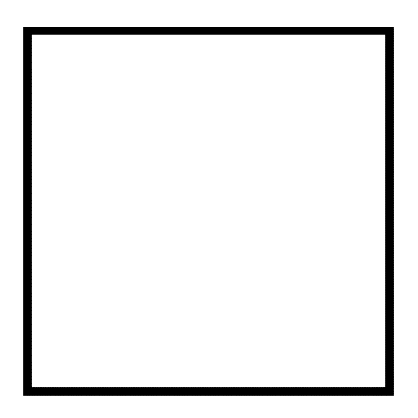
Principle 0.0: Levels
Levels is a Keyword/Vocabulary Word of Wizardry, and a major Vocabulary Word of Wizardry.
Principle 0.0:10 Core Numbers
In Numerology there are the Core 10 Numbers. 0,1,2,3,4,5,6,7,8,9. Also known as the Single Digit numbers.
Principle 0: Levels
In Numerology Level 4 is Expert. Level 5 is Master. Level 6 and higher are Doctorate. This lines up with Level 4 is a Bachelor’s Degree, Level 5 is a Masters Degree. Level 6 and higher is Doctorate.
Principle 0: Tome Of The Yellow Wizard
This book combined with the book “Tome of the Yellow Wizard”…when Fused together, can get a person to Expert Wizard and beyond.
Information 0: Training Time
If a person were a “full time student”(40 hours a week)…then they could probably get at least Expert Wizard in 1 to 2 years. “part time student”(20 hours a week) 1 years to 2 years. (10 hours a week) 2 to 3 years.
Principle 0: Training Time
In Wizardry we Enchant ourselves with Wizardry Enchantments that take time to grow. This makes Wizardry Level Increase not about only learning Knowledge. It is also about letting Enchantments have time to grow.
Principle 0: Training Time
There is probably the Expert Knowledge Wizard, who could get there in 3-6 months. This book teaches Knowledge and Sorcery that takes a minimum 1 year to get to Expert Wizard.
Principle 0: Training Time
Part of the time required to get Expert Wizard is not Knowledge…and this is partly why it always takes at least a year to get Expert Wizard.
Principle 0: Wizardry Levels
Wizardry Levels takes time to grow. This is common to gaining Levels in Reality.
Principle 0: Wizardry Enchantments
By now you have read the Word “Wizardry” many times, and read a Wizardry Book Item. This will have boosted your Wizardry Level at least 0.1 Levels(if you were a Level 0 Wizard). In this situation the experience has Made an Enchantment on you. This Enchantment will grow all on its own, from now on.
Principle 0: Junior Wizards 0
Levels 1,2 and 3 are Junior Wizard Levels. Junior Wizardry is priceless, and there is much use for it. You do not need to become an Expert Level 4 Wizard to use Wizardry.
Principle 0: Junior Wizards 1
Getting Level 1 happens almost right away. If you read all of “Tome of The Yellow Wizard”, it happened while you were reading it. Getting a Level 1 is usually a quick thing.
Principle 0: Junior Wizards 2
Level 2 in things usually requires little effort. If you do this book and Tome Of The Yellow Wizard, you will be at least a Level 2 Wizard, when you finish them both.

Principle 0: Junior Wizards 3
Level 3 takes much more time to get, than Level 2. A year after you have done both books you are likely to be at least a Level 3 Wizard. Done both books means you learned everything good enough.
Principle 0: Junior Wizards 4
Going from Level 3, to Level 4 is 10 times more difficult than going from Level 2 to Level 3. Level 4 requires a great deal of discipline.
Principle 0: Junior Wizards 5
Getting Levels 1, 2 and 3 requires very little discipline. Its part of why they are so worthwhile, its easy to do.
Principle 0: Junior Wizards 6
If you ever hit Level 2 Wizardry, after that your Wizardry Level will grow on its own. Eventually you will end up a Level 3 Wizard. This will not take long either.
Principle 0: Junior Wizards 7
As with many things… training Wizardry can be work. However the tiny amount of time to get Level 2 Wizard is very worthwhile. And you get to call yourself a Jr. Wizard too.
Principle 0: Junior Wizards 8
If you finished reading Tome of The Yellow Wizard, without taking notes, just a general read… you are likely at least Level 2 right now. It really takes very little to get to Level 2.
Principle 0: Wizardry Practical Use 0
Wizardry tends to be very useful as an inspiration.
Principle 0: Wizardry Practical Use 1
Wizardry has Spells that are very useful.

Principle 0: Wizardry Practical Use 2
This book teaches Spells and Spell Parts, that are useful to Level 1 Wizards and remain useful for the rest of your Wizard existence.
Principle 0: Wizardry Practical Use 3
Since the Word “Levels” is a major Vocabulary Word, its often all about Levels. Wizardry is often about Increasing Level gain per hour, and using high Levels in things like Chess. A High Level Chess person, who is also is a Wizard can do unique(Hybrid) High Level Chess Spells.
Principle 0: Wizardry Practical Use 4
One major use of Wizardry is doing Enchantments. Enchanting things like Charms and Shrines, can result in 5% enhancements to performance and Level gain. This usually takes little time and effort to do these 5% Enchantments.
Principle 0: Wizardry Practical Use 5
Higher than 5% Enchantments can be gotten as well.
Principle 0: Wizardry Practical Use 6
There are Spells that will do 5% boosts as well. Higher than 5% boosts can be gotten.
Principle 0: Wizardry Practical Use 7
The Spells and Spell Parts in this book will be more than enough for 5% gains and Higher.
Principle 0: Wizardry Practical Use 8
Fusing Wizardry with other areas of Science is another big use for Wizardry. Even Junior Wizards can do this. This is called Hybrid Wizardry.
Principle 0: Wizardry Practical Use 9
Wizardry is very easy to learn, and requires very little effort to get Level Increase’s. Compared to other areas of Science it is super fast to train.

Principle 0: Spell Parts
All Spells are both Spells, and Spell Parts.
Principle 0: Core 10 Spells
At the beginning of this book is the “Core 10” Spells. Room 2.

