ObjectName: Room
ObjectNumber: 7

Maker: Wizardry Practice 0A
Model: Charm Spells 0A

Name: 0
Rank: 0
SerialNumber: 0

Level: 0
Score: 0
Birth: 9-27-2021
Label: Room
Title: Charm Spells
Details: Charm related Spells…

Principle: Spells Powerful.
Agenda: Spells Powerful.
Action: Spells Powerful.
Information: Spells Powerful.

Room 7:
Charm Spells
Charm related Spells…


Principle 0: This set of Spells are related to Charms.

ObjectName: Spell Item
ObjectNumber: 0

Maker: Wizardry Practice 0A
Model: Wizardry Charm 0A

Name:0
Rank:0
SerialNumber: 0

Level:0
Score:0
Birth: 8-26-2021

Label: Action
Title: Wizardry Charm 0A
Details:
Draw the drawing on a piece of paper. Close enough, is good enough. Notice Wizardry Spell 10A is a part of this Spell. You must write the Word Wizardry 10 times. Do not draw on other side of paper. Make sure to use a blank piece of paper. Draw the drawing, not print the drawing. This is a Weak Wizardry Item. Turn it into a Scroll and you Make a Strong Wizardry Item.
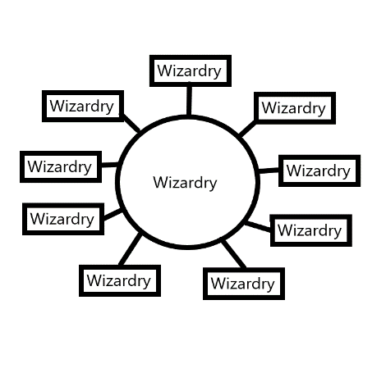
Principle: Weak Wizardry Item.
Agenda: Weak Wizardry Item.
Action: Weak Wizardry Item.
Information: Weak Wizardry Item.

ObjectName: Spell Item
ObjectNumber: 0

Maker: Wizardry Practice 0A
Model: Quick Paper Scroll 0A

Name:0
Rank:0
SerialNumber: 0

Level:0
Score:0
Birth: 8-26-2021

Label: Action
Title: Quick Paper Scroll 0A
Details:
You can roll up a piece of paper and it turns into a Scroll. If you have no rope/string or something else to role it up with… you can bend it at the center to keep it closed. It is better Kept in a closed manner.

Principle: Strong Wizardry Item.
Agenda: Strong Wizardry Item.
Action: Strong Wizardry Item.
Information: Strong Wizardry Item.

ObjectName: Spell Item
ObjectNumber: 0

Maker: Wizardry Practice 0A
Model: Shrine Grow 0A

Name:0
Rank:0
SerialNumber: 0

Level:0
Score:0
Birth: 10-2-2021

Label: Action
Title: Shrine Grow 0A
Details:
1-First you must decide which Shrine Enchantment you are trying to Increase. If it is the Wizardry Enchantment on the Shrine… then the Keyword of this Spell is Wizardry. If it is the Chess Enchantment on a Shrine… then the Keyword of this Spell is Chess.
2- With your Shrine before you. Bow 3 times. Each time you Bow think the Keyword then think the Word Shrine. After 3 Bows then Pause for a moment. During Pause do Controlled Breathing(Control your Breathing).

3-Example 0: If is Wizardry Keyword then… With your Shrine before you. Bow 3 times. Each time you Bow think the Words “Wizardry Shrine”. After 3 Bows then Pause for a moment. During Pause do Controlled Breathing.

Principle: Spell Item that does Standard Shrine Enchantment Level Increase.
Agenda: Spell Item that does Standard Shrine Enchantment Level Increase.
Action: Spell Item that does Standard Shrine Enchantment Level Increase.
Information: Spell Item that does Standard Shrine Enchantment Level Increase.

