ObjectName: Room ObjectNumber: 8

Maker: Wizardry Practice 0A
Model: Charms Basics 0A

Name: 0
Rank: 0
SerialNumber: 0

Level: 0
Score: 0
Birth: 9-22-2021

Label: Room
Title: Charms Basics
Details: Charms…

Principle: Charms.
Agenda: Increase Wizardry Levels.
Action: Increase Wizardry Levels.
Information: Charms.

Room 8: Charms Basics
Charms Basics…
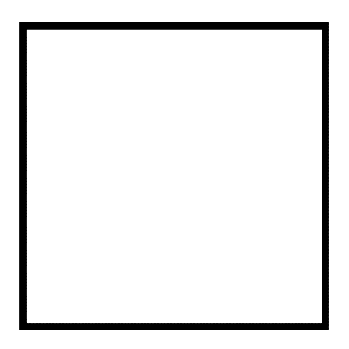
Item Group 0: Vocabulary Start
Principle 0: Physical Items are a major Part of Reality. In Wizardry it has been decided to use the Vocabulary Word Charms. This seems better than Writing “Physical Items” all the time.
Principle 0: All Physical Items are Charms. A drop of water is a Charm. A Building is a Charm. Planets and Moons are Charms.
Principle 0: All Charms have Properties. All Properties are also Enchantments.
Principle 0: All Charms have Enchantments.
Principle 0: All Charms have an Infinite amount of Properties.
Principle 0: All Charms have an Infinite amount of Enchantments.

Item Group 0: Charms Basics
Principle 0: Charms is a major Vocabulary Word of Wizardry. The next step is to do Charm Spell 10A. Spell 10A is High Powered the first time you do a Word. After that it is not worth the time. This is why we only do it 1 time.
Action 0: Do 1 Round of Charm Spell 10A.
Action 0: Do 1 Round of Property Spell 10A.
Action 0: Do 1 Round of Enchantment Spell 10A.
Principle 0: Runes are Writings/Paintings/Symbols/Pictures. Brail is Runes.
Action 0: Do 1 Round of Rune Spell 10A.
Action 0: Do Breathe Spell 11A for 10 seconds or close to 10 seconds.
Principle 0: If a person went and did Charm Spell 11A at this point. They would not have the Word Charm Trained up. They would not have that Spell Trained up.
Principle 0: At this point a person can Train up Charm Spell 11A because of all the Spell 11A’s that have already been done. It would take 2 hours to Train Charm Spell 11A. It is not worth doing right now.
Principle 0: All Physical Items people own are called Charms. All Physical Items people own are called Equipped Charms. All things a person owns are Equipped things.
Principle 0: A Wizardry Charm is a Charm Devoted to Wizardry. It has a Wizardry Enchantment. A Chess Charm is a Charm Devoted to Chess. It has a Chess Enchantment. A Charm can have multiple things its Devoted to.

Item Group 0: Shrines
Principle 0: One type of Charm is the “Shrine”.
Principle 0: A Shrine is a Paranormal/Supernatural/Mystical Location that is Devoted to one thing or multiple things.
Principle 0: A Shrine can be Devoted to virtually anything. A Shrine to Wizardry, Chess, Education, Psychology, Football. Multiple things as well.
Principle 0: A Shrine is Equipped by at least its owner. Possibly more people.
Principle 0: Shrines can do many things for the people who own them. Also a person can use other people’s Shrines.
Principle 0: A person does not need to be near the Shrine to use it.
Principle 0: A person does not need to be near a Charm to use it.
Agenda 0: The next Agenda is Make a Wizardry Shrine.
Action 0: Do 1 Round Shrine Spell 10A.
Action 0: Do 1 Round of Shrine Spell 1A(Write the Word Shrine 1 time). Do this with your Off Hand. This is not for just Exercising your Hand. This is a big Spell too.

Action 0: Write the following Runes on a blank piece of paper. A piece of paper you will be able to roll up after you are done. Close enough is good enough.
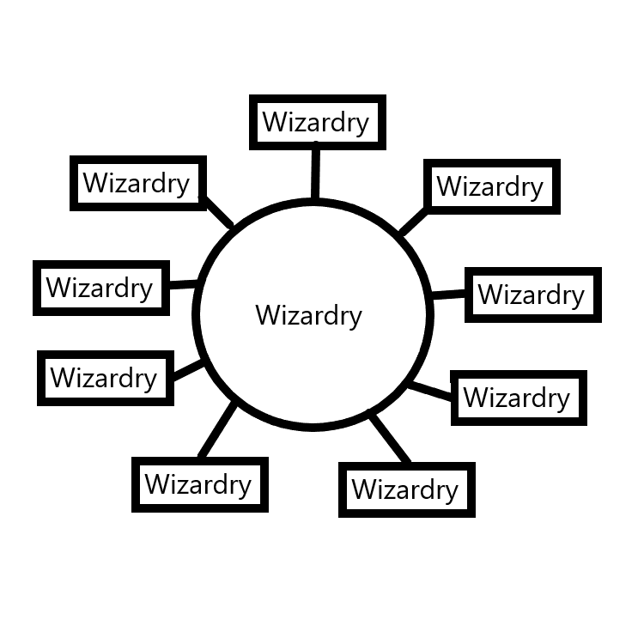
Agenda 0: Make a Wizardry Mini-Charm, by Making a Wizardry Scroll. These will be used for the Shrine.
Action 0: Roll up the piece of paper you into a Scroll.
Action 0: Bend it at the center, so it will stay closed. Now you have a Wizardry Mini-Charm. A Wizardry Scroll.
Action 0: Repeat the process and Make 1 more Wizardry Scroll.
Principle 0: These Scrolls have a great Connection to Wizardry. They have a nice Wizardry Enchantment. At least a Level 1 Enchantment. Likely a Level 2 Enchantment. The Enchantment will grow over time.
Action 0: Do 1 Round Demi God Spell 10A. This Spell is only good once.
Action 0: Do 1 Round Titan Spell 10A. A Spell that’s great to do 1 time, and then never again.
Action 0: Write the following Runes on a blank piece of paper. Close enough is good enough. Now you have a Charm, that has a huge Connection to Shrines.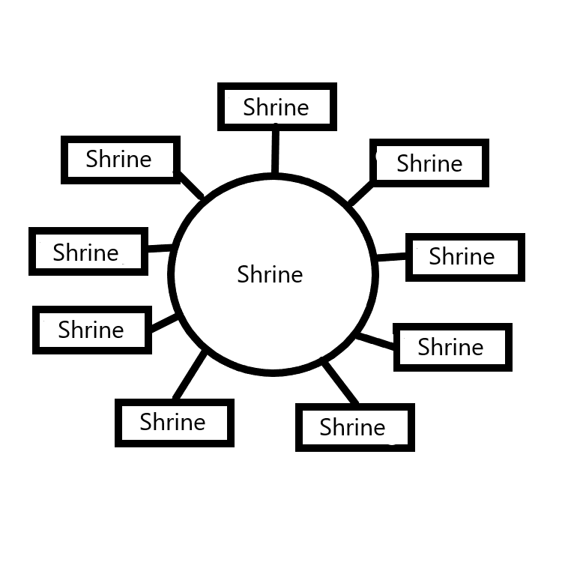
Action 0: Put the Shrine paper somewhere. Then put on top the 2 Wizardry Scrolls. Now you have a Wizardry Shrine.

Principle 0: Another option is roll up the two Scrolls in the Shrine paper. Then bend at center. Drop that somewhere.
Principle 0: Could use rope to Tie Scrolls together. Rope, string, can be used to Tie Scrolls together.
Principle 0: Much Sorcery can be done with Writing.
Principle 0: The Wizardry Shrine will help a person in their Wizardry. It will Increase Level gain per month and more.
Principle 0: The Shrine will Grow more Powerful on its own. Over time it will help a person more.
Principle 0: All Charms must be Tamed before they are useful. The Shrine will not help a person until they have Tamed it.
Principle 0: Shrines are Tamed, just by owning them, as time goes on. No Actions needed.
Principle 0: Taming can be sped up with Spells, and Actions.
Principle 0: Some Charms are “no touch” Charms. Meaning your not supposed to touch it. Often Antiques, and older stuff. Often Shrines are this way. A no touch Shrine.
Principle 0: Lots of Charms can be damaged just by touching them. Some Charms should never be touched.
Principle 0: Often Restoration Experts touch Charms that are typically no touch. This is ok for them to do.
Principle 0: Dusting a Charm is a great Action to Tame a Charm faster.
Principle 0: Cleaning a Charm is a great Action to Tame a Charm faster.
Principle 0: Polishing a Charm is a great Action to Tame a Charm faster.
Principle 0: Holding a Charm is a great Action to Tame a Charm faster.
Principle 0: Touching a Charm is a great Action to Tame a Charm faster.
Principle 0: A Chess Expert Tames Chess Charms faster.
Principle 0: Most of the time Taming takes little time and effort.
Principle 0: A Shrine should be cleaned/dusted once a week or once a month. Unless it is a “no touch” Shrine.
Principle 0: Time owning a Charm Tames the Charm some.
Principle 0: A Shrine almost always Begins with a Level 1 or Level 2 Enchantment.
Principle 0: The Wizardry Shrine Made earlier in this book is a quick Shrine. It Begins with a Level 1 Wizardry Enchantment.
Principle 0: The Wizardry Shrine Made earlier will quickly be a Level 2 Wizardry Shrine. No Actions required. Time will accomplish this.
Principle 0: Level 2 is usually very helpful.
Principle 0: Shrines are Equipped and always do something from that. No need to be near it.
Principle 0: Spells can be used on Shrines to accomplish things. Later in this book will be Spells on using Shrines.
Principle 0: Charms are Equipped and always do something from that. No need to be near it.
Principle 0: Spells can be used on Charms to accomplish things. Later in this book will be Spells on using Charms.
Principle 0: In Wizardry there is Ageing.
Principle 0: Ageing happens to all Charms. All Charms Age.
Principle 0: To Increase the Enchantment Level you sometimes Age the Charm.
Principle 0: Sometimes you Age a thing with time.
Principle 0: Sometimes you Age a thing with Spells and time.
Principle 0: Ageing is an Action in Wizardry.
Principle 0: Most of the time Enchantments take time to grow.
Principle 0: A Shrine is like a plant. It takes time to grow.
Principle 0: A Shrine is like a plant. You only need to water it a little here and there.
Principle 0: Enchantments are like a plant. They take time to grow.
Principle 0: Enchantments grow on their own. Once you Enchant something, the Enchantment starts growing.
Principle 0: Exercise is like a plant. The benefits of Exercise takes time to grow.
Principle 0: Muscle growth is like this. You do the Exercise, and later Muscle growths.
Principle 0: A person can do Spells, that have no impact for a long amount of time.
Principle 0: A person can do an Enchantment that starts out small, then grows big, all on its own.
Principle 0: Letting time pass is a major part of Ageing.
Principle 0: A good Enchantment can be one that starts out small, however grows well on its own.
Principle 0: A year after you have done Tome of The Yellow Wizard and this book, the Wizardry Enchantments on you are likely to be rather large.
Action 0: Do 1 Round of Breathe Spell 3A (control your Breathing…breathe in once, breathe out once).
Principle 0: The paper Shrine we have created is small and light enough to be a very mobile Shrine.
Principle 0: The Shrine Made earlier is a decent Shrine. There is such thing as better though.
Principle 0: Eventually we will take the paper Shrine and Fuse it with another Shrine. That Fusion will make the paper Shrine a Powerful enhancement tool.
Principle 0: When a person Makes a Charm… It usually Begins with Either a Level 1 or Level 2 Enchantment.
Principle 0: When you Make a Wizardry Charm… most of the time… it Begins with a Level 1 or Level 2 Wizardry Enchantment.
Principle 0: When you Make a Chess Charm… most of the time… it Begins with a Level 1 or Level 2 Chess Enchantment.
Principle 0: When you Make a Teaching Charm… most of the time… it Begins with a Level 1 or Level 2 Teaching Enchantment.
Principle 0: When factories output mini-football Charms… they usually Begin with a Level 1 Football Enchantment.
Principle 0: When a Person manually Makes a mini-football Charm… it usually Begins with a Level 2 Football Enchantment.
Principle 0: Charms can Begin with Enchantments that Make them Grow faster, and bigger.
Principle 0: The paper Shrine we Made is in its Beginning. It can be Enchanted so that it Grows faster.
Action 0: For 10 minutes or close to 10 minutes…on your Shrine… do Spell Shrine Grow 0A. Use the Word Wizardry as your Keyword.
Principle 0: Now the Shrine has an Enchantment that will Make it Grow better and faster.
Principle 0: One Sorcery of Charms is to Make Enchantments on Charms. Also known as Enchanting Charms.
Principle 0: One Sorcery of Charms is to Increase Levels on already existing Enchantments.
Principle 0: A Person can Bond with their Shrine in ways.
Action 0: Bond with your Shrine. Make it Connected to you in a big way. Do 1 minute or close to 1 minute of Shrine Grow 0A. Use something you are either Expert or Amateur at as the Keyword. “Cleaning” would be fine if you like the Word “Cleaning”. You get to choose the Word in some ways.
Principle 0: Now your Shrine has a bigger Connection to you. Now the Shrine has 2 things it is Devoted to.
Principle 0: A Person can Tap into a Shrine more if a Person is Expert at the Shrines Devotion. A Chess Expert is able to Tap into Chess Shrines more.
Principle 0: When a Person is Expert at something, it Enhances their Sorcery regarding that Expertise.
Principle 0: When a Person is Amateur at something, it Enhances their Sorcery regarding that Expertise.
Principle 0: Being an Expert Teacher… gives you more Power using Teaching Shrines and Teaching Charms.
Principle 0: Being an Amateur Teacher… gives you more Power using Teaching Shrines and Teaching Charms.
Principle 0: The Higher Level you are in something, the greater your Sorcery regarding that something.
Principle 0: If your Level is below 1 in something. Then you are not even considered Amateur in that something. Such as Level 0.5 would be.
Principle 0: In a month your paper Shrine will likely be a Level 2 Shrine. With a Level 3 Wizardry Enchantment on it.
Principle 0: Enchantments and Shrines can Grow on their own… once you Make the Shrine or Enchantment.
Principle 0: Some Charms Begin with Enchantments that Make them Grow faster.
Principle 0: All Charms End up at the same Location. Level 4.
Principle 0: Charms beyond Level 4 are super rare.
Item Group 0: Mini Charms
All about Mini Charms…
Principle 0: A Mini Charm is defined as a small mobile Charm or just a small Charm. Something you take with you as you move about. Or something you might leave at a Shrine.
Principle 0: A Mini Charm is something small enough to fit in your Hand. A football is a Mini Charm.
Principle 0: It’s a Mini Charm if you can hold it up with 2 Hands.
Principle 0: Mini Charms are not as useful as Shrines. They are useful though.
Principle 0: Earlier in this book we Made 2 Wizardry Scroll Items. They are 2 Mini Charms.
Principle 0: When your not transporting your Mini Charm around…you are supposed to keep it at a Shrine. Then it joins to the Shrine. In a big way Connecting the two.
Principle 0: When you keep Mini Charms at Shrines you Age them in an awesome way.
Principle 0: Making Wizardry Shrines Connects a Person to Wizardry. Making Teaching Shrines Connects a Person Teaching. Making Chess Shrines Connects a Person to Chess.
Action 0: Make 2 more paper Wizardry Shrines. From this you will gain Wizardry Levels. From this you will gain some Shrine Making Levels. From this you gain Sorcery Levels. From this you Enchant yourself… you become a Beginner Shrine Maker...Level 1. This Action also does more.
Action 0: For 1 minute or close to 1 minute do Shrine Grow 0A before your 3 Shrines.
Principle 0: Everything a Person owns is an Equipped Charm.
Principle 0: Transporting around 1 Charm or an easy to manage bunch of Charms is a Standard use for Mini Charms.
Principle 0: “Personal Mini Charms” are the ones you transport around.
Principle 0: Being close to a Charm builds on your Connection to that Charm.

Principle 0: 1 Charm can be Fused with many things. 1 Charm can be Devoted to more than 1 thing. Making a bunch of Personal Mini Charms not required.
Principle 0: A Person can go with many Personal Mini-Charms. The important part is whether its easy for you to Transport around.
Principle 0: Personal Mini Charms are as close to Wands as it gets. One could use a Wand as their Personal Mini Charm/Charms.
Principle 0: Some Mini Charms you Keep only at your Shrine.
Principle 0: A Personal Mini Charm Makes a greater Connection between a Person and their Shrine.
Principle 0: A Personal Mini Charm is a big Power up for a Person.
Principle 0: All Personal Mini Charms End up at the same Location. Level 4 Enchantments.
Principle 0: Personal Mini Charms Grow very fast.
Principle 0: Even a Level 1 Charm has great value.
Principle 0: Level 1 is never long lasting. It always quickly leads to Level 2.
Principle 0: Experts can Tap Into a Mini Charms more.
Principle 0: If you’re an Expert Wizard, you can Tap Into Wizardry Charms better.
Principle 0: If you’re an Expert Teacher, you can Tap Into Teacher Charms better.
Principle 0: If you’re an Expert at Chess, you can Tap Into Chess Charms better.
Principle 0: Taming things is a thing of Wizardry.
Principle 0: A Person can Tame Spells. A Person can Tame Charms.
Principle 0: A Spell is not Tamed until it is Trained up.
Principle 0: A Charm is not Tamed until you have Tamed it.
Principle 0: In some things Taming is not easy. In Wizardry Taming is easy.
Principle 0: Some things cannot be Tamed. Such as pyro-kinesis…shooting fireballs from your Hand.
Principle 0: In Wizardry there is the main Vocabulary Word “Wield”.
Principle 0: A Person can Wield a Spell.
Principle 0: A Person can Wield a Charm.

Item Group 0: Huge Charms
All about Huge Charms…
Principle 0: The biggest Charms are something like the Oceans, and Mountains and so forth…
Principle 0: As for Human Made Charms, the biggest are Property’s/Buildings… Lands/Buildings.
Principle 0: More weight Makes it more likely the Charm has High Enchantment Levels.
Principle 0: More weight Makes it more likely the Charm has a High Chi Level.
Principle 0: Buildings/Property’s tend to be the biggest Charms that People Make.
Principle 0: The second biggest I believe to be the ships/trains/planes/trucks/cars. The transport Charms. Other things would be in this list like tanks.
Principle 0: The biggest things are Buildings. The second biggest things are the transport things that get us from Building to Building.

