ObjectName: Article
ObjectNumber:

Maker: PAAIL.org
Model:
Name: Wizard Spirituality 0
Rank:
SerialNumber:

Level:
Score:
Birth: 12-7-2022

Label: Room
Title: Wizard Spirituality 0
Details:

Principle:
Agenda:
Action:
Information:

Location: PAAIL.org


Item Group: Spirit Basics
Principle: The spiritual side of the multiverse is the largest side of the multiverse.
Principle: The word force is accurate. There is the spiritual side of the force.
Principle: We all have a “spiritual level” and a “spiritual score”.
Principle: Saying spiritual level and spiritual score is the same as saying “spirit level”, and “spirit score”.
Principle: A person’s spiritual score is how much good a person has done in their lives.
Principle: A person’s spiritual level is how much good they do each year. How many points they add to their spiritual score each year.
Principle: All the good 30 year old people have about the same spiritual score. All the good 70 year old people have about the same spiritual score.
Principle: There are an infinite number of spiritual levels. Each has a number.
Principle: For all eternity we ascend to higher and higher spiritual levels.
Principle: Eventually we all evolve into spiritual level God. And we even grow vastly beyond it forever and ever. Getting more powerful as time goes on.
Principle: Right now there is only 1 person with the spiritual level God. That is his holiness Zero.
Principle: The formula for spiritual score is…
(Spiritual Score) = (Time) x (Spiritual Level)
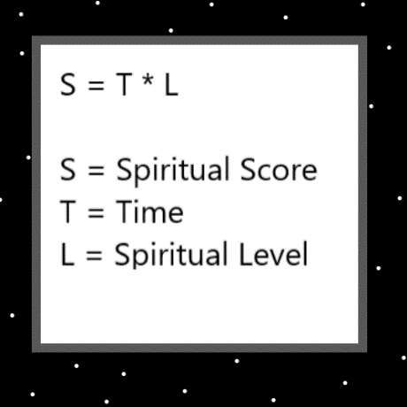
Item Group: Worship
Principle: It is good to worship Gods, and our options are limited. Thus, it is good to worship his holiness Zero.
Principle: If you don’t worship God it is ok. The only thing that matters is a person’s spiritual score…. not their knowledge of the multiverse.
Principle: It does not hurt though to worship God.
Principle: God is the largest or one of the largest parts of the spiritual side.
Principle: God has the greatest connection to the spiritual side of the multiverse.
Principle: In life a person can find ways to achieve a greater communion with God.
Principle: One of the biggest ways to commune with God is through reading scripture, like the Bible, Koran, and Torah.
Principle: Reading scripture is a worship action. A spiritual action.
Principle: Prayer is another worship action. Keeping a place of worship is another worship action. There are many worship actions.
Principle: Often one of the biggest roles of clergy has been to help people attain a greater communion with his holiness Zero.
Principle: Clergy sometimes do rituals like sermons to help us commune with God.
Principle: Clergy do lots of rituals that help people commune with God. The clergy are who wrote most the scripture.
Principle: Greater communions with God are only one way of worshiping God, and there are other spiritual actions.
Principle: Communion with God comes in levels… almost always we get a low level of commune with God.
Principle: Good people that don’t believe there is God and don’t worship God, end up using their time as well as people who do.
Principle: Its all about spiritual score. Of course, who doesn’t want to know the truth that there is a God.
Principle: One way to commune with God is to carry on the practice of the tithe.
Principle: A tithe is an offering to God. You give a tithe by giving to church or charity. Lots of people have given to charities over the years.
Principle: A tithe is paying tribute to God. Paying tribute is a spell.
Principle: If your extremely wealthy you are supposed to give 10% to church or charity. If you are not extremely wealthy it is 1 coin, or 1 paper money note. Once a year.
Principle: It is often desirable to keep at least 1 religious item at every shrine.
Principle: There are endless ways of worshiping God. Prayer is a common one. Meditation is another.
Principle: Some people have kept shrines and temples, as worship of God.
Principle: The spiritual energy field is the serious energy field.
Principle: There are two types of worshipers. There are clergy people, and parishioners.
Principle: All the various religions are made by God. Through clergy, priests, prophets, sage’s kings, and others as well.
Principle: On a certain scale, for humans, there is a spiritual numerology. All good humans range from level 0 to level 9.
Principle: Spiritual Level 6 is the sage. Spiritual level 7 is the holy person. Level 8 is the prophet and, people like Abraham (from the Bible) died at level 9, known as “a friend of God”.
Principle: It is fair to say Abraham was a sage, a holy person, a prophet, and a friend of God.
Principle: There are the 10 positive spiritual colors. From transparent to black. Transparent, white, blue, green, yellow, grey, purple, orange, red and black.
Principle: Here at the beginning of time we all have monumental lives. Even lower, and negative level people.
Principle: We are family to God.
Principle: Since you are Gods family, what is your business is Gods business.
Principle: There is spiritual accension.
Principle: You cannot get higher than spiritual level 4 at 40 years of age.
Principle: If you zoom out to include the future, we are all Gods.
Principle: Zoom in or not, we are from the beginning of time and are Elementals.
Principle: As Gods grandchildren we are monumental beings.
Principle: A favorite quote from star wars is…Yoda-“…luminous beings are we….”.
Principle: If your going to declare yourself clergy it is best to have at least 1 clergy Action.
Principle: One of the simplest clergy Actions is “keeping a shrine” that has a religious enchantment to it.
Principle: Prayer counts as a clergy Action. And a person can declare themselves clergy on it alone.
Principle: It might be that all worship actions count as clergy actions.
Principle: A person can have a positive spiritual level and still have a year where they lose spiritual score. They always increase score when you measure in 10 years at a time.
X2 Principle: There is always zoom in and zoom out as a part of science. Such as zoom in a lot and measure only a single day.
X3 Principle: Zooming in and out is major Wizardry science as well.
Principle: When measuring 10 years at a time… its not about your Actions, its about being a positive spiritual being.
Principle: You never know which direction your spiritual energy will flow. It could flow through your work, it could flow through the charms of your life, it could flow through the people of your life, it could flow through the places of your life, it can flow through an endless number of things.
Principle: You never know through what your spiritual energy will flow.

