ObjectType: Article  
ObjectNumber: 106

LocationName: PAAIL.org

LocationNumber:

Language: PAAIL 2.8

Maker: PAAIL.org  
Model:   
  
Name:

Rank:

SerialNumber:

Level: 6.1

Score:   
Birth: 7-8-2025

Label: Room 106

Title: Smith Notes 20

Details: PAAIL.org Scripture…

Principle: Ultimate Scripture….

Agenda: Ultimate Scripture….

Action: Ultimate Scripture….

Information: Ultimate Scripture….

Item Group: Understanding The Force 0

Principles: On some Maps, the Word “Multiverse” means all Universes combined/Fused. On some Maps the Word “Multiverse” and the Word “Force” mean the same thing. The Science of the Force is the Science of the Multiverse. There be the Cosmic Side of the Force. The Cosmic Side of the Multiverse.

Principles: The Bible is Scripture and it is not accurate to call it a Science text book. PAAIL.org Wizardry is Scripture, and it is accurate to say it’s a bunch of Science text book writing.

Principles: Understanding his Holiness Origin is a Science. The Science of God.

Principles: Planet Earth is strong with the Dark Side of the Force…… Beware!

Principles: Divination is likely great for the electrical network in the brain.

Principles: Picturing a forest, means Forcing a Vision of a forest into your Mind. It is a Vision when you picture something in your Mind.

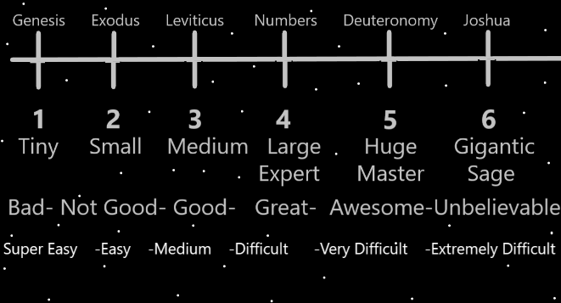

Principles: Divination Forces Visions into the Mind.

Principles: There be lots of 1 to 6 Numerology Systems that can be designed. A person could design a chess program that gauges player skill Level from 1 to 6. If your totally new, you might play in Level 1 Rooms. If you think of yourself as a chess Sage (Level 6) you could play in Level 6 Rooms. If you think yourself a chess Master, you might play in Level 5 Rooms. If you think yourself an Expert, just under Master, you might play in Level 4 Rooms. Then there is Level 3 and Level 2 Rooms.

Principles: There is much less to write these days. Wizardry technology is at a Level 6. When “Tome of the Yellow Wizard” was finished, we were at a Level 4.

X2 Principles: Many things were not known at the End of Tome Of The Yellow Wizard.

X3 Principles: Things such as picturing a forest is Forcing a Vision of a forest into your Mind. Things like Divination Forces Visions into people’s Minds.

Principles: The PAAIL.org Wizardry Scripture is that that it is gigantic for a person to get Wizard Level 3. That it should be a priority in life. The sooner the better. And also that a person should work over a period of Time on getting Level 4 as well.

Principles: Often when speaking of theories, we End up speaking of evidence. To the Wizard they be also known as “signs”. In PAAIL, One might also want to use the Word “View”. A phrase like “the View presents, such and such evidence”.

Principles: I’ve read the Words “dark matter” in other writings. Its apparently a physics term. If exists, then in God’s Science it is likely also called “Negative matter”. Perhaps also Fire matter.

Principle: The Spiritual Energy Field is the most important Energy Field.

Principle: Spiritual Levels and Scores are the most important Levels and Scores.

Principles: People have Principles. People have Agendas. People have Actions. People know Information and Information is all around them.

Principles: It’s the Science of God. Level 4 is Expert, Level 5 is Master and Level 6 is Sage.

Principles: The Science of God is the Laws of Reality.

Principles: When measuring Time a person can use the 1 to 6 Numerology System. 1 could be a “tiny” amount of Time and Level 6 a “gigantic” amount of Time. Example: Getting to Level 6 chess may take a gigantic amount of Time. A 6 amount of Time.

Principle: All the good people live in God’s book of heroes.

Principles: We all have ESP Levels. Some have higher Levels than others. Likely Divination increases Levels. Likely Body exercise, Breathing exercise, and Meditation exercise do so also. Many things increase it, some more than others. Music likely is a big One.

Principles: The 1 to 6 Numerology System is gigantic Wizard tech. A crowning achievement of PAAIL.org.

X2 Principles: It be Map technology. Ultimate Map technology.

X2 Principles: Other Words might be the “1 to 6 Numerology Mapping System”.

Principles: “If you do not breathe right, you do not move right.”-Unknown. This is true of the Chi. In life, your Chi does not move right if you do not breathe right. Your Chi does not evolve right if you do not breathe right.

X2 Principles: If there were paranormal warriors throughout history, the One thing they all had in common is that they breathed right.

Principles: The author has read most of the Bible. Much of this was inspired by the Bible.

Principles: “I see the truth of it.”-The Movie Dune.

Principles: It has been a marijuana apocalypse. Partly because it has been a “gateway drug”, and even more so, because it should have been legal for recreational use. Many places still do not have it legal. This is more apocalypse. It be a Dark thing that it is not legal. More blessed are the lands that make it legal for recreational use.

Principles: Some people and alcohol don’t mix. Some people should never drink. It is likely the same with marijuana. For some people alcohol and marijuana have psychological benefits. Likely outright medicinal and therapeutic. Very good for a person.

Principles: You can always swap the Word “to” with the Word “Growth”. “I went Growth the store. I went Growth get milk.”. This is because Growth is One of the core Types of Energies.

Principles: It may be that often you have to sacrifice power for accuracy. And sacrifice accuracy for power.

Principles: Experts about the Bible know that the Bible has Two main Parts. The Old Testament and the New Testament. This is because they testify things. The Bible testifies things. It be a testimony.

Principles: My first Wizardry Principle was inspired by the Bible. I read in the Bible “I don’t know what bodies we will have in Heaven. Heavenly bodies!”. This Make me conclude the Stars are the Angels. I picked a random page and read like 10 pages. It is a Divination to pick a random page and then read 10 pages. I did not know I was doing Divination then. Here’s too Divination with the Bible.

Principles: “Feel the vibe of this place.”-Unknown

Principles: If we are all family of God, then we are all family to each other.

Principles: The End of the road is Zero. Its before Positive Time and Negative Time. It’s the first frame of the first movie. The first movie is the Beginning movie.