ObjectType: Article  
ObjectNumber: 86

LocationName: PAAIL.org

LocationNumber:

Language: PAAIL 2.8

Maker: PAAIL.org  
Model:   
  
Name:

Rank:

SerialNumber:

Level: 5.5

Score:   
Birth: 10-16-2024

Label: Room 86

Title: Smith Notes 8

Details: PAAIL.org Scripture…

Principle: Ultimate Scripture….

Agenda: Ultimate Scripture….

Action: Ultimate Scripture….

Information: Ultimate Scripture….

Item Group: Understanding The Multiverse 0

Principles: Sometimes you want to stretch yourself in One direction, sometimes you want to stretch the opposite direction. Some people could benefit from be passive Exercises. Others could benefit from be aggressive Exercises. Some people could benefit from slouching, others from standing/sitting up straight.

Principle: Passive or aggressive, often moments call for One or the other.

Principles: There be Positive Divination and Negative Divination. Negative Divination is where you are Negative during the Spell. Seeing overly Negative things as you do it.

Principles: One of the biggest Sciences his Holiness Origin knows is Wizardry. His Holiness Origin is a Wizard.

Principle: One of the biggest things about his Holiness Jesus, was that he was/is a Wizard.

Principle: The apostles were Wizards.

Principles: A person can experience/Sense the general Aura of a person, place or thing. A person can also experience/Sense specific Auras of a person, place or thing.

Principles: One of the best education Systems is the “at your own pace” System. Some people only have 20 hours a week to learn. Some people only have 10 hours a week to learn. Some people also learn faster than others.

Principles: Height, width, depth and Time are 4 Particles. 4 bend in Particles. Perhaps they are also “wave Type” Particles. Perhaps not. The theory is that there may be “Types” of Particles.

Principles: Wizardry is like reading and writing, everyone should learn it.

Principles: When you do the math… the rotation of Earth, the movement of Earth around the Sun, the movement of this Galaxy in Heaven, the movement of Heaven around his Holiness Origin…. We are all traveling a billion miles per hour.

Principle: It may be every Number has a System.

Principles: The Word “Holy” has a huge Connection to the Words “Wholly” and “Whole”. Being about the whole is Holy. The whole is the big picture. There is the opposite of the whole, the small picture. Caring about all nations is more wholly/Holy.

Principles: When jobs go to other nations it can be a good thing. It turns out that poor nations need jobs too.

Principle: On some Maps the Number 0 is greater than the Number +1 million.

Principles: The term “cursed” can be a very Negative Word. Sometimes you might call something cursed, even though the more accurate truth is that it has a Dark Aura, it is not entirely “cursed”.

Principles: New technology can be cursed because humans have not adapted to it yet. It Wields people, more than people Wield it.

Principle: When a person is hypnotized by a thing they are especially Wielded by that thing.

Principles: It can be great to be hypnotized by good things. It can even be a Positive ESP experience.

Principles: A Planet Wields its Moons, and Moons Wield their Planets. When Two Charms are near each other they Wield each other. People Wield all the Charms in their Room. All the Charms in the Rooms Wield the people in the Rooms. Reality is things orbiting other things. Like Stars, Planets, and Moons.

Principles: Because the Number 0 is a Energy Bit Number and Number of the Origin moment, the physics of the Origin moment is governed by the Laws of Energy Bit physics.

X2 Principles: Energy Bit physics can be strange. Example: A / 10 = A \* 10

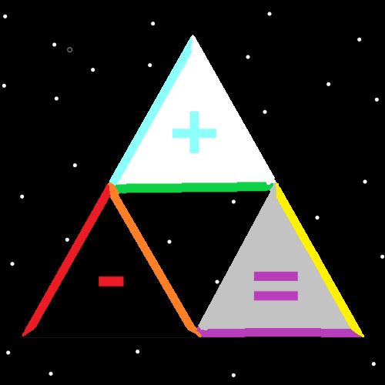

Principles: The up, right, line of a triangle is the Positive line. The up, left, line of a triangle is the Neutral line. The bottom line is the Negative line. If the triangle is upside down the Story is different. The top line would be the Positive line, the down, left would be Negative, and the down, right would be Neutral.

Principles: Sorcery is not fireballs and lightning bolts, its Enchantments that Make a person smarter, wiser, and more graceful. Along with other Virtues. Virtues is a much greater thing than fireballs.

Principles: I suppose One of the biggest lessons is that if you are a good person, your life has great meaning.

Principle: To a mathematician the Four Force’s are Addition, Subtraction, Multiplication and Division.

Principles: Parables, metaphors, analogies…. Everything’s a ship. A restaurant is a ship, a business is a ship, a nation is a ship. Heaven is a ship going round and round his Holiness Origin. A person’s life is a ship. Parables, metaphors and analogies are great tools.

X2 Principles: Often there is a owner of the ship. Often there is a captain of the ship. Sometimes the captain owns the ship.

Principles: Parables, metaphors, analogies….Reality is a ship. Reality is a chess match. Reality is a football game. Reality is a football season. Reality is a warzone. Reality is a garden. Reality is a restaurant. The list is endless. If you were a Expert on horses you might say Reality is a horse, and you can understand the Multiverse through horses.

Principles: Parables, metaphors, analogies….Everything’s a game of chess, everything’s a football game, everything’s a football season, everything’s a garden and so forth.

Principles: Parables, metaphors, analogies….Everything is a game of chess, everything is a bunch of chess pieces, everything is a chess board, everything is a chess board and a bunch of chess pieces. Everything is a king chess piece, everything is a pawn chess piece. A government is a pawn chess piece. A ship is a pawn chess piece. A government is a garden. A government is a gardener. A government is a tree. A government is a tree in a garden. A government is game of chess.

Principles: Parables, metaphors, analogies….A ship is a game of chess. A game of chess is a ship. A football game is a game of chess. A football game is a ship. A ship is a football game.

Principles: Parables, metaphors, analogies….a government is the captain of a ship. A chess game is the captain of a ship. A government is a sailor. A government is the engine of a ship.

Principles: Parables, metaphors, analogies….Things mirror other things. You can mix virtually anything together.

Principles: Parables, metaphors, analogies….The Spiritual Side of Reality is a pawn from the game chess.

Principles: Parables, metaphors, analogies…. You can see things through the “lens” of a expertise. If you know about ships, you can see things as a ship. If you’re a sailor you can see things through the lens of the sailor. If you know a bunch about football you can see things through the lens of football. If you are a gardener you can see things through that lens. Chess player, then you can see through that.

Principle: On One “lens” you see everything’s Made of +1’s and -1’s.

Principles: In the US people are peasants or officers. People who hold an office (appointed or elected) are officers. People in the military that are officers are officers. Police officers are officers. The majority of people are peasants.

Principles: Media on the brain increases Intelligence, and so does art. Looking at a car is looking at some art. Looking at a candy wrapper is looking at some art.

