ObjectType: Article  
ObjectNumber: 94

LocationName: PAAIL.org

LocationNumber:

Language: PAAIL 2.8

Maker: PAAIL.org  
Model:   
  
Name:

Rank:

SerialNumber:

Level: 6.0

Score:   
Birth: 1-20-2025

Label: Room 94

Title: Smith Notes 12

Details: PAAIL.org Scripture…

Principle: Ultimate Scripture….

Agenda: Ultimate Scripture….

Action: Ultimate Scripture….

Information: Ultimate Scripture….

Item Group: Understanding The Multiverse 0

Principle: Knowing his Holiness Origin’s Name in Numbers is Zero, Makes a person more Connected to his Holiness Origin.

Principle: Knowing his Holiness Light’s Name in Numbers is One, Makes a person more Connected to his Holiness Light.

Principle: Knowledge about his Holiness Origin creates a greater Connection to his Holiness Origin.

Principle: Wizardry knowledge creates a greater Connection to the Multiverse.

Principle: The Cosmic knowledge End of Wizardry is the greatest of all knowledge. Knowledge of Details like there is a God.

Principles: Light Grows and Darkness shrinks. The Light will forever Grow and the Darkness will forever shrink.

Principle: The biggest area the Spiritual Energy field flowed through was the “honest work”. There is also “honest rest”.

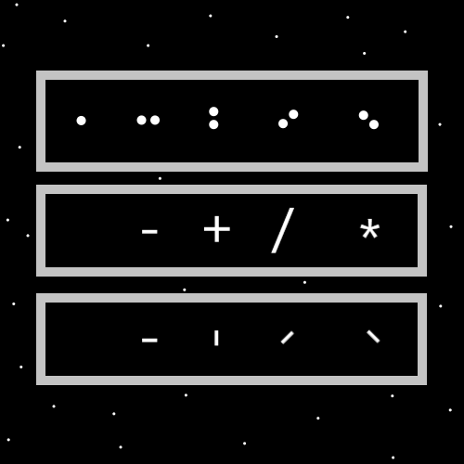

Principles: Level 3 and higher Divination Makes for more powerful Divination Spells. It Makes Divination go better.

Principle: A person can rate Time from 1 to 6. 1 is a tiny amount of Time. 2 is a small amount of Time. 3 is a medium amount of Time. 4 is a large amount of Time. 5 is an awesome amount of Time. 6 is an unbelievable amount of Time.

X2 Principle: This is a Map. It uses the Numerology 1 to 6 System.

Principle: The Higher your Levels the more powerful your Spells.

Principle: The Higher your Levels the faster you can Cast Spells. Less Time to finish the Spell.

Principle: The Higher the Spell Level the more difficult it is to Cast. The Higher the Spell Level the more Time it takes to Cast.

Principles: The Zero moment likely has Laws that contradict each other. There is no Energy, and yet there is Energy at the same time.

Principle: It may be that the Zero moment is before the existence of Laws. Or is before the existence of Laws is some ways.

Principles: Understanding the Zero moment Connects a person to where they come from and what they are Made of. We are all Made of the Zero moment Energy, and we all come from the Zero moment Energy.

Principle: The first Principle of equipping gear is that you are safe with the choices you Make.

Spell: Equip Gear 0

Details: Equip the right amount of gear. Equip the right Type of gear. Sometimes you want a small amount of gear. Sometimes you want a large amount of gear. 0 gear is a quantity.

X2 Principles: Lots of gear can be a hazard. It also has less of a Connection to the Word peace, and the Word quiet.

Principles: A Water gear situation is when you choose a very little amount of gear. Fire gear situations are when you choose to have lots of gear equipped. Police officers are an example of Fire rigged with their gear.

Principles: The Earth and Air Elements come from the Fire and Water Elements. The Multiverse is more Made of Fire and Water, than it is Earth and Air. The Water Element is also known as the Light Element and the Fire Element known as the Darkness Element.

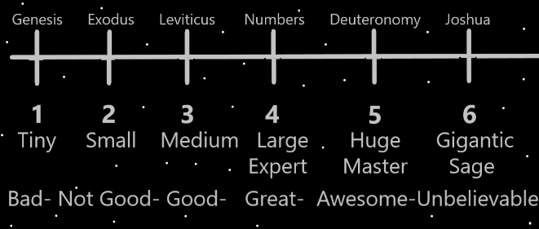

Principles: Wizardry and Wizardry Maps re-wire the human brain. In a Positive way.

Principle: All this music is Beginning of Time music.

Principle: Other Maps can be Made with the 1 to 6 Numerology System.

Principles: The Zero moment is also known as the “Transparent moment”, and “invisible moment”. His Holiness Origin likely has a huge Connection to the Word “invisible”. He who be the invisible being.

Principles: Protons may be big Particles. They may be more like huge Particles, that’s why they have the biggest impact on things. It may be right to call them “Quantum” Particles, and also call them huge Quantum Particles. They could be the biggest or One of the biggest Quantum Particles.

Principles: In the 1 to 6 System, when something is either Level 5 or Level 6, it can be hard to tell if it’s a Level 5 or a Level 6. In this situation its “the Level 5/Level 6 range”. There is the 1 to 2 range, the 2 to 3 range, the 3 to 4 range, the 4 to 5 range and the 5 to 6 range. A person could also use a 1 to 3 range, a 2 to 4 range, and so forth. A person is quite uncertain when using 1 to 3, or 2 to 4.

Principle: Cleaning has a huge Connection to the Light Side of the Force.

Principles: So much can be done with the 1 to 6 Numerology System. A person can rate their day, from 1 to 6.

Principles: 1 dollar is a tiny amount of money (1). 10 dollars is a small amount (2). 100 dollars is a medium amount (3). 1000 dollars is a large amount of money (4). 10,000 dollars is a huge amount of money (5). 100,000 dollars is a gigantic amount of money (6).